Once the Token installation has been completed, you need to launch BOTH the Secure Mobility Client application and the RSA SecurID Token application to complete the connection process.

Launch the Cisco AnyConnect Secure Mobility Client application

- Go to Start > (All) Programs > Cisco > Cisco AnyConnect Secure Mobility Client > Cisco AnyConnect Secure Mobility Client

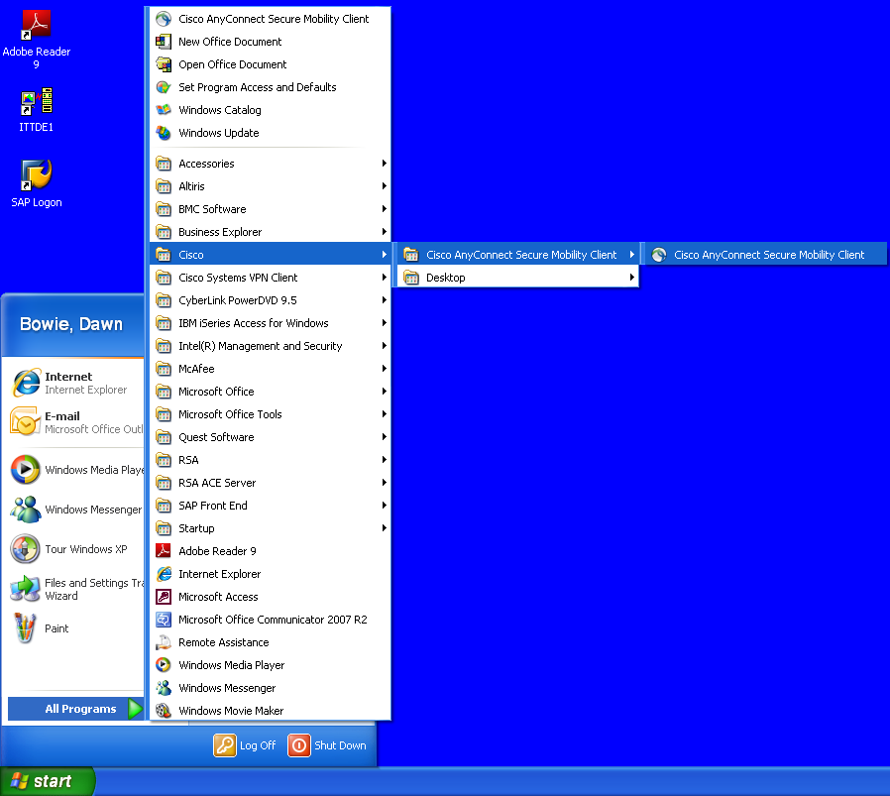

The Cisco AnyConnect Secure Mobility Client window will open in the bottom-right corner of the Desktop.

- In the white text field box, type in the following connection string: Usfwa01-vpn01.itt.com

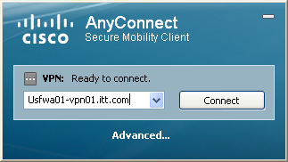

- Click the Connect button.

- You may see a Security Alert popup window (below). If you do, click the Yes button to proceed beyond this Security Alert .

- Make sure to select WEBVPN under the Group drop-down menu.

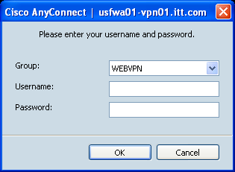

- Type in your current user logon ID in the Username field.
(Example: firstname.lastname@exelisinc.com for most Exelis users).

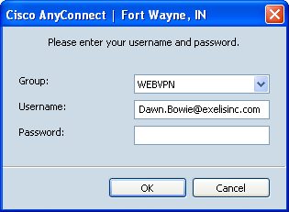

- Enter your 6 to 8 digit pin in the Password area.

Launch the RSA SecurID Token application

- Go to Start > (All) Programs > RSA > RSA SecurID Token > RSA SecurID Token (highlighted in the red ovals).

The RSA SecureID Token window will open.

- The window will display a 6 digit Tokencode in the RSA window. Click the Copy button.

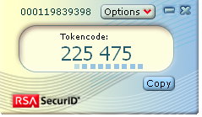

Authentication Completion

- Return to the Cisco AnyConnect window. Right-Click into the Password field behind the pin you entered originally and select Paste.

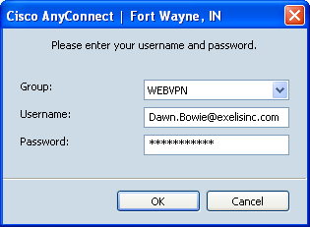

- This enters the RSA Tokencode data from the RSA window into the Cisco AnyConnect Password field. The PIN +Tokencode together become your PASSWORD in the Cisco AnyConnect window.
- Now click the OK button to initiate the connection process into the Exelis networks.
- If you have correctly entered your logon information, you will see the following banner page. Click the ACCEPT button and you will be connected to the ITT network via VPN.

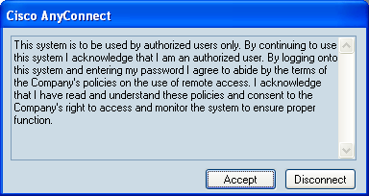

This is referred to as "two factor authentication". Your PIN is the first factor (something you must know) and your SecurID is the second factor (something physical you must have, this includes software in your computer [soft tokens]). There is added security in that a hacker must have both in order to compromise an account. Remember, don’t share your PIN with anyone and don’t allow anyone access to your SecurID token.

Congratulations! You have completed are now connected to the new VPN environment. Going forward, your VPN client will select the optimal connection automatically.

