- Right click my computer, and select manage as shown 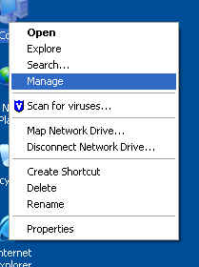
- Click on the services option on the bottom 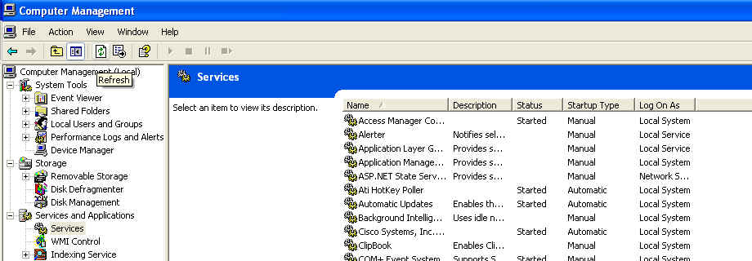
- Select “Cisco Systems, Inc. VPN Service” and in the upper left hand corner you can select stop. 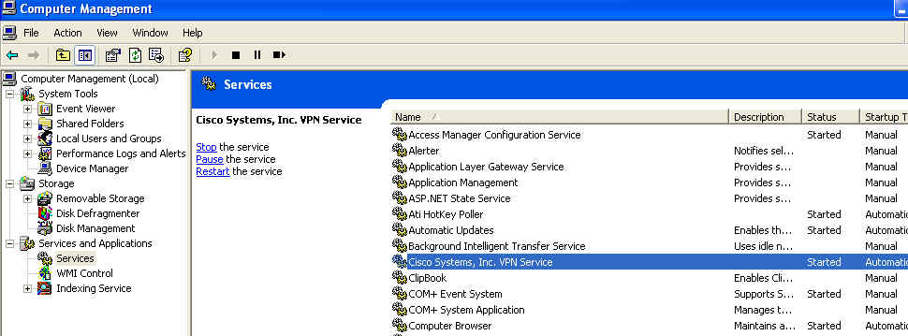
- Once the service is off you should be able to connect to a remote session also if you do not want to restart the service you do not have to b/c the service is set to automatic.

