Undo the Screen Saver settings for special need lab computers
Logon as administrator
Start > Run
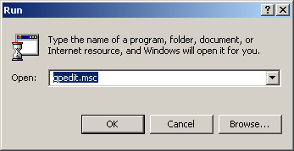

Select User Configuration > Administrative Templates > Control Panel >Display
Change all the “Enabled” Policy’s to “Not configured”
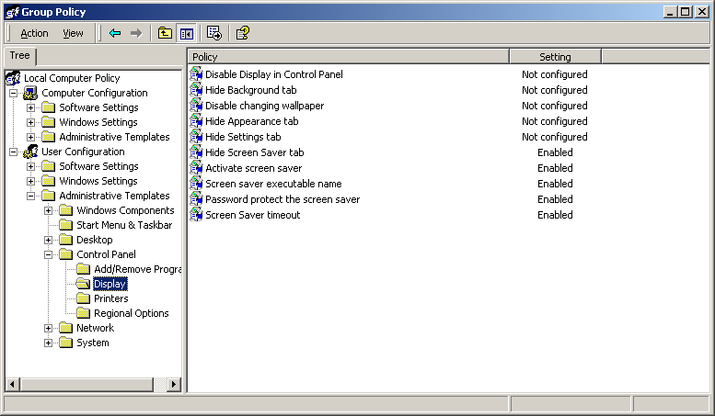

If W2K machine run the following to set the new policies:
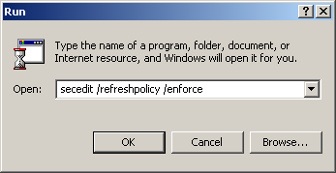

If XP machine run the following to set the new policies:
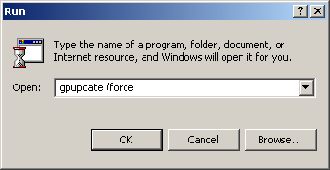

Right click on the desktop and select Properties:
Select the Screen Saver tab and change the screen save to meet the needs of the special lab computer.

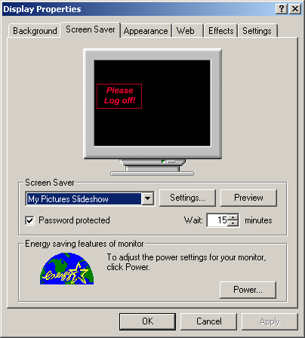

Remove the link called “UsrLogin” from the startup:
C:\Documents and Settings\All Users\Start Menu\Programs\Startup
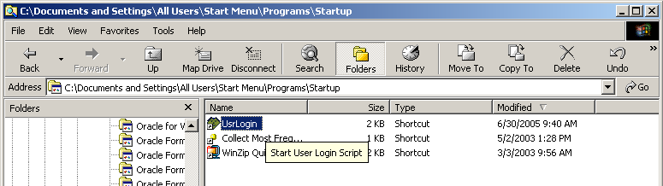

Change the Registry to suit the special needs of the lab computer. In this example set the timeout to 3600 seconds or one hour.

Windows Registry Editor Version 5.00

[HKEY_CURRENT_USER\Control Panel\Desktop]
"ScreenSaveTimeOut"="3600"
"SCRNSAVE.EXE"="C:\\WINNT\\system32\\logon.scr"

