PARAMETER
CHANGE
TO COMPENSATE
FOR POTENTIAL
REPORTED
CEM PATH WIDTH
FAILURE
WHEN UPGRADING
FPS
FROM VER. 8.4

TO VER. 9.2
Revised 10/28/04
by J.Gilly per C.Mcllelan/M. Wiggers

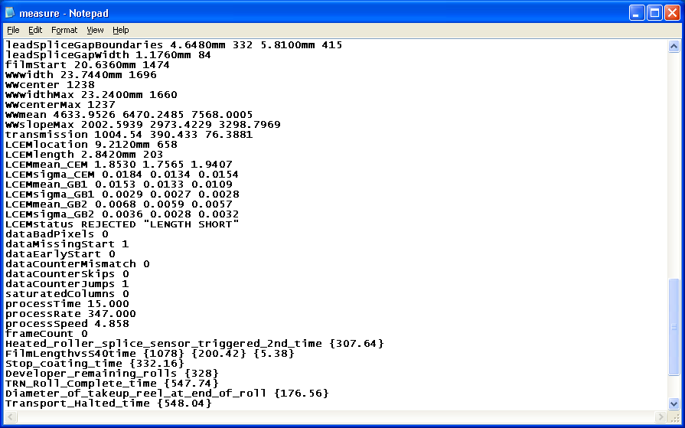
As evidenced while viewing D:\rolls\xxxxxx\metadata\measure.txt
After 9.2 upgrade……..machine fails alignment roll for LCEMstatus REJECTED “LENGTH SHORT” (machine ran fine on 8.4)

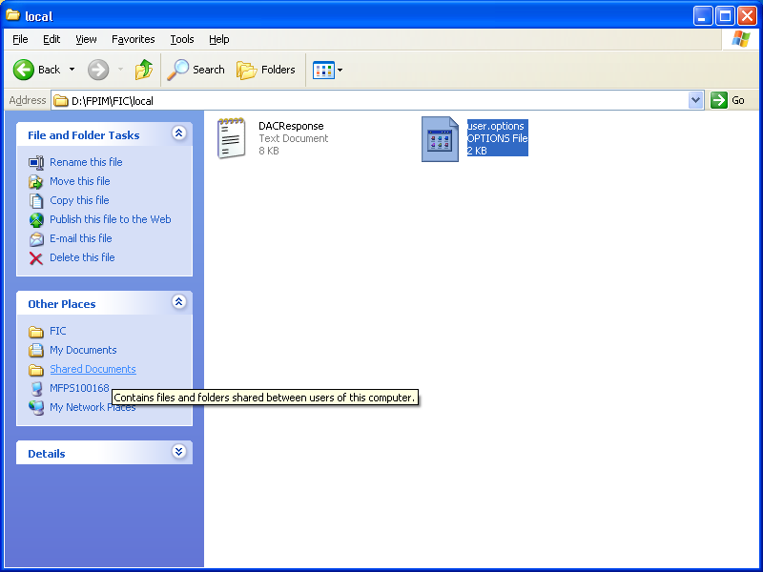
To remedy, open this file in “Notepad”.

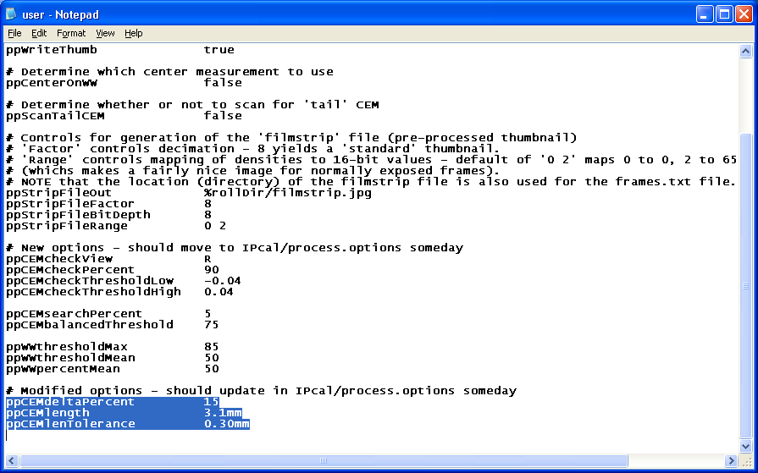
Scroll down to these parameters.
Edit these highlighted values to those shown in the above screen capture.
Save file, close FIC, restart KIS, and re-initialize.

