Keypoint Document
For
CEM Firmware
Programming

(Uncontrolled
draft copy for
reference only)

John Gilly 9/17/04

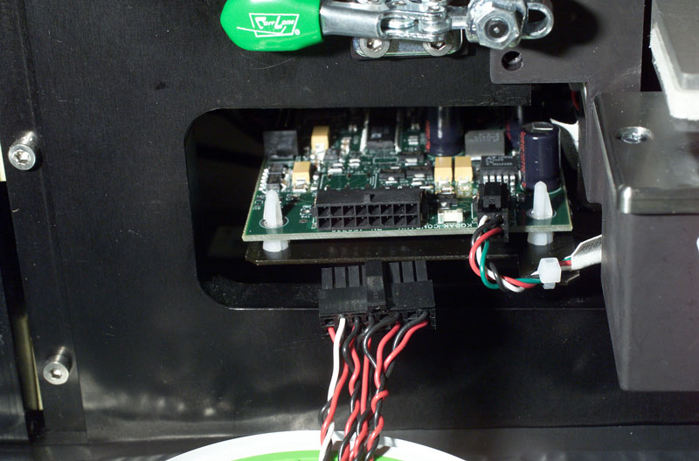
Clamp CEM into fixture and attach main power connector here.

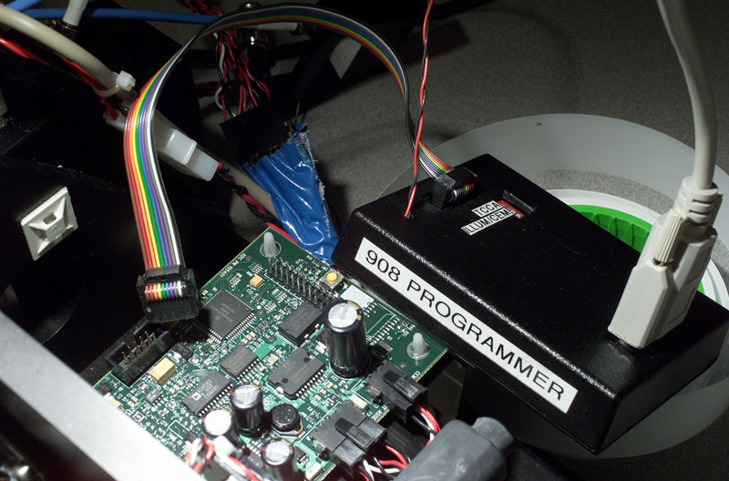
Reach behind fixture mount plate and attach programmer module to CEM board here.

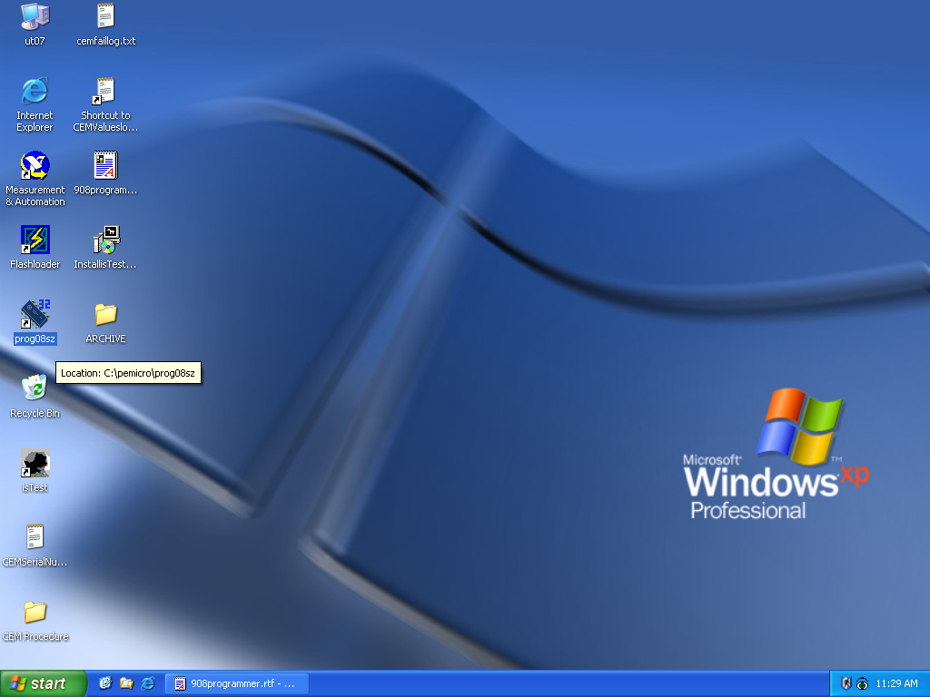
Doubleclick on prog08sz icon to open programming application.

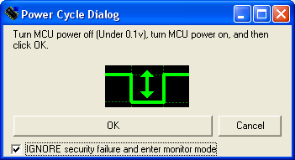
Check “ignore security” box, cycle power as instructed, and click OK button.

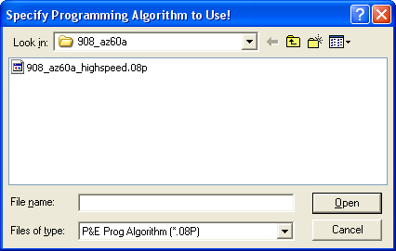
Look for this dialog box.

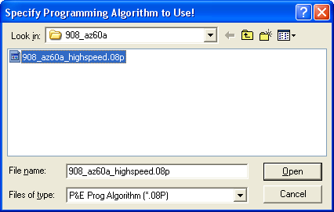
Choose highlighted file and click open button.

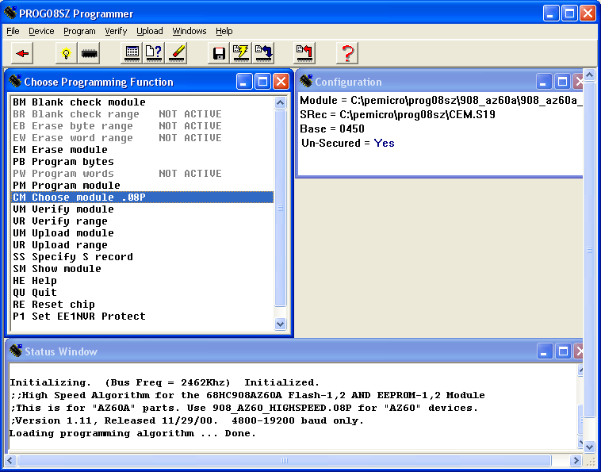
Make sure the status window confirms step done as above.

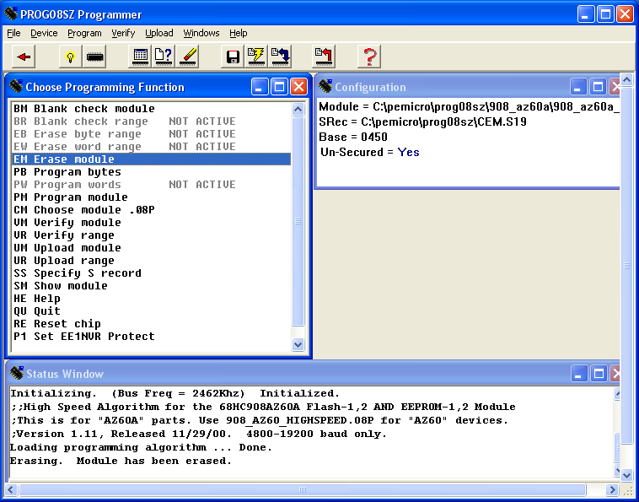
Doubleclick “erase module” and check status window to confirm.

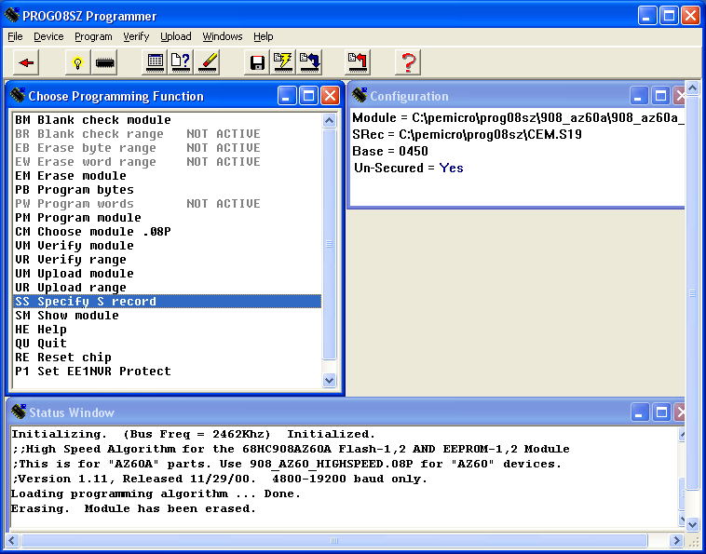
Doubleclick “Specify S record”.

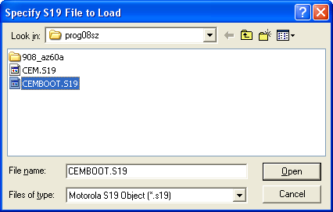
Choose “CEMBOOT.S19” and click open.

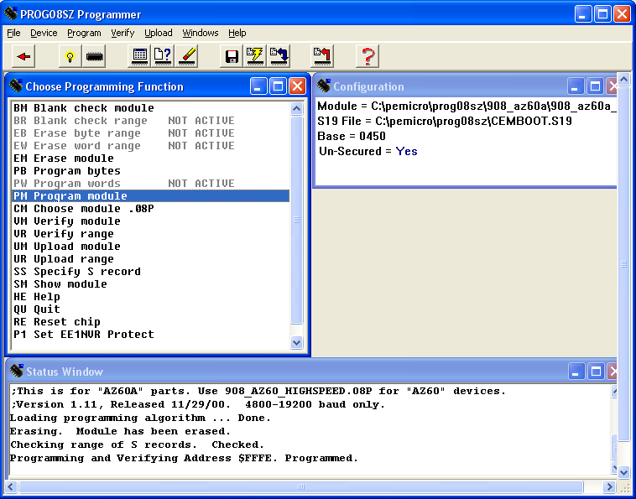
Doubleclick “Program module”, check status window for confirmation.

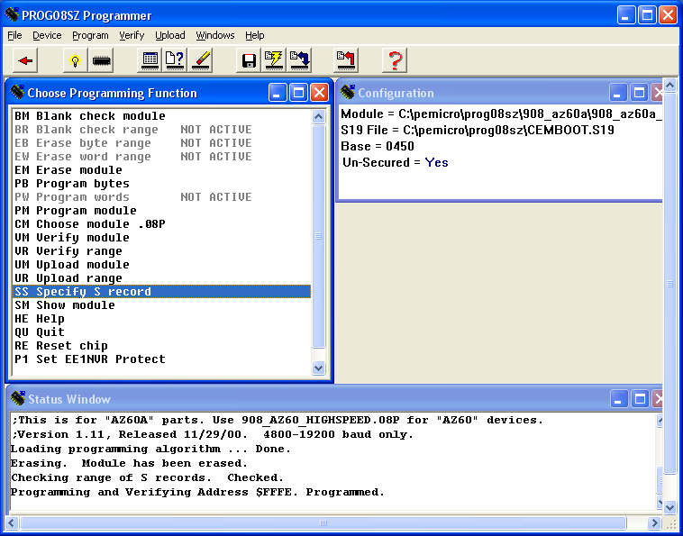
Again, doubleclick “Specify S record”

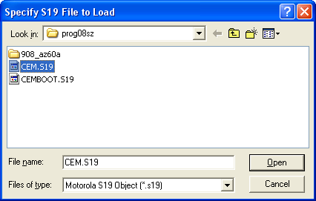
Choose file CEM.S19 and click open.

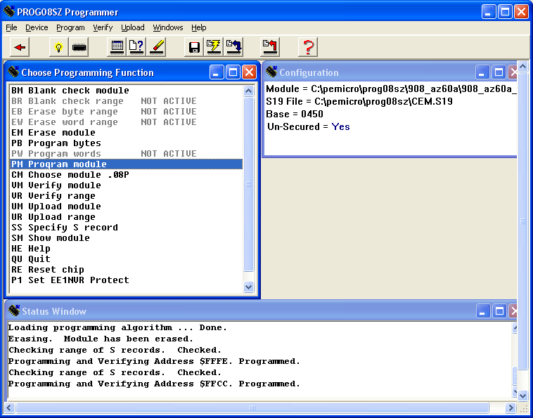
Again, doubleclick “Program module” and check status window for confirmation.

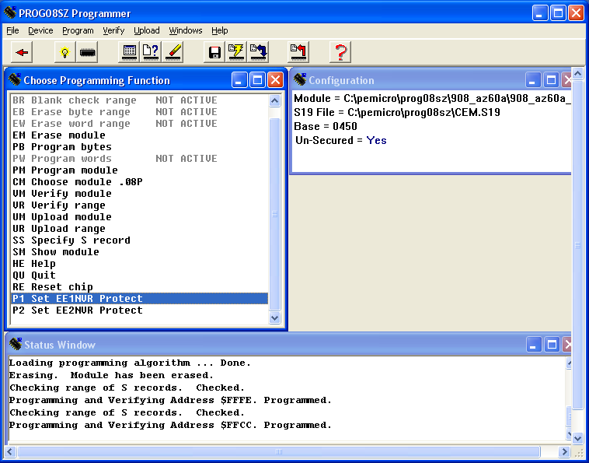
Scroll down to see P1 and P2 entries in window, doubleclick “Set EE1NVR Protect”.

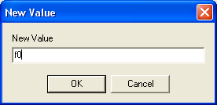
Type “f0” (lowercase letter f followed by zero) and click OK.

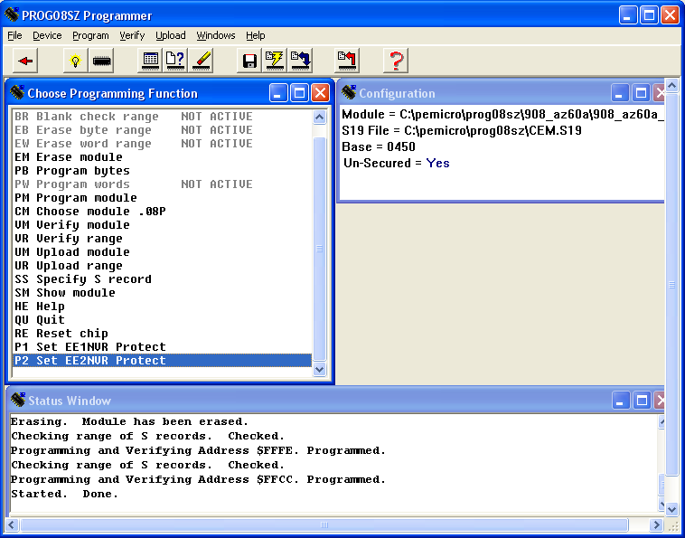
Doubleclick “Set EE2NVR Protect”.

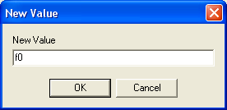
Again, type “f0” (lowercase letter f followed by zero) and click OK.
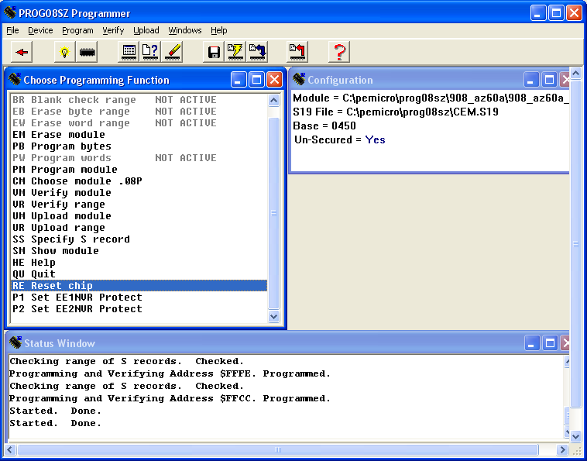
Doubleclick “Reset chip”.

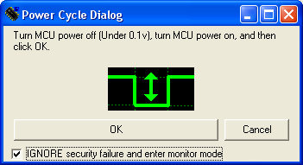
Check “ignore security” box (if not checked), cycle power as instructed, and click OK button.
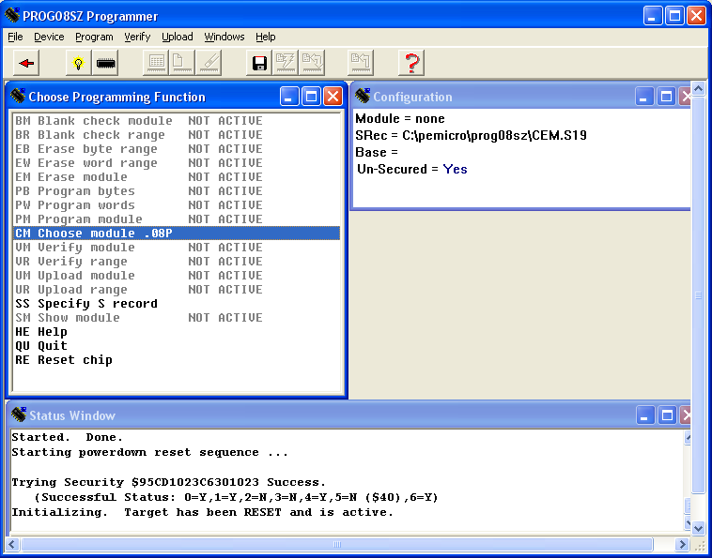
Check status window for successful reset, power down, disconnect programmer.

You are now ready to run the CEM Calibration Application.

