|  |  |
| --- | --- |
| **USB ID** |  |

If you have more than one device (radio and/or rotor) connected through USB ports, the port number assigned when you reboot may change. What was ttyUSB0 for radio 1 and ttyUSB1 for radio 2 can be reversed. The list order can change because response timing may vary when you reboot even though no changes have been made.

A utility program is provided on the RSS Desktop and in the Ham Radio menu to rename the ports and make them stable. The program is name USB ID.

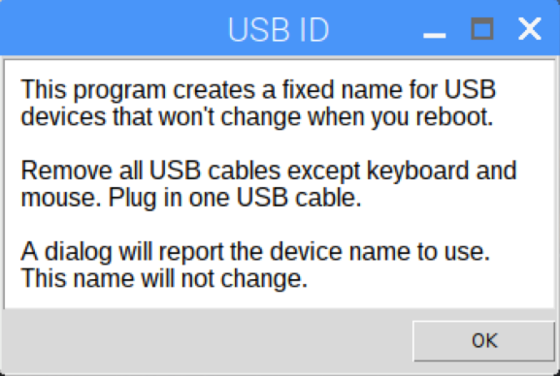

The original port continues to be listed as ttyUSBx. Once you run USB ID, the connect for that radio or rotor will be listed as radiox, where x will remain unchanged. You might see radio1 which is the same as ttyUSB2.

**Clearing the Radio list**

At some point you may wish to clear the list of radios USB ID maintains to have a fresh start.  Here is how to do that:

1.From RSS Desktop, open Terminal

2.Type sudo su <return>

3.Type cd /etc/udev/rules.d <return>

4.Type rm 99-hamdevices.rules <return>

5.Type touch 99-hamdevices.rules <return>