KB0015397

Pulse Secure - Convert the Pulse Secure Client to Use RSA Token from Defender Token

Article metadata. Authored by Kelley Fitzgerald

This article was updated•  4mo ago4 months ago

This article has 720 views.•  720 Views This article has average rating: 2 out of 5 stars• (*)(*) ( ) ( ) ( )

**Convert the Pulse Secure Client to Use RSA Token from Defender Token**

To switch the Pulse VPN Client from using the Defender token for Multi-factor Authentication to using the RSA token, users with L3Harris machines will run the converter process from Software Center following the steps below.

Users with non-L3Harris machines will not need to run the converter process.

**tting started** **Before getting started**

* **Please make sure you have your RSA token and PIN.  Following the conversion, they will be required for your next login.**
* **If you do not have an RSA token, follow the instructions**[**here**](https://connect.l3harris.com/sites/itservicenow-kb/Shared%20Documents/KB_Articles/Obtaining%20an%20L3Harris%20RSA%20Token%20User%20Guide.pdf)**to provision and install it on your mobile device, then complete the configuration by setting a PIN for the first time as indicated.**

**Using a Non-L3Harris machine:**

L3Harris users with personal systems and a Defender token need to:

1. Get RSA token and PIN
2. Update the Pulse Secure Client "Connections"

            a.  Open Pulse Secure:

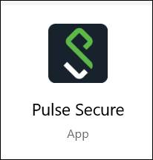

            b.  Click on the + sign to add the connection

                 OR click the "pencil" and edit your existing connection

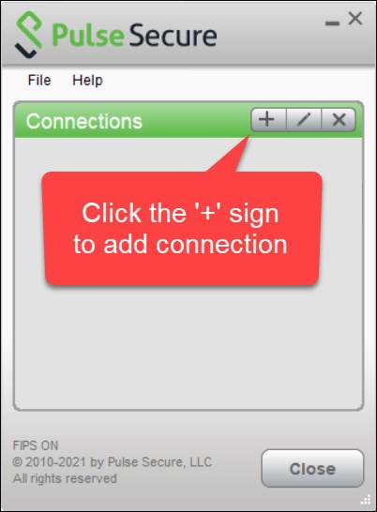

           c.  Choose a name, fill in these fields, then click "Add"

                    Name:  **EX: VPN.L3HARRIS.COM**  
                    Server URL:    [**https://vpn.l3harris.com/**](https://vpn.l3harris.com/non-standard)

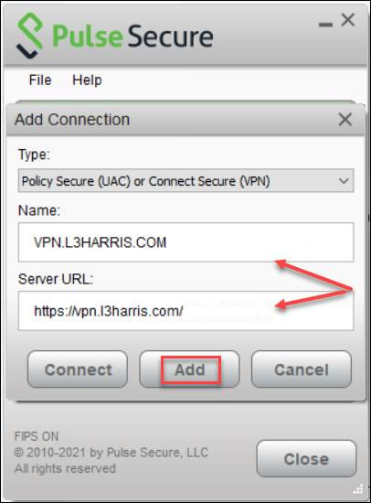

            The connection will now be available in the list of connection

      3. When you need to connect, choose the new connection and click "Connect"

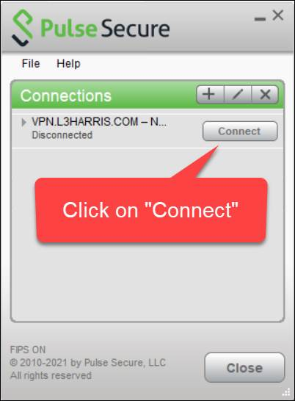

           a.  Type in User Name and PIN+RSA code then click "Connect"

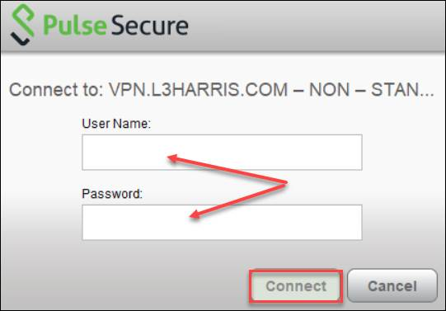

**Using a L3Harris machine:**

L3Harris users with an L3Harris systems and a Defender token need to:

1. Get RSA token and PIN
2. Run the Pulse Secure - Convert to RSA - Setup from Software Center

Click the Search icon near your Windows Start menu. Type ‘Software Center’ and click the application that appears in the results.

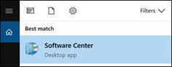

Software Center will open

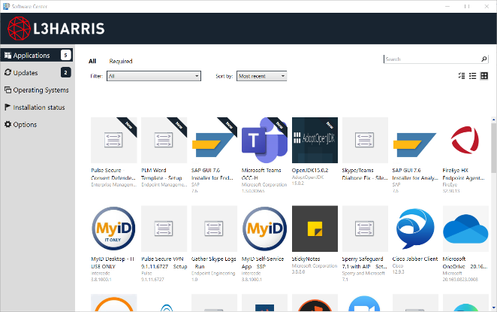

In Software Center, type Pulse into the Search box in the upper right and hit Enter.

Click on Pulse Secure – Convert to RSA - Setup

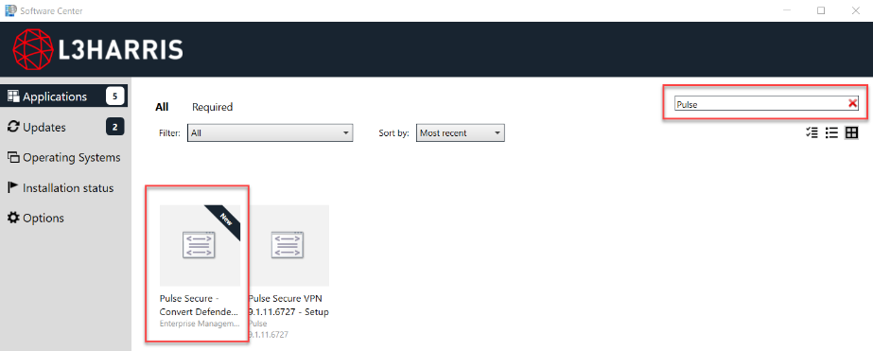

Click Install.

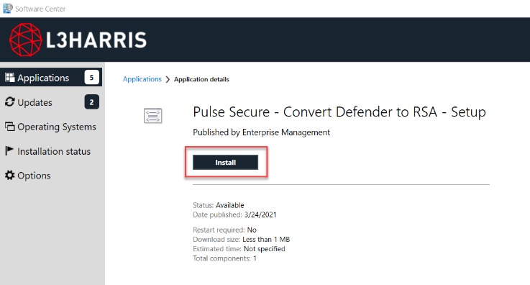

Click Continue.

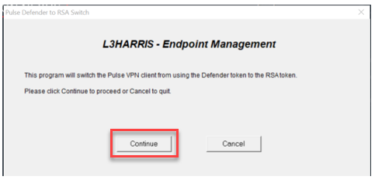

The Defender to RSA token conversion process will complete.

**After conversion has finished, re-boot your machine**.

Copy Permalink

Helpful?

Yes No

31% found this useful

Rate this article

( )( ) ( ) ( ) ( )

 Post a comment...

Comments

 (Latest comment about a year agoabout a year ago by [Natalya Tokarchuk)](https://l3harris.servicenowservices.com/sp?id=user_profile&sys_id=cb8130f4db901010a05f7b231f961958)All Replies

**[EG](https://l3harris.servicenowservices.com/sp?id=user_profile&sys_id=f18b87a9db6237c0a05f7b231f9619fd" \o "Evan Gill)**

[Evan Gill profile](https://l3harris.servicenowservices.com/sp?id=user_profile&sys_id=f18b87a9db6237c0a05f7b231f9619fd" \o "Evan Gill)• about a year agoabout a year ago

why does this have to be so confusing

 Like  Reply**3**

[Justin Maggio profile](https://l3harris.servicenowservices.com/sp?id=user_profile&sys_id=a130bb2ddb1a53003cb7f2821f961984" \o "Justin Maggio)• about a year agoabout a year ago

I had some trouble on getting my personal PC to connect with the RSA at first. It would say "limited connection" and not allow for much anything else. Here's what worked for me:

1. Remove all traces of Pulse Secure from PC - I had to uninstall a few different things called Pulse Secure.
2. Go to vpn.l3harris.com > select that you are connecting with a personal PC.
3. Login with your credentials and RSA PIN plus 8-digit code.
4. Download the Pulse Secure on the site. I had to download a couple of times for it to work and setup properly.
5. Connect to VPN in Pulse as you used to before with Defender, now using your RSA PIN + 8 digit code for the secondary password.

All should be back to normal functionality after that!

 Like  Reply**1**

[Marsha Sanders profile](https://l3harris.servicenowservices.com/sp?id=user_profile&sys_id=076ced58db1e4700b8e494d4db961998" \o "Marsha Sanders)• 2y ago2 years ago

What if I don't have a smart phone or the app doesn't work on my phone?

 Like  ReplyReplies

[Bryan Vitz profile](https://l3harris.servicenowservices.com/sp?id=user_profile&sys_id=97f64786db0693009c56f2821f9619db" \o "Bryan Vitz)• 2y ago2 years ago

I don't see an obvious way to use the instructions for the Non-L3Harris machine (personal computer) to achieve a remote desktop connection. Did anyone at IT actually test this method? Why are there no steps after 1 and 2? Pressing the Pulse Secure "start" button does not work for me presumably because it is already installed.  
  
I have had an RSA token since March 2021 and so far it seems IT has not provided clear transition instructions. I had to read the comments here to find out how to manually update pulse secure for my personal PC.

1. Within pulse secure, add a connection (plus button) to: <https://vpn.l3harris.com/non-standard>
   1. This connection is a duplicate of the Melbourne connection if you look at the details
2. Name it whatever you prefer. I did "L3Harris"
3. Use the new connection with the RSA Pin + Token Code and Pulse secure automatically updates to use RSA instead of defender (at least it did for me).

Instructions pulled from Kenny Fourspring below:  
<https://confluence.roc-devops.corp.exelisinc.com/display/OIT/Non-standard+defender+token+converstion+to+RSA>

 Like  Reply**3**Replies

[Kyle Wieszchowski profile](https://l3harris.servicenowservices.com/sp?id=user_profile&sys_id=a38d6590db5e4700b8e494d4db9619f6" \o "Kyle Wieszchowski)• 2y ago2 years ago

Just an FYI. On my Windows 10 personal PC, the current instructions under "Using a Non-L3Harris machine" never worked for me (tried it many times in the past). After connecting to the site, the start pulse secure button never seemed to actually do anything for me (never gave me the Pulse Secure client), and the website's terminal sessions would always error with "cannot contact server".

The way I currently connect is via the Pulse Secure Windows App (which has you create a connection via Windows VPN Settings). You have to use https://vpn.l3harris.com/non-standard for the connection site. I had no way of knowing this if not for a previous comment on this post. The downside to connecting this way (and not via the site's terminal session) is that you have to disconnect every time you want to use your own internet.

I'm assuming you can also update an existing Pulse Secure Client to point to that site, and it would work (as Kenny mentioned).