When imaging a pc you need to change the process of adding a pc to ARS.

Where you see “The following user or group can join this computer to a domain” -User or group: you need to double-click on the Change button.

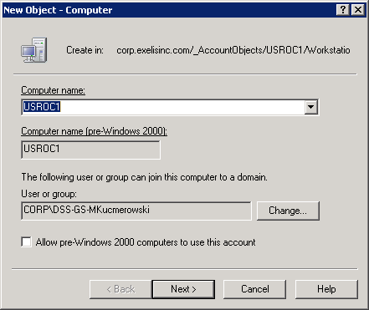

Browse to Active Directory-Corp.exelisinc.com-Account Objects-USROC1-Users - click on Service Account and say O.K. Find the SVC-GS-AltService acc ount-Double-click then O.K. 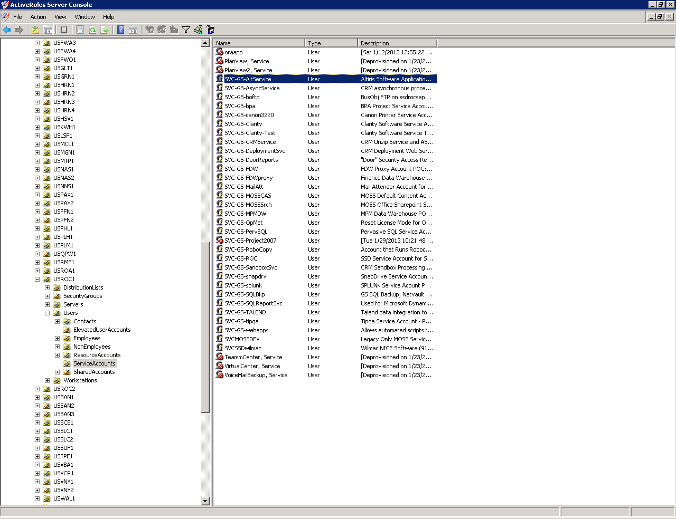

Select Next

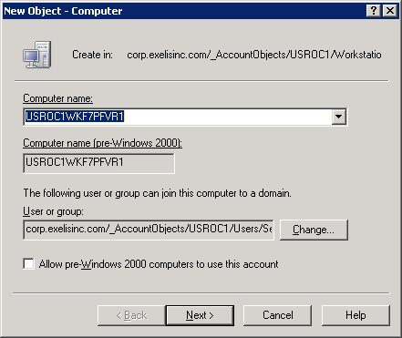

Double-click Managed by

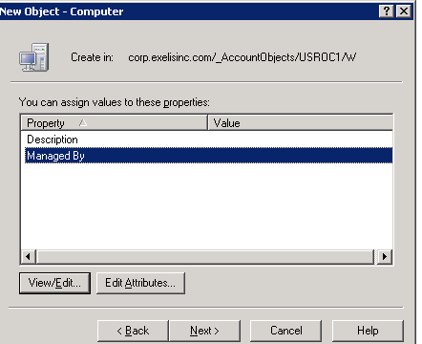

Select “…” button to go to the next window and select the Browse button

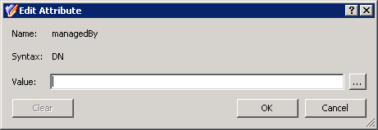

Browse to Corp.exelisinc.com-EnterpriseObjects-Users-ElevatedUserAccounts- click on GeospatialSystems then O.K.

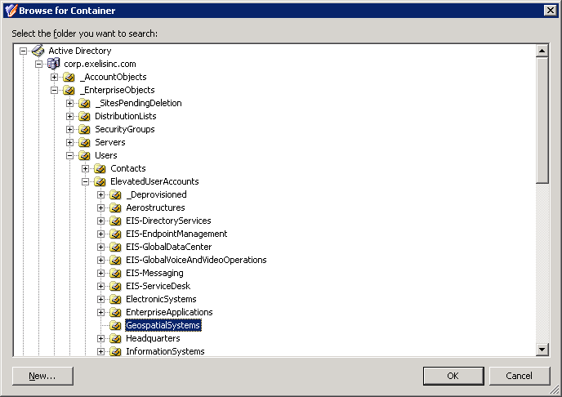

Double-click on GeospatialSystems group and say O.K.

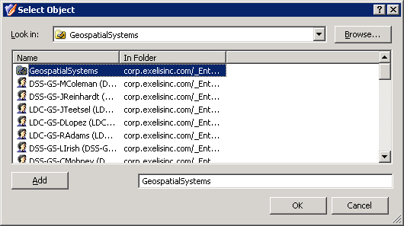

Select O.K.

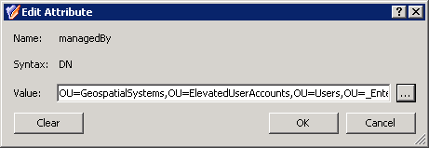

Double-Click on Description

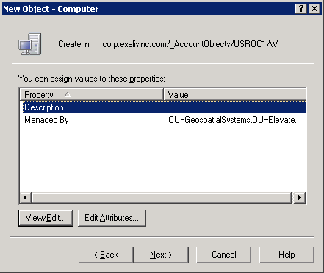

Select Add

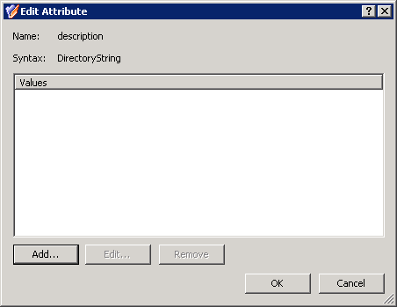

Input POC: firstname.lastname-select O.K.

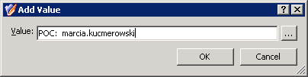

Select O.K.

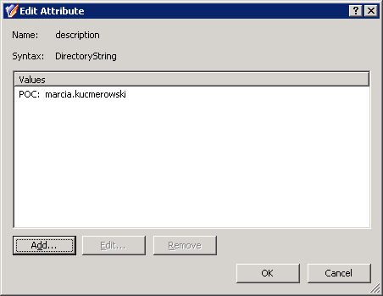

Select Next

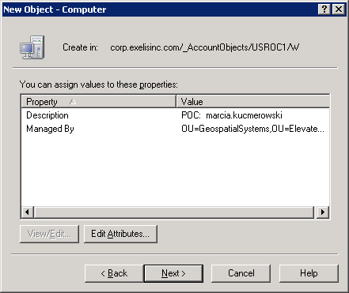

Select Finish

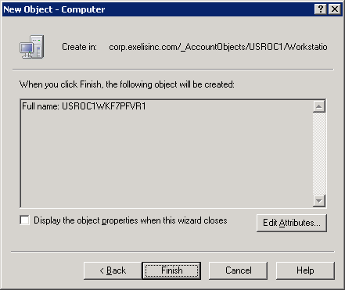

Now you can start the image process in Altiris