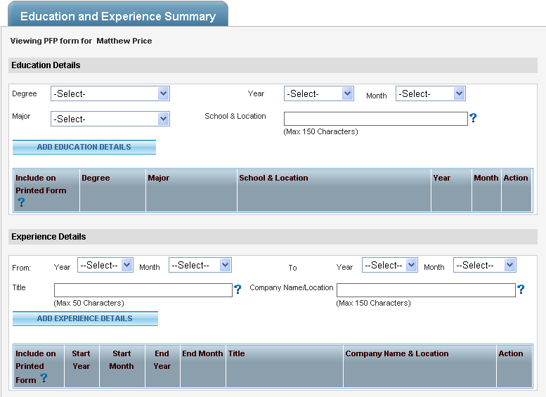

**2010 Goals and Objectives**

**Current Year Goals**List below mutually agreed upon [S.M.A.R.T.](https://myhr.itt.com/PfPEvalGoalObjAssignments.aspx)  
Goals/Objectives/Assignments   
(* Note: At least one goal is mandatory)

|  |  |
| --- | --- |
| **Goal # 1** | Select your business unit goal(s) which correspond to your individual [S.M.A.R.T.](https://myhr.itt.com/PfPEvalGoalObjAssignments.aspx) Goals/Objectives/Assignments |
|  | Business Development Collaboration Employee Engagement, Leadership & Values ITAR, Security and Safety Compliance Mission Success and Product Assurance Operational Excellence Systems Engineering & Technical Innovation |
| **Goal # 2** |  |
|  | Business Development Collaboration Employee Engagement, Leadership & Values ITAR, Security and Safety Compliance Mission Success and Product Assurance Operational Excellence Systems Engineering & Technical Innovation |
| **Goal # 3** |  |
|  | Business Development Collaboration Employee Engagement, Leadership & Values ITAR, Security and Safety Compliance Mission Success and Product Assurance Operational Excellence Systems Engineering & Technical Innovation |

**Competencies – Supervisor Input**

**Leadership Competency Summary**

|  |  |  |  |
| --- | --- | --- | --- |
|  | **Developing** | **Proficient** | **Excels** |
| [**Create the Future**](https://myhr.itt.com/PFPEvalValueBasedLeadershipComp.aspx) |  |  |  |
| [**Deliver Results**](https://myhr.itt.com/PFPEvalValueBasedLeadershipComp.aspx) |  |  |  |
| [**Inspire Commitment**](https://myhr.itt.com/PFPEvalValueBasedLeadershipComp.aspx) |  |  |  |
| [**Build Through Teamwork**](https://myhr.itt.com/PFPEvalValueBasedLeadershipComp.aspx) |  |  |  |
| [**Live Our Values**](https://myhr.itt.com/PFPEvalValueBasedLeadershipComp.aspx) |  |  |  |

**Employee Strengths Against Goals and Leadership Competencies [SUPERVISOR]**

|  |
| --- |
|  |

**Devlopment Opportunities Against Goals and Leadership Competencies [SUPERVISOR]**

|  |
| --- |
|  |

**Career Aspirations**

The Individual Development Plan is designed to assist ITT's employees, plan and reach their career and professional goals while at ITT. While the Plan and the employee's progress under it may be considered during the evaluation process, the Plan is not part of the evaluation and is not a substitute for the performance evaluation.

**Do you aspire to a higher position or leadership role within the organization?**

|  |
| --- |
| **Yes No** |

**What are the positions you aspire to reach over the next 5 years in ITT? \***

|  |
| --- |
|  |

**What are your longer-term career aspirations? \***

|  |
| --- |
|  |

**Are you willing to relocate geographically during the next year?**

|  |
| --- |
| **Yes No** |

**What constraints, if any, are there on your relocatability? \***

|  |
| --- |
|  |

**Assessment of Employee’s Career Aspirations and Readiness**

|  |
| --- |
|  |

**Next Developmental Opportunity [Supervisor]**

|  |  |  |
| --- | --- | --- |
| **Development Objective/ Supporting Activities** | **Where** | **By When/Date** |
|  |  |  |
|  |  |  |
|  |  |  |

**Summary Comments/Observations**

**Assessment of overall performance [SUPERVISOR]**

|  |
| --- |
|  |

**Indirect Supervisor's Comments**

|  |
| --- |
|  |

**Next Level Manager's Comments [SUPERVISOR’S SUPERVISOR]**

|  |
| --- |
|  |