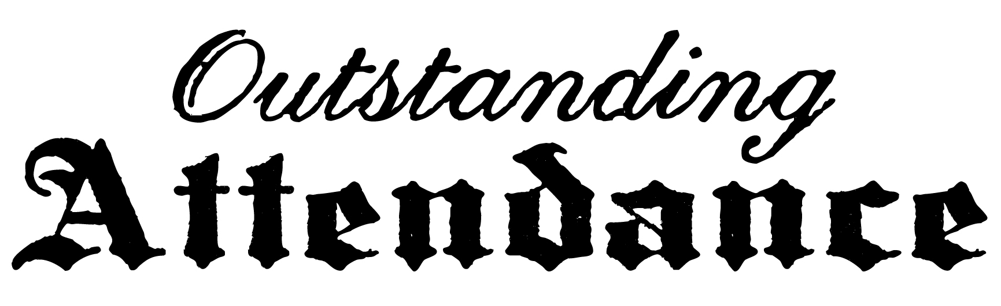

we recognize
Alexis Adams
for outstanding attendance
Thank you for your dedication

______________ ______________
Signed Date

