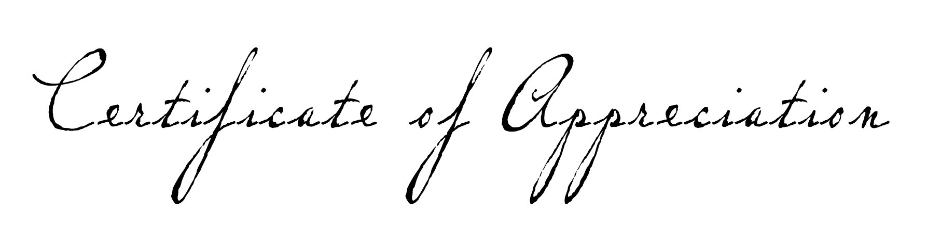

In grateful recognition of your continuing
service and support we hereby present

David William Dillon

with this certificate of appreciation

for your donation to the Youth Program

________________
Paul K Norman, Youth Leader

