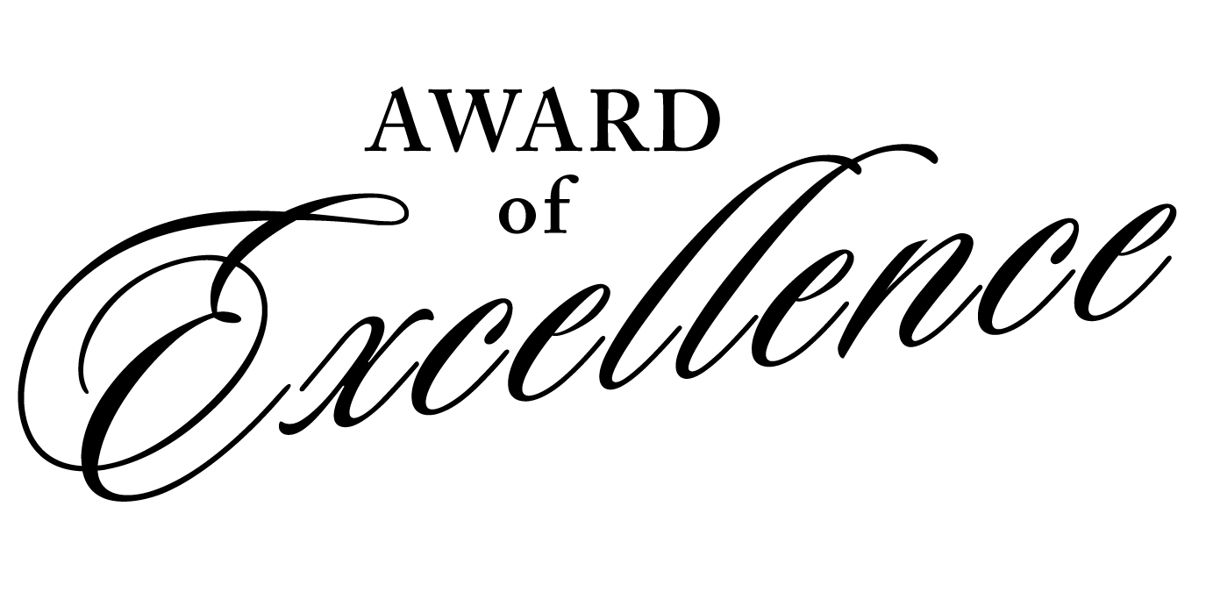

In honor of outstanding performance and dedication we present

Nathan J. Keller

with this certificate of recognition for high standards of excellence in

Quality Control Accuracy
1st Quarter

____________________________ ________________________________
MICHAEL CONRAD, CEO KEVIN O’LEARY, VP OPERATIONS

