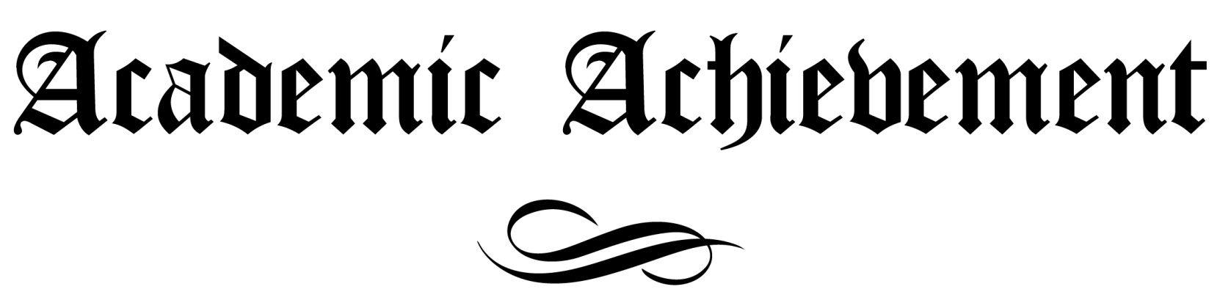

This certificate is proudly awarded to

Benjamin Henning

in recognition of

COLLEGE OF FINE ARTS
FALL SEMESTER DEAN’S LIST

___________________________ _________________________
Signed Awarded On

