**[RemoteTx](https://www.remotetx.net/)**

Operate Anywhere

* [RADIOS](https://www.remotetx.net/radios/)
* [LIVE DEMO](https://www.remotetx.net/icom-remote-live-demo/)
* [HARDWARE](https://www.remotetx.net/hardware-lists/)
* [RESOURCES](https://www.remotetx.net/resources/)
* [CONTACT](https://www.remotetx.net/contact/)
* [FREE TRIAL](https://www.remotetx.net/signup/)
* [PRICING](https://www.remotetx.net/pricing/)
* [SHOP](https://www.remotetx.net/shop/)
* [CART](https://www.remotetx.net/cart/)

Top of Form

Search for:

Bottom of Form

**Icom 7300 Quick Start**

The Icom 7300 has a USB port that allows both CI-V radio control as well as sound control.  It also supports turning the radio on and off while power is continuously supplied to the radio.

**Radio Firmware Version:**

Make sure the radio firmware version is at 1.2 or higher.  
(Shown at bottom right of screen when the radio is being powered on.)  
[**Icom Firmware v1.3 download**](http://www.icom.co.jp/world/support/download/firm/IC-7300/1_30/)  
See Chapter 15 of the Icom 7300 Manual for firmware upgrade directions.

**Icom 7300 Preparation:**

Several settings are required for the IC-7300 to work properly with RemoteTx.

* [**View Screen Shots**](https://www.remotetx.net/ic-7300-settings/)

1. Menu -> SET -> Connectors -> ACC/USB Output Select: **AF**
2. Menu -> SET -> Connectors -> ACC/USB Output Level: **50%**
3. Menu -> SET -> Connectors -> USB MOD Level: **50%**
4. Menu -> SET -> Connectors -> DATA OFF MOD: **USB**
5. Menu -> SET -> Connectors -> USB Serial Function: **CI-V**
6. Menu -> SET -> Connectors -> USB Send/Keying -> USB SEND: **OFF**
7. Menu -> SET -> Connectors -> USB Send/Keying -> USB Keying (CW): **OFF**
8. Menu -> SET -> Connectors -> USB Send/Keying -> USB Keying (RTTY): **OFF**
9. Menu -> SET -> Connectors -> CI-V -> CI-V Baud Rate: **Auto**
10. Menu -> SET -> Connectors -> CI-V -> CI-V Address: **94h**
11. Menu -> SET -> Connectors -> CI-V -> CI-V Transceive: **ON**
12. Menu -> SET -> Connectors -> CI-V -> CI-V Output (for ANT): **OFF**
13. Menu -> SET -> Connectors -> CI-V -> CI-V USB Port: **Unlink from [REMOTE]**
14. Menu -> SET -> Connectors -> CI-V -> CI-V USB Baud Rate: **Auto**
15. Menu -> SET -> Connectors -> CI-V -> CI-V USB Echo Back: **ON**
16. Menu -> SET -> Function -> Time-Out Timer (CI-V): **3min**In case all control is lost due to a USB malfunction, radio will stop transmitting after 3 minutes.  
    See FCC Part [**97.213**](http://www.remotetx.net/fcc-part-97-213-remote-control-timeout/)If network connection is lost while transmitting, RemoteTx will automatically switch the radio back to Rx within a minute regardless of the above setting assuming there has not been a USB/CI-V control malfunction between the RPi and the radio.
17. Menu -> SET -> Connectors -> ACC/USB Beep/Speech… Output: **ON**  
    This setting allows CW sidetone to be heard via the USB radio sound card.

* [**View IC 7300 Settings Screen Shots**](https://www.remotetx.net/ic-7300-settings/)

**Setup procedure:**

1. Connect the usb port on the IC-7300 to any of the usb ports on the RPi with a USB cable.
2. Plug the ethernet network port on the RPi into an Internet connected router with a cat5 network cable. (Wifi can be configured later once initial connection is established via ethernet.) Remember to copy the ‘remotetx.conf’ file to the ‘/boot’ folder of the RPi SDCard first.
3. Apply power to the RPi so that it boots up.  It should take about 1 to 2 minutes. During this time it will acquire a network address from the router and automatically connect via the Internet to the RemoteTx service.
4. Make sure power is applied to the radio. (The radio does not have to be on. RemoteTx can turn it on and off.)

**Remote Control:**

1. Using a Mac, PC, tablet or phone open a browser (Chrome or Safari) to **https://your-callsign.remotetx.net**
2. At the login prompt, enter your RemoteTx username and password.
3. Accept the prompt to allow the use of the microphone by the browser. You may also be prompted to save your password.  This is a good idea if you are using a device that you use often.
4. The RemoteTx station control interface will appear showing the ‘Settings’ tab.
5. Select IC-7300 from the radio choices. The default radio settings should not need to be changed for a basic setup.
6. Select the upper  ‘Radio’ tab and click on the ‘Connect IC 7300 ‘ button. This will initiate a control connection to the radio and show it’s current status. (It could be on or off.)
7. If the radio status is ‘OFF’ click the ‘On ‘ button to bring the radio online and display its controls. (This can take a few seconds for the radio to start.)
8. The radio control interface should now be online.
9. Select the upper ‘Audio ‘ tab and in the ‘Remote Audio’ area select the ‘USB Audio Codec’ sound card choice.
10. Click on ‘Start/Restart Audio 1’.
11. Wait about 5 seconds after which the ‘Call Radio’ and ‘Hang Up ‘ buttons should appear in the ‘Local Audio’ area.
12. Click on the ‘Call Radio’ button to initiate bi-directional audio to the radio. If audio becomes disrupted due to unreliable network conditions, clicking ‘Reset Local’ will re-initiate the browser audio and re-clicking the ‘Set Audio 1’ button will re-initiate the RasPi audio. (Normally re-clicking the ‘Set Audio 1’ button is only necessary if there has been an Internet disruption at the radio site.)
13. Return to the upper ‘Radio’ tab to operate the radio.

**Typical Radio Control Settings:**

RemoteTx allows setting the most frequently used controls during typical operation. Buttons either toggle features on and off or cycle through available values. Slider controls allow setting variable values. Following are initial settings that are known to work well. They can be fine tuned to personal preference as experience is gained with the solution.

* Mod-Source: USB  (This sets the Data Off Mod source to USB which is required for Tx.)
* USB-TX: 50
* COMP: ON  (Button will be blue color, this is important)
* COMP LEVEL: 3
* RF-GAIN: 100 or as preferred
* USB-RX: 50
* AF-GAIN: Has no effect so leave at 0. If it is above 0, the radio speaker will be heard at the station location.

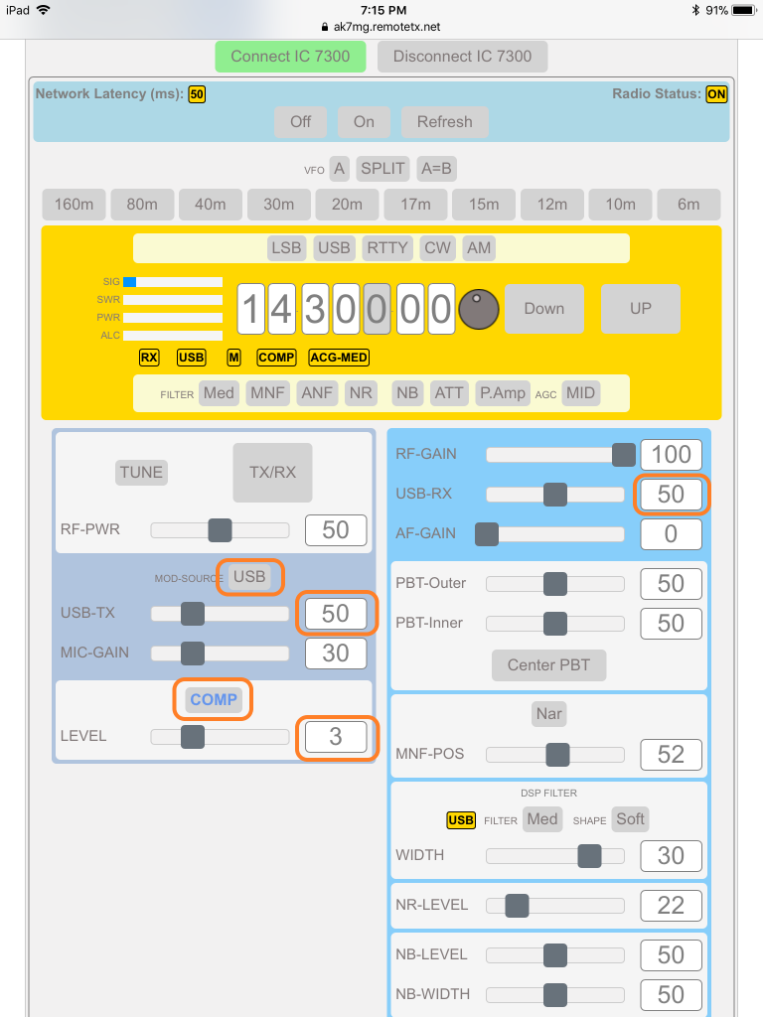

The rest of the controls are self explanatory to an operator experienced with the Icom 7300.  
If you are using a Mac or PC with a mouse that has a roller button, the roller can be used to change the values of controls that the mouse is hovering over. This includes the individual frequency digits and slider controls.

**Disconnecting from Radio:**

Release control of the radio in this order.

1. Select upper ‘Radio’ tab.
2. Click the ‘OFF’ button to turn the radio off if this is desired (it can also be left on, ready for the next connection).
3. Click the ‘Disconnect IC 7300’ to release remote control of the radio.
4. Close the browser to disconnect from the RPi.