**SHTF Survivalist Radio Frequency Lists**

Posted on [2013 June 29](https://radiofreeq.wordpress.com/2013/06/29/shtf-survivalist-radio-frequency-list/) | [58 Comments](https://radiofreeq.wordpress.com/2013/06/29/shtf-survivalist-radio-frequency-list/#comments)

51 Votes

**Frequency List for SHTF Survivalist Radio Communications and Preppers**  
Information about common frequencies and channels for tactical, emergency, and survival for HAM, CB, MURS, GMRS, PMR, Marine, and other radios.  
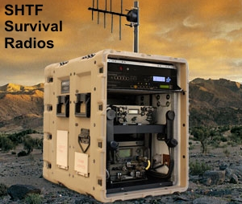  
SHTF Survivalist Radio Frequency List and Charts for the doomsday prepper…

©2013 RadioMaster Reports

[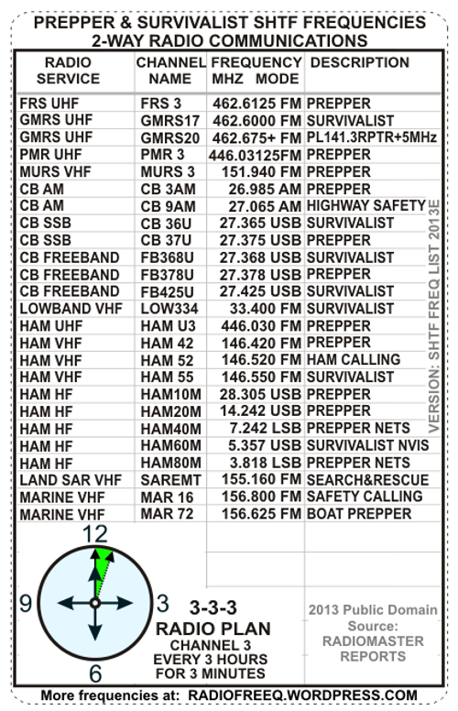  
CLICK TO PRINT WALLET SIZE – SHTF FREQUENCY LIST  
Prepper Survivalist Channel Frequencies Basic Chart  
VHF UHF HF CB MARINE HAM FRS GMRS PMR MURS FM SSB AM  
[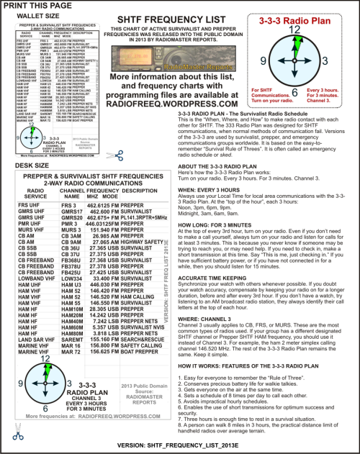](https://radiofreeq.files.wordpress.com/2013/11/shtf_frequency_list_2013e_print.png)](https://radiofreeq.files.wordpress.com/2013/11/shtf_frequency_list_2013e_print.png)

Powered by wordads.co

Seen ad many times

Not relevant

Offensive

Covers content

Broken

REPORT THIS AD

The original source of this article and chart is [RadioMaster Reports](https://radiofreeq.wordpress.com/" \o "RadioMaster Reports).

==== SHTF SURVIVALIST RADIO FREQUENCY LIST BASIC CHART ====

=== BAND === | CHAN. | FREQUENCY MHZ| DESCRIPTION

============ | ===== | ============ | ==================

FRS UHF ==== | FRS 3 | 462.6125 FM =| PREPPER

GMRS UHF === |GMRS17 | 462.6000 FM =| SURVIVALIST

PMR UHF ==== | PMR 3 | 446.03125FM =| SURVIVALIST PREPR

MURS VHF === |MURS 3 | 151.9400 FM =| SURVIVALIST PREPR

CB AM ====== |CB 3AM | 026.9850 AM =| PREPPER

CB AM ====== |CB 9AM | 027.0650 AM =| HIGHWAY SAFETY

CB SSB ===== |CB 37U | 027.3750 USB | SURVIVALIST PREPR

CB FREEBAND= |FB425U | 027.4250 USB | SURVIVALIST PREPR

LOWBAND VHF= |LOW334 | 033.4000 FM =| SURVIVALIST

HAM UHF ==== |HAM U3 | 446.0300 FM =| PREPPER

HAM VHF ==== |HAM 42 | 146.4200 FM =| PREPPER

HAM VHF ==== |HAM 52 | 146.5200 FM =| HAM CALLING

HAM VHF ==== |HAM 55 | 146.5500 FM =| SURVIVALIST

HAM HF ===== |HAM10M | 028.3050 USB | SURVIVALIST PREPR

HAM HF ===== |HAM20M | 014.2420 USB | PREPPER

HAM HF ===== |HAM40M | 007.2420 LSB | PREPPER

HAM HF ===== |HAM60M | 005.3570 USB | SURVIVALIST NVIS

HAM HF ===== |HAM80M | 003.8180 LSB | PREPPER

LAND SAR VHF |SAREMT | 155.1600 FM =| SEARCH AND RESCUE

MARINE VHF = |MAR 16 | 156.8000 FM =| SAFETY CALLING

MARINE VHF - |MAR 72 | 156.6250 FM =| BOAT PREPPER

The source of this chart is RadioMaster Reports.

Updated 2015. Entered into public domain. Free to copy.

[**CSV file for Chirp DOWNLOAD**](https://www.dropbox.com/s/zdguo662ks78ffp/SHTF_SURVIVALIST_PREPPER_FREQUENCIES_HF_VHF_UHF_2013G.csv)

[**SHTF SURVIVALIST PREPPER FREQUENCY LIST**](https://www.dropbox.com/s/zdguo662ks78ffp/SHTF_SURVIVALIST_PREPPER_FREQUENCIES_HF_VHF_UHF_2013G.csv)

[**HF VHF UHF CSV FILE FOR PROGRAMMING RADIOS**](https://www.dropbox.com/s/zdguo662ks78ffp/SHTF_SURVIVALIST_PREPPER_FREQUENCIES_HF_VHF_UHF_2013G.csv)

**[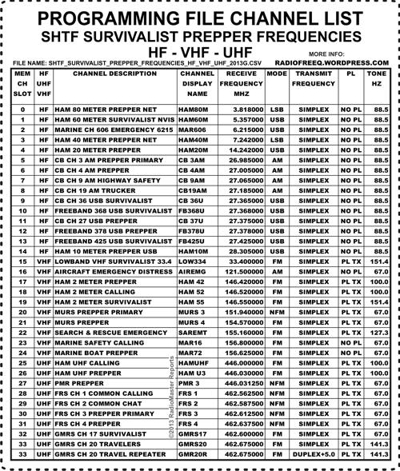](https://radiofreeq.files.wordpress.com/2013/11/shtf_survivalist_prepper_frequencies_hf_vhf_uhf_2013g_print.png)**

**Background Notes and History of These Frequencies**

*Reference: First-hand physical research, correspondence, and open public domain sources 1997-2013. Updated NOV-2013. The basic SHTF Survivalist Radio Frequency List chart was entered into the public domain 2013 by Radiomaster Reports.*

Powered by wordads.co

Seen ad many times

Not relevant

Offensive

Covers content

Broken

REPORT THIS AD

**Low Band VHF Frequencies:**

[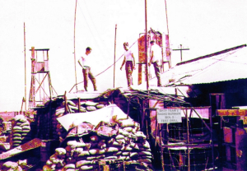](https://radiofreeq.files.wordpress.com/2013/07/radio_bunker_bol_2_test_drill.jpg)

Radio Bunker at Bug Out Location 2 during SHTF Test Drill

**LOWBAND VHF | LOW334 | 033.4000 FM | SHTF SURVIVAL**  
33.4 MHz is an ancient Low Band VHF FM itinerant business channel with a 1 watt limit. Popular among reenactors, survivalists, and bulletproof-radio enthusiasts using old military surplus manpacks or military handheld sets on this channel (especially PRC-77). The reason they use 33.4 is probably because it is the only low power itinerant channel that old green manpacks can select with their 50 kHz or 25 kHz channel spacing dials. At low power in the field, they aren’t bothering anybody. Useful for patrols and tactical communications. All scanners can receive this channel.

[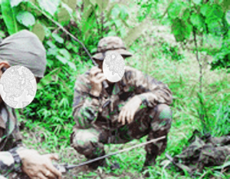](https://radiofreeq.files.wordpress.com/2013/07/survivalist_team_3_military_surplus_radios_low_band_vhf_hts.jpg)

Preppers Test Out Military Surplus Low Band VHF Radios on SHTF Survival channel 33.400 MHz FM Simplex

[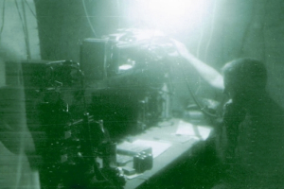](https://radiofreeq.files.wordpress.com/2013/07/radio_bunker_bol_3_test_drill.jpg)

Radio Bunker at Bug Out Location 3 during SHTF Test Drill

**Some interesting older “green” military surplus radios common for Low Band VHF frequencies:**  
Military manpack set PRC-9, AN/PRC-9 (27.0-38.9 MHz FM) continuously tunable  
Military manpack set PRC-10, AN/PRC-10 (38.0 to 54.9 MHz) continuously tunable  
Military manpack set PRC-77, AN/PRC-77 (30-52.95; 53-75.95 MHz FM) channel spacing 50 kHz  
Military manpack set PRC-25, AN/PRC-25 (30-52.95; 53-75.95 MHz FM) channel spacing 50 kHz  
Military handheld set PRC-68, AN/PRC-68, PRC-68A, PRC-68B (30-79.975 MHz FM) channel spacing 50/25/12.5 kHz  
Military handheld set RT-1547/PRC-126, AN/PRC-126 (30-88 MHz FM) channel spacing 25 kHz  
Military handheld set AN/PRC-128 (30-88 MHz FM) channel spacing 12.5 kHz  
Military manpack set AN/PRC-119 (30-87.95 MHz) channel spacing 25KHz  
Military radio set AN/PRC-117 (30-90 MHz) channel spacing 25KHz

[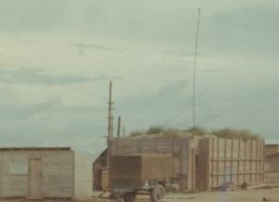](https://radiofreeq.files.wordpress.com/2013/07/radio_bunker_bol_1_test_drill.jpg)

Radio Bunker at Bug Out Location 1 during SHTF Test Drill

Powered by wordads.co

Seen ad many times

Not relevant

Offensive

Covers content

Broken

REPORT THIS AD

**High Band VHF Frequencies:**

**MURS VHF | MURS 3 | 151.940 FM | MURS PREPPER PRIMARY**  
151.940 MHz FM is the MURS Prepper channel, known as MURS Channel 3. Multi-Use Radio Service (MURS) is an unlicensed two-way radio service similar to CB but on VHF FM.  It is in wide use by preppers and survivalists. VHF has longer distance range in rural and suburban areas than either FRS or GMRS. Useful for mobile, base, patrols, practice drills, and tactical communications. Most scanners can receive this channel.

**MURS VHF | MURS 4 | 154.570 FM | MURS PREPPER**  
154.570 MHz FM is the MURS Survivalist channel, known as MURS Channel 4 or the Blue Dot  Channel. Multi-Use Radio Service (MURS) is an unlicensed two-way radio service similar to CB but on VHF FM.  It is in  use by some preppers, and has much better distance range in rural and suburban areas than UHF, FRS or GMRS. Useful for mobile, base, patrols, and tactical communications. Most scanners can receive this channel.

**LAND SAR VHF | SAREMT | 155.1600 FM | SEARCH & RESCUE**  
155.16 MHz FM Simplex is **Emergency Only.**SAR (Search And Rescue) National interoperability channel in USA for ground search teams. It is widely used by government and civilian SAR teams for field communications and interaction with governmental, law enforcement, or fire operations in the field. This channel is also known as Ground SAR, Land SAR, and identified in agency radios with the channel name SAR WFM or SAR NFM. It requires an FCC license to transmit on it, and should never be used by unlicensed operators, except in life-threatening emergency to communicate with a Search & Rescue unit. All scanners can receive this channel.

**MARINE VHF | MAR 16 | 156.8000 FM | SAFETY CALLING**  
156.800 MHz FM Simplex is VHF marine channel 16, the international primary Marine Safety, Emergency, and Distress guard channel worldwide. It is widely used and monitored by all boats, ships, and watercraft. Coast Guards monitor this channel, and it is audio-recorded in major ports. All scanners can receive this channel.

[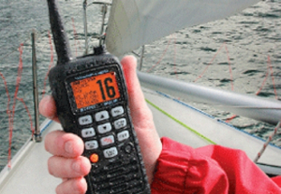](https://radiofreeq.files.wordpress.com/2013/07/marine_channel_16_distress_calling1.jpg)

**MARINE VHF | MAR 72 | 156.6250 FM | BOAT PREPPER**  
156.625 MHz FM Simplex is VHF marine channel 72, an international ship-to-ship or HT channel worldwide. It is widely used on sailboats, motor boats, yachts, and watercraft. It is designated for non-commercial use, is common for HT-to-HT informal communications, and is normally clear of commercial shipping or port operations. It is usually not monitored by coast guards, but it is audio-recorded in major ports. All scanners can receive this channel.

[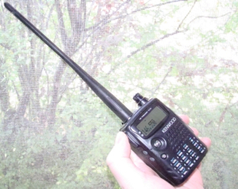](https://radiofreeq.files.wordpress.com/2013/07/ham_prepper_shtf_survival_channel_146_550_fm_simplex_ht.jpg)

HAM Prepper SHTF Survival Channel 146.550 FM Simplex

Seen ad many times

Not relevant

Offensive

Covers content

Broken

REPORT THIS AD

**HAM VHF | HAM 55 | 146.5500 FM | HAM SURVIVALIST SIMPLEX**\*  
146.55 MHz FM Simplex is the primary VHF Ham Survivalist local channel. It is one of very few ham radio 2 meter frequencies widely coordinated for FM-Simplex-only throughout USA. It is widely available to Technician basic ham license (or higher) ham operators in USA. It is popular among survivalists because it is the only coordinated 2 meter simplex channel compatible with bulletproof military surplus radios (AN/PRC-127, etc) and forest-fire radios (Bendix HTs, etc). These types of radios have 25kHz channel spacing, and are in wide use by ham radio survivalists/preppers. Useful for patrols and tactical communications. All scanners can receive this channel.

**HAM VHF | HAM 52 | 146.5200 FM | HAM CALLING SIMPLEX**  
146.52 MHz FM Simplex is widely known as the ham radio 2 meter Calling Frequency. It is the most widely monitored simplex frequency in USA, but it should not be depended upon for emergency 911 type calls, because there are no organized first-responders on it. It is widely available to Technician basic ham license (or higher) ham operators in USA. Known by most hams as *52 Simplex*, it is the channel for the Wilderness Protocol  in which hams often monitor it while in backcountry. The Long Tone Zero or LTZ protocol, applies on 52 Simplex, in which an emergency call may be transmitted at the top of the hour with the Zero key on the DTMF keypad being held down and transmitted for a long time prior to the voice call to attract attention. It is the most likely local ham radio frequency-coordinated FM Simplex channel to be activated in SHTF scenarios, especially when infrastructure and repeaters are down. All scanners can receive this channel.

**HAM VHF | HAM 42 | 146.4200 FM | HAM PREPPER SIMPLEX**  
146.42 MHz FM Simplex is a ham radio 2 meter frequency commonly used as a chat or SHTF practice channel by mainstream Prepper organizations. It is not a normal frequency-coordinated 2 meter simplex ham channel, although it is generally within the simplex bandplan for USA. It is widely available to Technician basic ham license (or higher) ham operators in USA. Useful for practice drills, patrols, and tactical communications. All scanners can receive this channel.

**Reference source: List of 2 Meter 146 MHz Simplex Reality in USA**  
= 146.400 Repeaters all areas  
= 146.415 Simplex (or Repeaters in some areas)  
= 146.430 Simplex (or Repeaters in some areas)  
= 146.445 Simplex (or Repeaters in some areas)  
= 146.460 Simplex all areas  
= 146.475 Simplex (or Repeaters in some areas)  
= 146.490 Simplex (or Repeaters in some areas)  
= 146.505 Simplex (or Repeaters in some areas)  
= 146.520 National Simplex Calling  
= 146.535 Simplex all areas  
**\* 146.550 Simplex all areas**  
= 146.565 Simplex & T-hunts (or Repeaters in some areas)  
= 146.580 Simplex all areas  
= 146.595 Simplex (or Repeaters in some areas)  
= 146.610 Repeaters all areas

* Compatible with Mil Surplus and Forest-Fire HTs using 25 kHz channel spacing

Seen ad many times

Not relevant

Offensive

Covers content

Broken

REPORT THIS AD

**UHF Frequencies:**

**GMRS | GMRS17 | 462.600 FM | SURVIVALIST CHANNEL GMRS 17 SIMPLEX**  
462.600 MHz FM is the GMRS Survivalist channel. It is GMRS Channel 17 in the Motorola channel naming system and GMRS Channel 3 in the Icom/GM channel naming system. This channel is popular among Survialist organizations and teams due to the the famous Survival Rule of Threes (since it is the 3rd GMRS-only channel). It is a simplex channel or a repeater output channel. If used with a repeater, the repeater input frequency is 467.600 MHz. The duplex is 5 MHz + split. PL 141.3 tone. Most scanners can receive this channel.

**GMRS | GMR20R | 462.675+ FM | GMRS REPEATER PL 141.3**  
462.675 MHz FM is recognized as the GMRS nationwide emergency and traveler assistance repeater channel. It is GMRS Channel 20 in the Motorola channel naming system and GMRS Channel 6 in the Icom/GM channel naming system. The repeater output is 462.675 MHz and uses a 5 MHz + split with an input frequency of 467.675 MHz and a PL 141.3 tone. Most scanners can receive this channel.

**FRS | FRS 3 | 462.6125 FM | PREPPER FRS CHANNEL 3**  
462.6125 MHz FM Simplex is FRS channel 3, it is commonly used for tactical patrols and neighborhood watch. It is an extremely short-range channel, but can be extended somewhat using GMRS radios that can also operate on this frequency or with simplex repeaters. FRS Channel 3 is on the channel list of several prepper networks. This channel is popular among Prepper organizations and teams due to the the famous Prepper Rule of Threes. Most scanners can receive this channel.

**PMR | PMR 3 | 446.03125 FM | PREPPER PMR466 CHANNEL 3**  
446.03125 MHz FM is the Prepper channel for Personal Mobile Radio (PMR or PMR466). PMR is a low power, short range, radio system similar to FRS. It is very common in Europe, Africa, and Asia. In USA and many other places, the 446 MHz band is assigned to Amateur Radio Service (Ham) so, the PMR channels can be used by hams in those areas. PMR Channel 3 is interoperable and compatible with the HAM UHF Prepper channel HAM U3, at frequency 446.030 MHz. This channel is popular among Prepper organizations and teams in Europe due to the the famous Prepper Rule of Threes.

[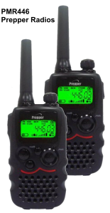](https://radiofreeq.files.wordpress.com/2013/11/pmr446_prepper_radios.png)

PMR446 Prepper Radios

Powered by wordads.co

Seen ad many times

Not relevant

Offensive

Covers content

Broken

REPORT THIS AD

**HAM UHF | HAM U3 | 446.030 FM | HAM PREPPER UHF SIMPLEX**  
446.030 MHz FM Simplex is a Prepper ham radio UHF frequency. Useful for practice drills, patrols, and tactical communications. It is not a normal frequency-coordinated UHF simplex ham channel, although it is a simplex frequency within the widely recognized simplex bandplan. It is interoperable and compatible with PMR Channel 3 (a channel popular among European Prepper organizations and teams) due to the the Rule of Threes. All scanners can receive this channel.

**Ham HF SSB Frequencies:**

**HAM HF —– | HAM10M | 28.3050 USB | HAM PREPPER TECH**  
28.305 MHz USB is a ham radio Upper SideBand local and international frequency in the 10 meter band. In USA, it is widely available to Technician basic ham license (or higher) ham operators. This channel also is compatible with less-expensive 10-meter SSB channelized radios and extra-channel or modified CB SSB radios. HF SSB radios and military surplus manpack radios can transceive on this channel. Shortwave receivers with USB or BFO can receive this channel. Most scanners can not receive this channel due to the use of Single SideBand.

**HAM HF | HAM20M | 14.2420 USB | HAM PREPPER**  
14.242 MHz USB is a ham radio Upper SideBand international and long distance frequency in the 20 meter band. In USA, it is only available to General license (or higher) ham operators. It is on the channel list of several organized survivalist and prepper networks, including TAPRN (The American Prepper Radio Network). HF SSB radios and military surplus manpack radios can transceive on this channel. Shortwave receivers with USB or BFO can receive this channel. Most scanners can not receive this channel due to the use of Single SideBand.

**HAM HF | HAM40M | 7.2420 LSB | HAM PREPPER NETS**  
7.242 MHz LSB is a ham radio Lower SideBand wide area frequency in the 40 meter band available to General license (or higher) operators in USA. It is on the channel list of several organized survivalist and prepper networks, including an active practice net by TAPRN (The American Prepper Radio Network). HF SSB radios and some military surplus manpack radios can transceive on this channel. Shortwave receivers with LSB or BFO can receive this channel. Most scanners can not receive this channel due to the use of Single SideBand.

**HAM HF | HAM60M | 5.3570 USB | HAM SURVIVALIST NVIS**  
5.357 MHz LSB is a ham radio Upper SideBand regional area frequency available to General license (or higher) operators in USA and other countries. The 5 MHz channels in the 60 meter band are recognized for use in EMCOMM Emergency Communications. This channel is optimum for long range mobile patrols and base NVIS (Near Vertical Incidence Skywave) HF communications dependably up to 500 miles on a regular daily basis. HF SSB radios and military surplus manpack radios can transceive on this channel. Shortwave receivers with USB or BFO can receive this channel. Most scanners can not receive this channel due to the use of Single SideBand.

**HAM HF | HAM80M | 3.8180 LSB | HAM PREPPER NETS**  
3.818 MHz LSB is a ham radio Lower SideBand night regional frequency in the 80 meter band available to General license (or higher) operators in USA. It is on the channel list of several survivalist and prepper networks, including an active practice net by TAPRN (The American Prepper Radio Network). HF SSB radios and some military surplus manpack radios can transceive on this channel. Shortwave receivers with LSB or BFO can receive this channel. Most scanners can not receive this channel due to the use of Single SideBand.

Powered by wordads.co

Seen ad many times

Not relevant

Offensive

Covers content

Broken

REPORT THIS AD

**CB Band and Freeband HF Frequencies**:

**CB AM | CB 3AM | 26.9850 AM | PREPPER CB**  
26.985 MHz AM is CB Channel 3. Useful for common tactical patrols and local area communications between vehicles and bases. Channel 3 CB is on the channel list of several survivalist and prepper networks. This channel is popular among Prepper organizations and teams due to the the famous Prepper Rule of Threes. Shortwave receivers can receive this channel. Some scanners can receive this channel.

**CB AM | CB 9AM | 27.0650 AM | HIGHWAY SAFETY CB**  
27.065 MHz AM is CB Channel 9. In USA, the radio regulations designate this as the Emergency and Travelers’ Assistance Channel in FCC rules 47CFR95.407(b). It is widely used by CBers during emergencies, but it should not be considered a 911 type channel because it is not reliably monitored by any first-responder organization. Some CB radios have a dedicated Channel 9 button. Shortwave receivers can receive this channel. Some scanners can receive this channel.

**CB SSB | CB 36U | 027.3650 USB | SURVIVALIST CB SSB**  
27.365 MHz USB is CB Channel 36 Upper SideBand. Highly useful for long range patrols and wide local area communications, espeically between vehicles and bases up to about 20 miles. Channel 36 USB CB is on the primary channel list of various survivalist groups. Shortwave receivers with USB or BFO can receive this channel. Most scanners can not receive this channel due to the use of Single SideBand.

**CB FREEBAND | FB368U | 027.3680 USB | FREEBAND SURVIVALIST SSB**  
27.368 MHz USB is the primary Survivalist Freeband Upper SideBand channel. It is in the gap between CB channel 36 and CB channel 37. Useful for long range patrols and wide local area communications, it is especially good between vehicles and bases up to about 20 miles or more. This frequency is clearer due to less interference and has longer distance range than normal CB channels for survivalist groups using CB SSB radios with unlocked clarifier. Shortwave receivers with USB or BFO can receive this channel. Most scanners can not receive this channel due to the use of Single SideBand.

[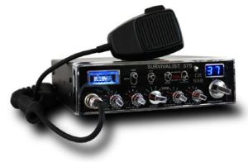](https://radiofreeq.files.wordpress.com/2013/07/survivalist_375_ssb_cb.jpg)

Survivalist 375 CB SSB Radio

**CB SSB | CB 37 U | 027.3750 USB | PREPPER CB SSB**  
27.375 MHz USB is CB Channel 36 Upper SideBand. Highly useful for long range patrols and wide local area communications, especially between vehicles and bases up to about 20 miles. Channel 37 USB CB is a prepper listed frequency. Shortwave receivers with USB or BFO can receive this channel. Most scanners can not receive this channel due to the use of Single SideBand.

Seen ad many times

Not relevant

Offensive

Covers content

Broken

REPORT THIS AD

**CB FREEBAND | FB378U | 027.3780 USB | FREEBAND PREPPER SSB**  
27.378 MHz USB is the most popular Prepper Freeband Upper SideBand channel in the gap between CB channel 38 and CB channel 37. It is useful for long range patrols and wide local area communications, especially between vehicles and bases up to about 20 miles. This frequency is clearer due to less interference and has longer distance range than normal CB channels for SHTF groups using CB SSB radios with unlocked clarifier. Shortwave receivers with USB or BFO can receive this channel. Most scanners can not receive this channel due to the use of Single SideBand.

[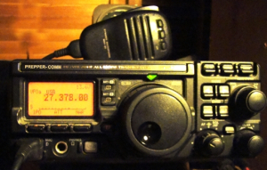](https://radiofreeq.files.wordpress.com/2013/07/prepper_comm_27378.jpg)

Survivalist Prepper Communications HF SSB Ham Radio Modified for CB Freeband

**CB FREEBAND | FB425U | 027.4250 USB | FREEBAND SURVIVALIST SSB**  
27.425 MHz USB is a CB freeband Upper SideBand channel in extra channels, about 2 channels above normal CB channel 40. For CBs with extra channels in bands, it is channel 2 of the band just above normal CB band (usually Band E). It is useful for long range patrols and wide local area communications, especially between vehicles and bases up to about 20 miles. This frequency is clearer and has longer distance range than normal CB channels for SHTF survivalist groups using radios with extra upper high channels. Shortwave receivers with USB or BFO can receive this channel. Most scanners can not receive this channel due to the use of Single SideBand.

**Notes on PL tones, Squelch, and DCS use**:  
The listings for FM Simplex are all carrier squelch receiver.  
=  
There is some advantage to transmitting a PL 151.4 to include those who may be using CTCSS.  
Continuous Tone Coded Squelch System:  
Interoperability with surplus military radios is desirable using Mil Tone Squelch frequency 150 Hz, compatible with PL tone and CTCSS radios using PL 151.4 Hz. This tone is also known as Motorola Code 4A or National Interagency Fire Center code NIFC 14.

**P25**

P25 digital radios can be used on some of the FM Simplex channels listed.  
Recommended Network Access Code NAC $F7E  
(Using NAC $F7E, receiver will unsquelch with any incoming NAC)

Everyone – Talk Group ID TGID $FFFF  
Individual Unit ID can be anything between $000001 and $98767F  
Unit ID for (All Call) everyone, Group call $FFFFFF

**DCS**

Digital-Coded Squelch (DCS) or Digital Private Line (DPL) or Digital Channel Guard (DCG)  
Not recommended due to interoperability issues.  
If used: DCS 023.

Powered by wordads.co

Seen ad many times

Not relevant

Offensive

Covers content

Broken

REPORT THIS AD

—  
*RadioMaster wishes to thank: “SHTF Team 2”, “Joe The Prepper”, “Darth_vader”, and “Mike the radio guy”, for their contribution of photos and useful information for this article.*

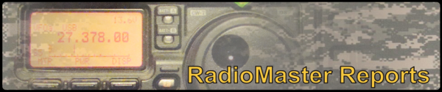  
Disclaimer: *Content provided in RadioMaster Reports is included for the sole purpose of providing educational information on a passive basis. This information may be useful to the public in the event of emergencies or disaster recovery, especially when normal techniques are not an available option. Users of this educational information are solely responsible for their actions.*

©2013 RadioMaster Reports