**Beginner’s guide to amateur (ham) radio for preppers**

 UPDATED NOVEMBER 11, 2017

BY JOHN RAMEY

* [Share](https://www.facebook.com/sharer/sharer.php?u=https://theprepared.com/survival-skills/guides/beginners-guide-amateur-ham-radio-preppers/)

* [Tweet](https://twitter.com/home?status=Beginner%E2%80%99s%20guide%20to%20amateur%20(ham)%20radio%20for%20preppers%20https://theprepared.com/survival-skills/guides/beginners-guide-amateur-ham-radio-preppers/%20on%20@ThePrepared)

* [Pin It](https://pinterest.com/pin/create/button/?url=https://theprepared.com/survival-skills/guides/beginners-guide-amateur-ham-radio-preppers/&media=https://theprepared.com/wp-content/uploads/2017/10/Puerto-Rico-Cell-Reuters-Alvin-Baez.jpeg&description=How%20will%20you%20communicate%20when%20the%20grid%20is%20down?%20Ham%20radio!%20Don%27t%20let%20the%20technical%20jargon%20confuse%20you.%20We%20break%20it%20down%20so%20you%20can%20get%20started%20quickly.)

* [Email](mailto:?&subject=Beginner%E2%80%99s%20guide%20to%20amateur%20(ham)%20radio%20for%20preppers%20on%20@ThePrepared&body=https://theprepared.com/survival-skills/guides/beginners-guide-amateur-ham-radio-preppers/)

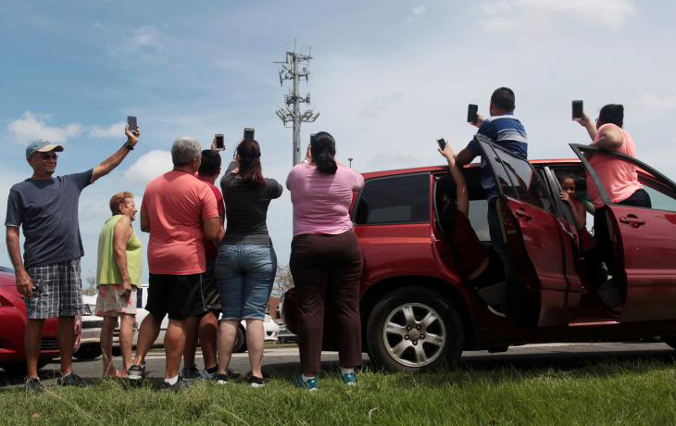Americans trying to find cell service after the 2017 hurricanes - via Reuters / Alvin Baez

The phone network is down and the internet is inaccessible. 911 is overloaded. Power is out. How do you communicate when all else fails? Ham radio. We break it down in this one-page beginner’s guide.

**LAST UPDATED: NOVEMBER 11, 2017**

Based on reader questions, we added a section explaining how Ham radio can usually crossover into other radio types, but not vice versa. We also slightly modified the average range numbers.

As recent disasters have shown, you simply cannot rely on mobile phones or the internet to communicate in an emergency, because these communication channels depend on the electrical and data grid.

FEMA and the Red Cross frequently rely on local Hams for spreading key info. When the devastating hurricanes of 2017 knocked out Puerto Rico’s communications, Ham radio operators on the island sprung to action, establishing crucial contact with rescue agencies.

You can think of countless situations where communication could make the difference between life and death on an individual level, too. What if disaster strikes when someone in your family is 10 miles away at work? Or you have a medical emergency while camping?

But the trucker-cliche CB and “toy” versions of radio, like the common and cheap walkie-talkies anyone can buy and use, aren’t very useful in survival scenarios.

Amateur radio — also known as Ham radio — is the best overall way for preppers to keep in contact during an emergency.

**Common sense prepping, straight to your inbox.**

Get our free newsletter for great new articles and giveaways. 1-2 emails a month. 0% spam.

Top of Form

Subscribe

Bottom of Form

Ham radio seems like a complicated, technical, and expensive hobby. Some of that impression is justified because the ham community has not done a good job of making things easy for people who want to get started and keep things simple. There’s too much technical jargon and too many arguments over little but complicated things that don’t matter to 99% of preppers.

Ham has been around for over 100 years, with 750,000 licensed operators in the US and six million around the world. It’s also the top choice for many preppers because of advantages in range, flexibility, community, and equipment compared to other options like CB and FRS.

You need a license from the FCC to communicate via a Ham radio. But with recent changes (like dropping the Morse code requirement), you can easily prepare for the test in just a few days using free online resources. The test is usually only $10-15. Combined with the advent of affordable and easy-ish to use Ham radios, it’s become much more practical to incorporate amateur radio as part of your emergency preparedness.

**In this guide:**

* [Common types of civilian radio: Ham, CB, FRS, GMRS, and MURS](https://theprepared.com/survival-skills/guides/beginners-guide-amateur-ham-radio-preppers/#radiotypes)
* [Why Ham radio is the best choice for preppers and survival](https://theprepared.com/survival-skills/guides/beginners-guide-amateur-ham-radio-preppers/#whyham)
  + [Criteria](https://theprepared.com/survival-skills/guides/beginners-guide-amateur-ham-radio-preppers/#whyham)
  + [Contact with emergency services](https://theprepared.com/survival-skills/guides/beginners-guide-amateur-ham-radio-preppers/#themoreyouknow)
  + [Crossover between radio types](https://theprepared.com/survival-skills/guides/beginners-guide-amateur-ham-radio-preppers/#crossover)
  + [Ease of learning vs. benefits](https://theprepared.com/survival-skills/guides/beginners-guide-amateur-ham-radio-preppers/#easevsvalue)
  + [Costs](https://theprepared.com/survival-skills/guides/beginners-guide-amateur-ham-radio-preppers/#costs)
* [What is the range of Ham radio, CB, FRS, GMRS, and MURS?](https://theprepared.com/survival-skills/guides/beginners-guide-amateur-ham-radio-preppers/#radiorange)
* [Do you need a license to use amateur Ham radio?](https://theprepared.com/survival-skills/guides/beginners-guide-amateur-ham-radio-preppers/#needlicense)
* [Which Ham radio license is best for survival prepping?](https://theprepared.com/survival-skills/guides/beginners-guide-amateur-ham-radio-preppers/#whichlicense)
* [How to get a Ham radio license](https://theprepared.com/survival-skills/guides/beginners-guide-amateur-ham-radio-preppers/#howlicense)
* [How to prepare for the Ham radio test](https://theprepared.com/survival-skills/guides/beginners-guide-amateur-ham-radio-preppers/#howprepare)
* [Intro to how radio works in easy terms](https://theprepared.com/survival-skills/guides/beginners-guide-amateur-ham-radio-preppers/#radiointro)
  + [Radio is part of a broader spectrum](https://theprepared.com/survival-skills/guides/beginners-guide-amateur-ham-radio-preppers/#radiointro)
  + [What are radio frequencies?](https://theprepared.com/survival-skills/guides/beginners-guide-amateur-ham-radio-preppers/#frequencies)
  + [What are radio wavelengths?](https://theprepared.com/survival-skills/guides/beginners-guide-amateur-ham-radio-preppers/#wavelength)
  + [What does HF, VHF, and UHF mean?](https://theprepared.com/survival-skills/guides/beginners-guide-amateur-ham-radio-preppers/#hf)
  + [What are radio bands?](https://theprepared.com/survival-skills/guides/beginners-guide-amateur-ham-radio-preppers/#bands)
  + [What are radio channels?](https://theprepared.com/survival-skills/guides/beginners-guide-amateur-ham-radio-preppers/#channels)
* [The tradeoff between distance and penetration](https://theprepared.com/survival-skills/guides/beginners-guide-amateur-ham-radio-preppers/#tradeoff)
* [Ham radio repeaters can extend your range](https://theprepared.com/survival-skills/guides/beginners-guide-amateur-ham-radio-preppers/#repeaters)
* [Intro to amateur Ham radio equipment](https://theprepared.com/survival-skills/guides/beginners-guide-amateur-ham-radio-preppers/#equipment)

**Why you should trust us**

We spent over 33 hours putting together this guide, and contributing experts have over *96 years* of combined experience as Ham radio operators. Ham radio is too confusing for beginners, so it was our goal to provide just the right information to get you started and cut through the noise.



* [Twitter](http://twitter.com/theprepared)

John Ramey. Founder of The Prepared. Prepping for 14 years and teaching survival skills for 10 years. Worked for DoD and White House on emergency technology and related issues like economic decline.



* [Radio club](http://www.okdxa.net/)

Gene Lewis, callsign W5LE, contributing expert. Ham for 55 years. Officer with Oklahoma DX Assoc and W5 Incoming Bureau Manager for ARRL.

**Emergency radios: Ham vs. CB vs. FRS vs. GMRS vs. MURS**

There are many types of radio, and they are not created equally.

In the US, the FCC sets aside blocks of radio frequencies for civilians to communicate with each other and benefit from the public airwaves that we all own. In later sections on this page, we dig deeper into [how the radio spectrum works](https://theprepared.com/survival-skills/guides/beginners-guide-amateur-ham-radio-preppers/#radiointro).

Different blocks of frequencies have different names, rules, and pros/cons. These are the most relevant radio types:

* Amateur “Ham” radio
* Citizen’s Band (CB)
* Family Radio Service (FRS)
* General Mobile Radio Service (GMRS)
* Multi-Use Radio Service (MURS)

What makes these different? The government will specify things like the amount of power that can be used to transmit a signal, restrictions on equipment and antennas, whether you can use repeaters, available frequencies, and so on.

**Amateur “Ham” Radio**

*1.8 – 1300 MHz with gaps in between. By far the widest range of frequency options.*

Note that “Amateur Radio” does not mean any broadcast radio used by civilians. In this case, “amateur” means “non-commercial.” You can’t use it to make money. Even a non-profit radio station would be considered commercial because it’s broadcast for the general public’s benefit, rather than a communication from one person to another.

Some will refer to the other types (CB, FRS, etc) as “Personal Radio” to distinguish it from amateur radio. The spiritual difference is that amateur radio is non-commercial but still powerful and broad, where personal radio is specifically meant for families on a hike or truckers stuck in traffic.

Base stations can legally be up to 1,500 watts. A typical handheld Ham radio is 5-8 watts. There are fewer restrictions (if at all) on antennas, etc.

**Citizens Band (CB)**

*26 – 27 MHz (HF), 11 meter band, 40 channels.*

CB has been around a long time, and was quite popular around the 1970’s. CB has fallen out of favor in recent years, although it’s still used by some truckers and offroading clubs. It’s unreliable, crowded, and the language can get pretty vulgar. You do not need a license to operate CB.

Power is limited to 4 watts. Even though that’s more power than MURS and FRS, CB still has lower quality because of interference from nearby channels (e.g. baby monitors), and it relies on AM technology instead of FM. There are ways you can tweak CB to be better, but we think that’s too complicated for most people. CB also requires much larger antennas because of the longer wavelength compared to VHF/UHF.

**Family Radio Service (FRS) vs. General Mobile Radio Service (GMRS)**

*462 – 467 MHz (UHF), 22 channels*

These are technically two different radio types. But they overlap on almost all the same frequencies, can talk to each other on most of those frequencies, and in 2017 the FCC changed the rules so that they became even more similar. Because of this, the popular radios sold in this category can usually do both FRS and GMRS.

The FRS block was proposed by the RadioShack store in the 1990s so families could quickly buy and use walkie-talkies that were better for personal use than CB, but didn’t require a license. This lead to the growth of the common “bubble pack” paired radios you find in gas stations and Walmart.

GMRS is kinda-sorta the business equivalent of FRS. For example, farmers and businesses with employees spread around a small area would use GMRS.

You still need a license to operate GMRS, which costs around $85, but there is no test involved. GMRS could operate with up to 50 watts of power, although most products are still 3-5 watts.

GMRS is the only radio option other than Ham that allows radio repeaters.

**Multi-Use Radio Service (MURS)**

*151 – 154 MHz (VHF), 5 channels*

MURS was created in 2000. It’s not very popular and generally not seen in prepping. You do not need a license to operate MURS. Power is limited to 2 watts.

However, some recent products marketed towards preppers are built on MURS in the background, for example, the goTenna device that pairs with your phone to send short text messages without the cell network. This product transmits over MURS to other nearby goTennas, creating a peer-to-peer radio network.

**Ham radio is the best choice for preppers**

With all of these different types of radios, which one should you depend on when preparing for emergencies?

We consider these criteria when choosing:

* Signal range in a variety of practical situations (urban, woods, etc.)
* How easy is it to learn and use
* Can you listen to emergency broadcasts
* Can you communicate with emergency services
* Overall cost to be properly prepared
* What kind of equipment is available and does it fit well with emergency needs
* How easy is it to modify and repair in normal life and an emergency

Whenever we make a recommendation or draw a conclusion, we normally like to show the data, testing, and reasoning that supported it.

In this case, since radio can get complicated pretty quickly and this is a beginner’s guide, we can’t put it all together in one linear section or explain every possible combination. For example, it’s hard to understand differences in signal range without first understanding how radio waves and radio equipment works.

“As a prepper, I turned to Ham over the other radio choices. When I thought about the wide range of scenarios that could affect my family, Ham seemed like the best choice because of its power, range, and flexibility. I’ve been licensed for 11 years and still feel confident in my choice.” — Ham veteran AJ Hoekstein.

Preppers generally agree Ham is the best choice because:

* Ham is the only option where you can listen and talk to your local emergency services.
* Ham radio has a much wider range of frequencies than the others. CB can get quite crowded, for example, since everything happens between 26 and 27 MHz.
* Ham has better range. There is some nuance to this, explained below.
* Ham can use High Frequency (HF) bands, which are the best bands in a major SHTF emergency because they can easily reach hundreds of miles without depending on anything (or anyone) else.
* Ham has more power. Other forms are limited to 0.5 – 4 watts. Handheld Ham units are typically 5-8 W, and base stations can get up to 1,500 W.

**Listening to broadcasts and communicating with emergency services**

Since we’re assuming the normal communication grid is down, how will you get info from emergency services? How will you know if you should evacuate or when it’s safe to come out?

Many preppers have a NOAA emergency radio in their home supplies. You can only listen, but it’s a simple way to receive emergency broadcast radio stations like NOAA.

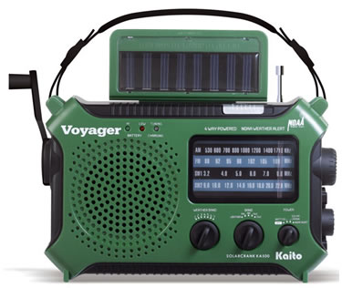These pick up “normal” radio broadcasts but you can’t hear or talk with emergency services and other people.

However, those radios, like the green one pictured here, can be quite limited, cheap, and bulky. We generally don’t recommend keeping these in your bug out bag or get home bag.

Many portable Ham radios can listen to NOAA and commercial FM stations, as well. Plus, you get the huge bonus of picking up and talking with your local emergency services (fire, police, medical, etc.).

You’ll also want to talk with other people in your family or community, and to use equipment that is portable enough to be practical.

So even if you don’t get your license, a $40 handheld Ham is more valuable than a $20 NOAA/FM-only one.

CB, FRS, GMRS, and MURS simply do not work on emergency broadcast and local emergency responder frequencies. Ham does.

Basic Ham radio equipment is not guaranteed to pick up all of your local emergency services. Some police and fire departments have moved to digital and encrypted systems. To listen to those you’d need a dedicated police scanner, which is a different topic altogether.

Look up your local emergency services frequencies on [RadioReference](https://www.radioreference.com/" \t "_blank).

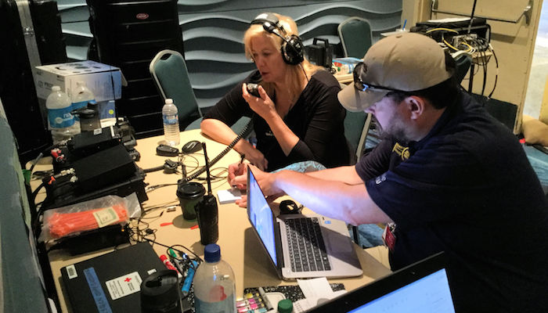50 Ham volunteers went to Puerto Rico to help in the recovery efforts after Hurricane Maria

A lot of Hams are preppers. So the network of people you’ll meet before and during an emergency are like-minded and more likely to know what’s happening compared to a random CB trucker.

Many Ham radios have a built-in function to easily listen to typical commercial AM/FM radio stations. To the best of our knowledge, CB radios don’t. Some of the common FRS/GMRS radios you find at Walmart will have an AM/FM commercial radio feature so you can listen to broadcasts on a hike.

**Crossover between radio types**

Ham is considered the most versatile when it comes to “crossing over” into other types of radio. Take care, because some of what you see about this on the internet is technically illegal — in some cases you’re modifying equipment or using it in ways that aren’t allowed by the letter of the law.

Ham radios can be used or modified (either through software or hardware) to access the CB, FRS/GMRS, and MURS frequencies. This can be illegal because a Ham radio might broadcast with more power than the FCC allows on lower power frequencies like CB or FRS. But there are videos showing you how to do this on YouTube.

While Ham can touch most or all of the other radio types, it’s essentially impossible to go the other way. You can’t make an FRS radio talk to CB, for example.

**Ease of learning and using**

This is the major place where Ham loses vs the other radio formats. All of the other types of radio are designed to be turnkey.

CB and FRS are the easiest radios to get started with: you buy a unit off the shelf, have everyone in your party turn it to Channel 3, and you’re good to go. The barrier of entry is low, and you don’t need a license.

But there are tradeoffs. When we balance out the pros and cons of each, most survival experts believe the pros of Ham outweigh the extra steps.

Because the government made it easy for anyone to use those license-free bands, they require manufacturers to cripple the equipment so that people can’t abuse the airwaves or broadcast in places or ways they’re not supposed to.

For example, many turnkey radios are prohibited by law from having removable antennas. CB radios can’t have upgraded power without breaking the law. And so on.

CB, FRS, and MURS don’t need any kind of license. GMRS does, but there’s no test.

Ham requires at least a basic license and test that might take you 2-3 days, including study time. More advanced Ham licenses require more studying.

Learning and using the equipment is also harder in Ham than the others. But it’s the cost we pay to have what we need in the widest range of emergencies.

If you personally decide that you’ll only ever need to talk to a closed network of people within a short distance, then the more turnkey versions like CB or MURS would be a fine way to go.

**Cost of Ham radio vs. the others**

If your primary concern is cost and you’re fine with the tradeoffs, then FRS or CB is better than Ham.

Ham is not nearly as expensive as it used to be. But because the equipment is more powerful and flexible, the costs are generally higher.

A handheld Ham radio, like the popular [Baofeng BF-F8HP](https://theprepared.com/pick/baofeng-bf-f8hp-8-watt-handheld-ham-radio/" \t "_blank), can be as little as $30-60.

The real money comes in with mobile units (car mounted) and base stations (home mounted), which can be $500 or more. Although, there are plenty of DIY and used options.

**What is the range of Ham radio, CB, FRS, GMRS, and MURS?**

If you ever want to start an internet debate, bring up radio ranges.

It’s *impossible* to give simple numbers that everyone thinks are correct. There are so many variables that it’s hard (and technically not 100% correct) to give averages. We almost didn’t include this section at all, but many people ask and what’s important is the relative relationship between the different radio types. In short, Ham radio beats the other types.

Because of how variable the range can be, we’ve personally experienced situations where we contacted someone 200 miles to the East, but couldn’t contact someone 10 miles to the West. In that case, East was flat but West had deep mountains.

Range is affected by:

* size and quality of the antenna
* how high the antenna is off the ground / relative to the horizon
* what kind of terrain or structures are in the way
* urban vs. rural
* wavelength / frequency
* transmission power
* weather, including unseen stuff like atmospheric layers and solar flares
* Murphy’s Law

Those factors are quite different based on what kind of radio equipment you’re using. Powered base stations with fixed antennas on your chimney will perform better than a battery-powered handheld unit with a whip antenna.

Since most people want to keep things simple, we tried to evaluate the average practical ranges you could dependably achieve in a mix of common scenarios and environments.

Average ranges between two average handheld radios:

* Ham: 2 miles
* CB: 1 mile
* MURS: 1 mile
* GMRS: 0.5 mile
* FRS: 0.25 mile

Average ranges between two average base station radios:

* Ham: 18 miles
* CB: 14 miles
* MURS: 10 miles
* GMRS: 9 miles
* FRS: *(No base stations due to fixed antenna and power limit laws)*

In general, flat rural areas have the best range. The more terrain and structures there are in the way, the shorter the range. The same radio might get 10 miles in the country, 5 miles in the suburbs, and 1-2 miles in the city.

You will usually see marketing for CB and FRS / GMRS / MURS walkie talkies touting ranges of 30-50 miles. They are plain lying. Those are the theoretical maximums if you were standing at the highest point in the region, at night, with flat terrain, no buildings, perfect weather, and a blessing from the Radio Gods.

CB usually has a range of 1-2 miles. That range can be extended with more advanced CB technology like Single Side Band and so on. A limitation of CB is that the antennas need to be quite large, which is why CB base stations can get a decent boost in range with antennas that wouldn’t otherwise fit on a vehicle. So we think it gets impractical to reach those ranges compared to more modern tech like Ham.

MURS has less power than CB and GMRS at 2 watts versus 4-5 watts, respectively. However, since [VHF has more range than UHF](https://theprepared.com/survival-skills/guides/beginners-guide-amateur-ham-radio-preppers/#tradeoff), MURS usually comes out ahead on distance.

GMRS users usually report practical ranges of 0.5 to 1 mile. In clear line of sight situations you might get up to 2 miles.

FRS is usually the shortest range with averages of 0.5 to 1 mile.

Ham’s signal range varies widely based on the equipment and band you’re using. A handheld unit might only get a few miles in some circumstances, while a base station on HF bands can bounce off the atmosphere to talk around the globe.

Handheld Hams will usually be 5-8 watts. But a base station can get up to 1,500 W of power!

**“Don’t just buy a top-rated handheld Ham and expect it to perform well in every location,” said Robert Wright, an Extra-class Ham who’s been licensed for 26 years.**

26-year Ham expert Robert Wright suggests contacting your [local CERT group](https://theprepared.com/community/guides/cert-training-community-emergency-response-team/), which can recommend the best radios and frequencies for your area, and most importantly, offer training classes and opportunities to practice using your radio.

UHF, such as the popular 70 cm band, is generally considered line of sight. VHF, including the popular 2 m band, is generally limited by the horizon (which may be truncated by buildings etc). HF is where Ham gets really stretchy.

**Do you need a license to use Amateur (Ham) radio?**

Yes — if you want to transmit over the Ham radio frequencies.

Anyone can buy Ham radio equipment and listen to whatever signals they can receive. Those signals are floating through the air anyway, and it’s harmless to listen in.

Although we don’t recommend it, you could buy a simple but solid Ham radio like the [BaoFeng BF-F8HP](https://theprepared.com/pick/baofeng-bf-f8hp-8-watt-handheld-ham-radio/" \t "_blank) and listen to nearby traffic, such as your local fire department. Then, in an emergency, perhaps you could figure out how to transmit or get lucky. No test required.

Anyone can transmit on amateur Ham radio without a license in a bona fide emergency. In a real Shit Hit The Fan situation, it’s of course unlikely anyone will care anyway. But there are hefty fines if you’re caught transmitting outside of an emergency. Yes, it’s actually enforced.

You wouldn’t buy a gun and wait to shoot it for the first time after SHTF. The same goes for Ham — you won’t automatically be comfortable with it the first time you use it. Even though Ham is getting easier to learn, you do still need to *learn*.

For example, knowing how to access a local signal repeater so you can extend your range from 2 miles to 50 miles could be the key to saving your life.

Since you are not truly prepared until you practice with your gear, we recommend getting at least the most basic license level so you can get to know your radio and how to use it.

If getting a license is just not an option for you, many preppers still believe having a ~$50 Ham radio is better than nothing. You might be able to pick up FM and emergency channels, get lucky by contacting someone else, or run into a group of experienced Hams that can add you to their network.

**Which Ham radio license should you get for prepping?**

There are three levels of licenses:

* Technician (entry)
* General
* Extra (advanced)

Each of these licenses lasts 10 years and require a test. The major difference between levels is how many frequencies you have access to.

The entry-level Technician license gives you access to amateur bands above 30 MHz, including the popular 2 meter and 70 centimeter bands.

The General license gets you into the lower frequency, longer wavelength High Frequency bands that are [better for long distance](https://theprepared.com/survival-skills/guides/beginners-guide-amateur-ham-radio-preppers/#radiointro).

For 99% of people, start with the Technician license. 80% of you will likely stop at that level.

Once you’ve learned the ropes, if you’re serious about setting up the equipment to talk hundreds or even thousands of miles away without being dependent on the power grid or repeaters, you’ll want access to the HF bands. So you’ll need the General license.

**How to get a Ham radio license**

Most tests are conducted through your local amateur radio club on a monthly or quarterly basis.

Find your closest Ham testing session on [ARRL](http://www.arrl.org/find-an-amateur-radio-license-exam-session/).

The amateur radio license test has a small fee, usually around $10-15, which can vary between radio clubs.

Volunteer Examiners (VE) administer the test, and they appreciate the courtesy of a heads up that you plan to attend.

The written, multiple-choice Technician’s test is 35 questions. You must get 26 correct to pass.

The VE will grade your test on site. If you pass, they mail your info to the FCC. After 1-2 weeks you’ll receive your amateur radio license and call sign (e.g. “YX8WU”).

Everywhere around the world has specific call sign blocks assigned to them (“WO\_ \_ \_”) to help with licensing and identification: G, M & 2E for England, D for Germany, I for Italy, AA-AL, K, W, N for USA, and so on.

You are not allowed to talk on the air until you receive your unique call sign.

Note that when you become licensed with the FCC, your name and address will be searchable through their ULS system. Many preppers want to maintain some privacy, so they set up a P.O. Box or some other address before they apply for a license.

**How to prepare for the Amateur (Ham) radio test**

Most people going for the Technician entry-level license want to get ready for the test as quickly as possible.

The FCC releases current versions of the [test question pools](http://www.arrl.org/question-pools). The 35-50 questions on an exam are randomly pulled from a pool of ~350.

If you like to learn in-person, [ARRL](http://www.arrl.org/find-an-amateur-radio-license-class) has a list of local classes. The intro classes are usually a few days long and cost $10-$15. It’s a great way to start meeting local Hams.

You can find free online flashcards and practice tests that use questions from the real exam on [QRZ](https://www.qrz.com/hamtest/), [eHam](http://www.eham.net/exams/" \t "_blank), [ARRL](http://www.arrl.org/exam-practice), and [Hamstudy](https://hamstudy.org/" \t "_blank).

If you want to dig deeper, check out [ARRL’s study guides](http://www.arrl.org/ham-radio-license-manual).

Hams even have a special name for passionate advocates that enjoy teaching newbies: Elmers. Try finding an Elmer to be your mentor via EHam.net’s [Elmer forum](http://www.eham.net/ehamforum/smf/index.php/board,12.0.html).

**Radio 101 (in easy terms)**

We’ll keep the science to a minimum, but to understand things like the difference between CB and Ham or how far your signal will reach, it’s helpful to understand the basics of radio.

**Radio is part of a broader spectrum**

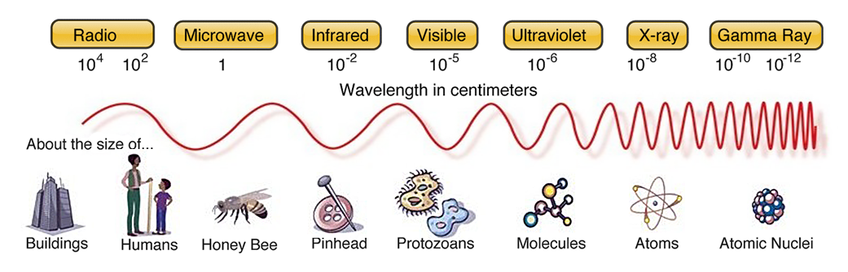The electromagnetic spectrum

There are all kinds of signal waves around us called the “electromagnetic spectrum.” The visible light we see, UV rays from the sun, X-rays, microwaves, the signal from your remote control to a TV, GPS, and radio all fall on this spectrum.

The difference between types of waves is how big and fast the waves are.

Because different sections of the spectrum work well for different jobs (like transmitting TV shows versus cooking food), and to keep the airwaves more organized, governments create and manage blocks of frequencies for different purposes.

Blocks are reserved for satellites, emergency services, military, commercial aircraft, , commercial radio stations, mobile phones, and so on.

That’s why all FM radio stations you listen to in the car are between 88 and 108, which correlates to their frequency of 88 MHz to 108 MHz. AM stations are always between 540 and 1600 KHz.

But not all frequencies are created equal. For example, FM radio stations usually sound clearer than AM radio stations.

The bands used to transmit HD TV signals are different than those used for garage door openers. It boils down to how big and fast the waves are, which affects how much info you can package into a signal. HD TV requires more info per second than simple talk radio.

**What are radio frequencies?**

“Frequency” means how often something happens in a specific time window. Fast music might have a frequency of 120 beats per minute, where slow music might be 66.

The red wave has a lower frequency than the purple wave

In radio, frequency is the number of waves per second. You’ll see frequencies listed like “840 kHz” or “300 MHz”.

Hz stands for Hertz, which means one wave.

The k, M, and G that goes before Hz is for kilo, Mega, and Giga — yes, the k is lowercase while the others aren’t. Just like on the computer, where a Kilobyte < Megabyte < Gigabyte.

A Megahertz is one million waves. So a frequency of 300 MHz would be 300,000,000 waves per second.

**What is a wavelength?**

This one’s easy: a wavelength is the physical length from one point on a wave (like the peak) to the same point on the next wave.

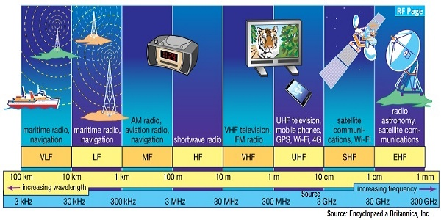Some radio waves have wavelengths of 60 miles (100 kilometers)!

Wavelength and frequency are an inverse relationship. The higher the frequency, the lower the wavelength.

Which makes sense — if a single wave is 60 miles long, it’d be a lot harder to scrunch 300,000,000 of those waves into one second’s worth of transmission than if each wave was only an inch long.

**What does HF, VHF, and UHF mean?**

High Frequency (HF), Very High Frequency (VHF), and Ultra High Frequency (UHF) are names for different bird’s eye view sections of the broader radio spectrum.

* High Frequency (HF) is 3-30 MHz
* Very High Frequency (VHF) is 30-300 MHz
* Ultra High Frequency (UHF) is 300 MHz to 3 GHz

There are of course other sections like Low Frequency, but you don’t hear much about them because they aren’t used for civilian radio.

The naming can seem confusing, but consider the history. The first radios were simple. So scientists thought “this part is low and this part is high”. Then, over time, we kept innovating into higher and higher frequencies. “Um, this one is Very High!”… “Now this next one is Ultra High!” And so on.

**What are radio bands?**

Bands are ranges or blocks of radio frequencies. They are referred to by their frequency (“14 MHz band”) or wavelength (“20 meter band”).

There are 27 amateur radio bands. These are the most popular:

| **Range** | **Band (Meter)** | **MHz** |
| --- | --- | --- |
| HF | 80 | 3.5 – 4.0 |
| HF | 40 | 7.0 – 7.3 |
| HF | 30 | 10.1 – 10.15 |
| HF | 20 | 14.0 – 14.350 |
| HF | 17 | 18.068 – 18.168 |
| HF | 15 | 21.0 – 21.450 |
| HF | 12 | 24.890 – 24.990 |
| HF | 10 | 28.0 – 29.70 |
| VHF | 6 | 50 – 54 |
| VHF | 2 | 144 – 148 |
| UHF | 70 cm | 430 – 440 |

But most beginner’s focus on just two bands: 2 meter / 144-148 MHz and 70 centimeter / 430-440 MHz.

Additionally, 2 meter and 70 centimeter are the bands used by local emergency radio services such as the Amateur Radio Emergency Service, Radio Amateur Civil Emergency Service, and [Community Emergency Response Teams](https://theprepared.com/community/guides/cert-training-community-emergency-response-team/).

**What are radio channels?**

Radio channels are like email addresses. Instead of telling someone to email your IP address (172.42.23.163), you give them an easier to remember label.

So when people use Channel 19 on CB radio, they’re just referring to the frequency 27.185 MHz that everyone knows as Channel 19.

For the types of radio that are meant to be easy for everyone (CB and FRS), you might not ever see the actual frequency — it just has the channels programmed in by default and the equipment knows the rest.

That’s also why we call TV stations “channels”, because they used to be transmitted over the air. CBS didn’t want to tell their viewers to “tune in to frequency 519.25 MHz!”

**Trade off between range and penetration in HF / VHF / UHF**

The most important thing to remember is that long wavelengths travel further and smaller wavelengths can sneak their way into buildings.

X-Rays work because they are so small, they can move through your body.

The higher the radio frequency, the smaller the wavelength. The UHF 70 cm band doesn’t get as much natural range as the VHF 2 m band, but it’s better at finding its way through windows and doors.

On the other end of the spectrum, the larger wavelengths are able to travel further than the horizon because they can bounce off of the atmosphere, mountains, and even the moon.

This video is a apples-to-apples test between VHF and UHF in an outdoor setting. Even with higher wattage on the UHF model, around two minutes in you can hear the UHF degrade compared to VHF as they hit the furthest distance before turning around:

Since VHF is the middle-of-the-road compromise between HF distance and UHF ability to pierce buildings, and since most people have their Technician’s license which doesn’t allow HF, VHF is usually the most popular band among Hams.

Depending on who you’re trying to contact, you might opt for one band over another. Take Puerto Rico, for instance. After Hurricane Maria wiped out cellular networks, police worked alongside Ham radio operators equipped with VHF mobile radios so they could talk on the 2 meter band with other emergency crews.

**What are Ham radio repeaters?**

Even though Ham radio has more inherent range than other options like the FRS walkie talkies, the popular 2m and 70 cm bands available to Technician-level Hams are generally limited to line-of-horizon or line-of-sight range. If you’re using a handheld unit, you may only get 1-2 miles.

Ham radio repeaters are the equivalent of mobile phone towers. They receive a signal from someone nearby and rebroadcast it into the greater network, usually with more power and clarity, so it can travel farther.

Repeaters are usually on top of a tall building or hill, with high quality equipment and antennas.

They’re freely available for public use. Repeaters are often set up and maintained by a local Ham who wanted to volunteer their time for public service.

Find your local repeaters with [RFinder](http://www.rfinder.net/" \t "_blank) (the official tally for the ARRL) or [RepeaterBook](https://www.repeaterbook.com/" \t "_blank).

If your signal bounces off of just one repeater, the range can get up to 50 miles. With a strong network of repeaters, a transmission could be daisy-chained to span the country.

A repeater can’t receive and transmit at the same time on the same frequency, just like normal transceivers. This is called simplex.

Since a repeater essentially needs to listen and repeat at once, they use two different frequencies that are slightly offset from each other. This is called duplex.

The good news is that most modern Ham equipment can manage the duplex offsets automatically. But it’s a perfect example of why you need to practice (with a license) in order to understand repeaters before you need them.

You can’t always depend on repeaters being available in an emergency, since most are powered by the normal electrical grid. Some are powered by solar or generators, but those too can fail.

In a real SHTF situation, it’s safest to assume you can only rely on the equipment you have. That’s why advanced preppers get their General license and move into the longer wavelength HF bands that can travel hundreds of miles without repeaters.

**Intro to Ham radio equipment for survival**

All radios require a power supply, antenna, and transceiver to send and receive signals. A transceiver is one unit that **trans**mits and re**ceives** (get it?!)

We’ll suggest specific products like radios, antennae, and brands in a future post. This is just the basics.

There are three basic types:

* Handheld radios. Sometimes called Handitalkies or HTs. The popular Baofeng radios are HTs.
* Mobile radios. Mounted in a vehicle, like a typical CB radio.
* Base stations. Typically in your home, with a large immobile antenna (perhaps on your chimney), power supply, and transceiver.

**Handheld Ham radios**

Note that “walkie-talkies” or “two-way radio” usually mean the simpler and cheaper Walmart products not meant for survival use. They operate on the Family Radio Service frequency bands and are programmed to only talk with each other on a limited set of channels.

The simplest way to get started is with a $40-60 handheld radio. The most popular beginner options among preppers are the Baofeng UV-5R and BF-F8HP.

**Quick Pick**

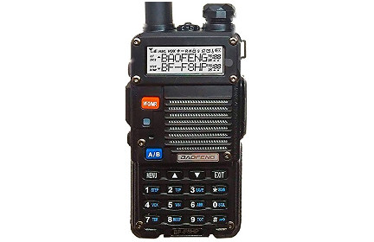

**Popular prepper radio:**

**BaoFeng BF-F8HP 8 Watt Dual Band Handheld Ham Radio**

One of the most popular handheld Ham radios because it's solid enough for most uses, but under $100. 3rd generation of the previously popular UV-5R.

* [Check price on Amazon](https://theprepared.com/pick/baofeng-bf-f8hp-8-watt-handheld-ham-radio/)

When you see the “dual-band” label, that just means the radio can access two different bands. In 99% of circumstances, that means it works on the two most popular VHF 2 m and UHF 70 cm bands — both are included in the entry-level Technician license.

Most popular Ham handheld radios use 5-8 watts of power off a rechargeable battery. The ARRL suggests a spare rechargeable battery pack, a car adapter, and a desktop quick-charger. We also have an adapter that replaces our HT battery with a compartment for four normal AA batteries in case we can’t use anything else.

**Mobile Ham radios**

Mobile radios are typically mounted in your vehicle’s dash, glovebox, or under a seat with a corded microphone that runs towards the driver’s seat.

Mobile radios can get at least double the signal range of an HT because of more power from the battery and a larger antenna.

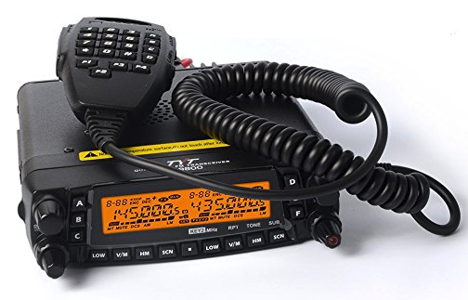

There’s a variety of ways you can attach an antenna to your vehicle. There are more fixed solutions where the antenna is bolted or screwed onto an aftermarket mount that attaches to your hood, roof, tailgate, etc.

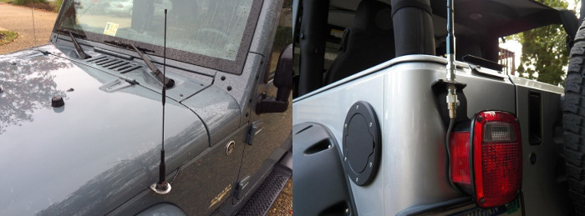Two of the ways you can mount an antenna to your car.

Magnetic mounts are handy because you can put up the antenna when you need it, but quickly remove it when you don’t.

Some mobile transceivers are designed to be removable. They normally sit stationary in a bracket in your vehicle. But the transceiver can be removed, thrown in a backpack, and off you go on foot.

If you get your General license to access the long range HF bands that are great for prepping, there are portable HF units that can fit in a backpack.

A new mobile rig setup could cost around $500-$800. The transceivers are usually the size of a thick sandwich.

**Ham base stations**

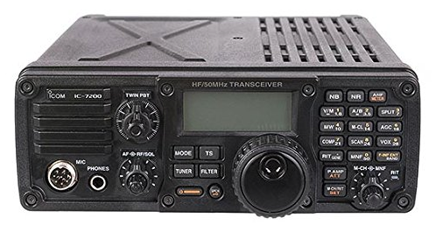

For most people with their own home, having a base station with external antenna is great for prepping. Especially once you have your General license, which gets you onto the HF bands that can travel thousands of miles without any repeaters.

They’re also practical for experimenting and modifying. If things really collapse, you can use coat hangers and wire to build makeshift antennas that run up a tree or chimney.

Setting up a base station will get close to $1,000 for new gear. It will be about the size of a Playstation. You can often find cheap used equipment, but it may be difficult to identify the good used picks until you’re more experienced.

**Power**

None of this matters if the radio doesn’t have juice.

Some preppers rely on generators for short term needs, although they are noisy, limited, and require ventilation.

Ideally your home is off the grid anyway. If it isn’t, some preppers have smaller solar panels and batteries specifically for radio — which many consider to be one of the most important electricity needs in an emergency.

If you would like a better idea of what is possible for prepping, every year amateur operators have an event the last weekend in June called Field Day, where Hams run radios off of alternative power.

**Antennas are the key**

Most hams agree that the most important piece of any radio is the antenna. If you want to make your $40 Chinese radio more ‘powerful’, you can easily screw on a better antenna for as little as $20.

A rule of thumb is the antenna should be at least 1/4 the size of the wavelength you want to use. The UHF 70 cm band only needs a 7 inch antenna. Whereas the 11 m CB band would need an antenna over 100 inches.

**Sources and footnotes:**

1. [With cell service crippled, Puerto Ricans look skyward for a signal](https://www.reuters.com/article/us-usa-puertorico-communication/with-cell-service-crippled-puerto-ricans-look-skyward-for-a-signal-idUSKCN1C30FA). Reuters. Sep 2017.
2. [Amateur Radio Operators Stepped In To Help Communications With Puerto Rico](http://www.npr.org/2017/09/29/554600989/amateur-radio-operators-stepped-in-to-help-communications-with-puerto-rico). NPR. Sep 2017.

[Expand](https://theprepared.com/survival-skills/guides/beginners-guide-amateur-ham-radio-preppers/#footnotes-collapse)