2/14/2020 W4PGT RigPi Macro Settings

# Macro Settings (User: radiorusso3)

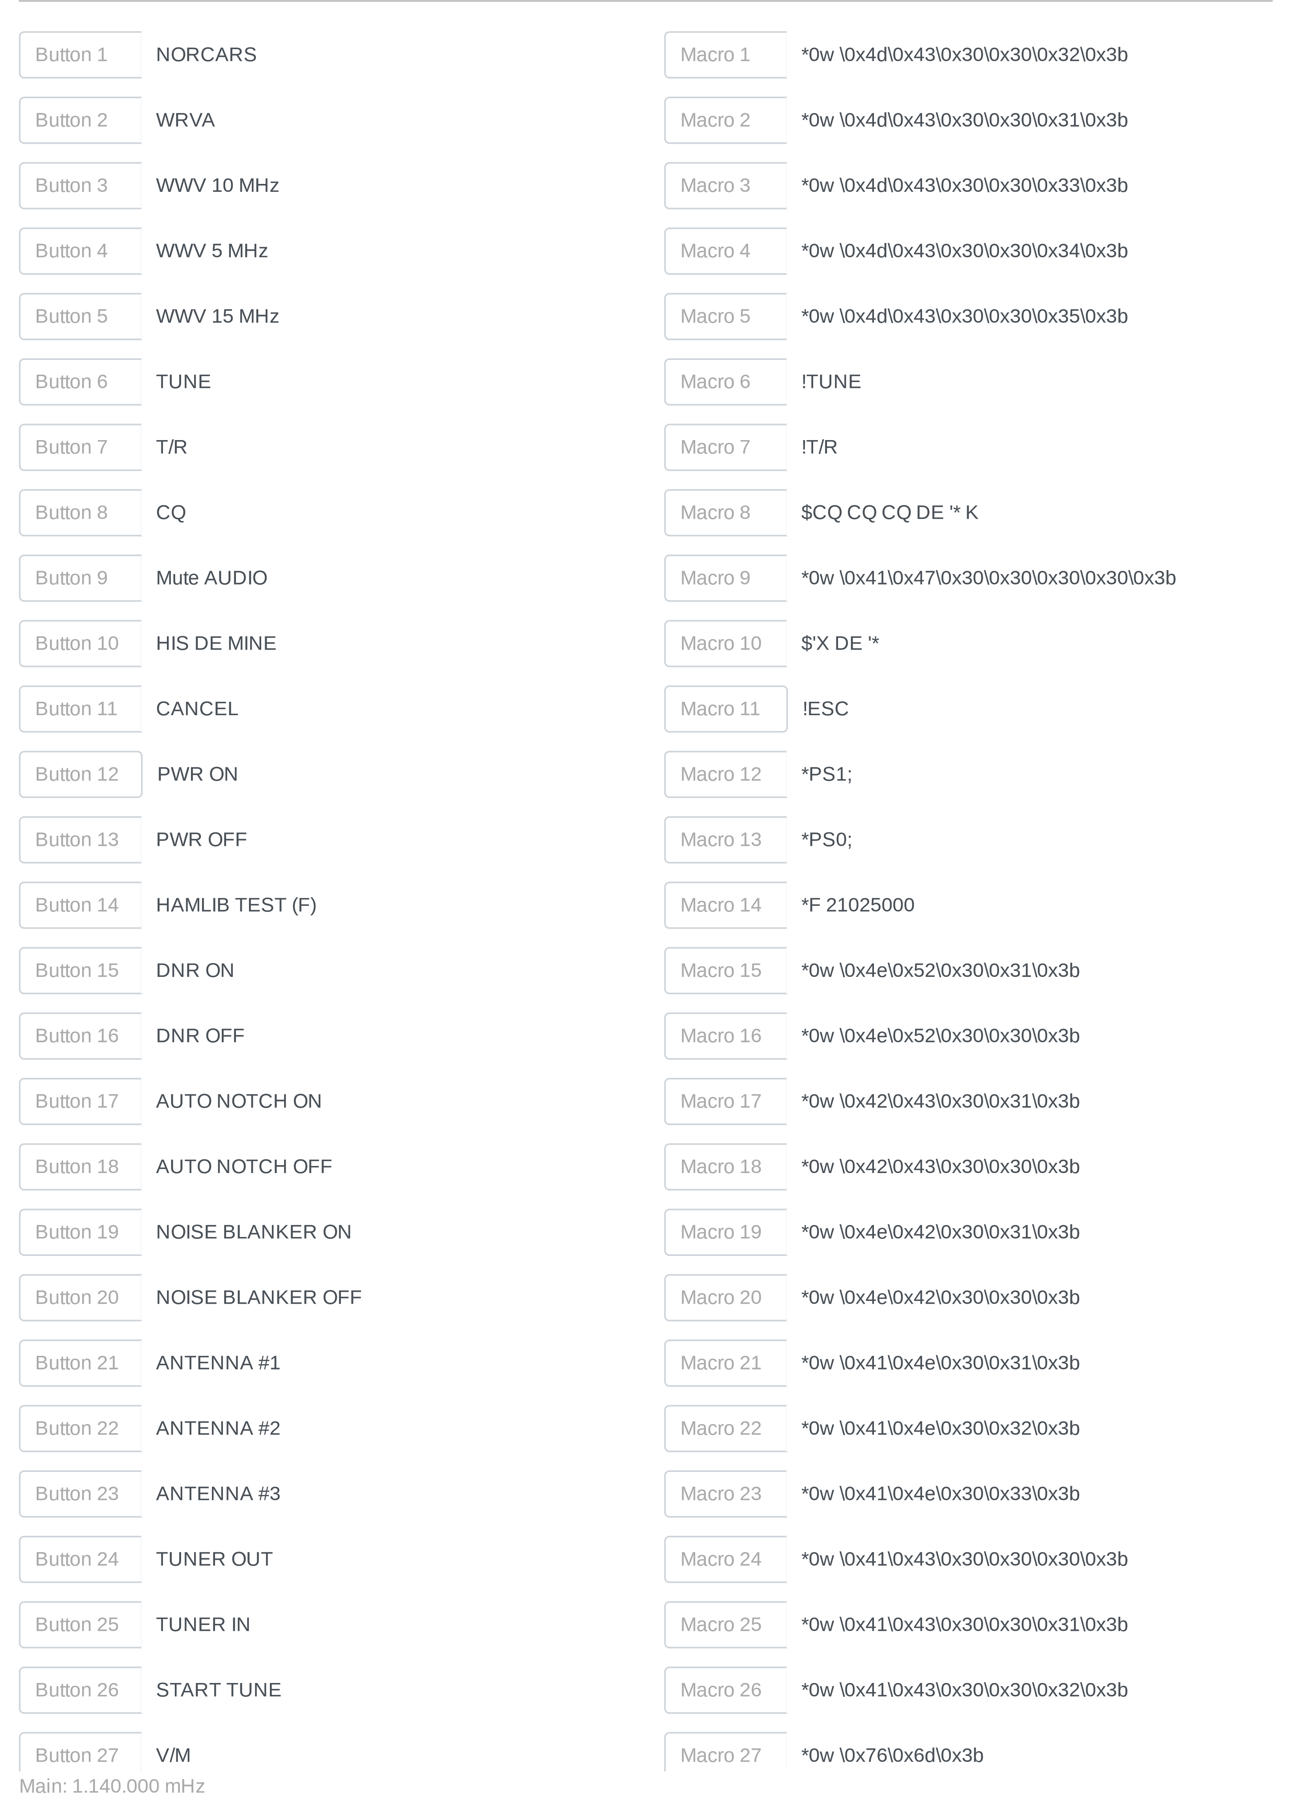

http://rigpi.local/macros.php?x=radiorusso3&c=W4PGT 1/2 2/14/2020 W4PGT RigPi Macro Settings

Button 28

MIC AUDIO USB PORT

Macro 28

*0

w \0x65\0x78\0x31\0x30\0x33\0x32\0x3b

Button 29

MIC AUDIO Front Mic Connector

Macro 29

*0

w \0x65\0x78\0x31\0x30\0x33\0x30\0x3b

Button 30

Macro 30

Button 31

Macro 31

Button 32

Macro 32

Main: 1.140.000 mHz

http://rigpi.local/macros.php?x=radiorusso3&c=W4PGT 2/2