**SIQT Reference Document**

**Dry Run Event**

**1/21/2014-2/2/2014**

**Version 5.0**

**Table of Contents**

1 Overview 4

2 TSW SIQT Orientation 4

2.1 Major Software SIRNs- Used During SIQT 4

2.2 TSW System Overview 4

2.3 Installation of TSW SIs. 6

2.4 Deviations at Start of Dry Run SIQT 9

2.4.1 Deviation for Using Calibration Factor and Mask Databases for SIQT. 9

2.4.1.1 Database Script File Content Used to Implement the Deviation 10

2.4.2 Deviations Required for Recovery from Software Problems on a STE 13

2.4.2.1 Deviation: Recovery of an MDU and STE from an Unknown State 14

2.4.2.2 Deviation: Recovery Steps to Take in the Event of a Hardware Change 15

2.4.2.3 Deviation: Steps Taken when Regression Testing a New Build 16

2.4.2.4 Deviation Recovery Steps to Take When System Cannot Enter Standard Codes 18

2.4.2.5 Deviatio:n Steps Taken in the Event of Missing Files 18

2.4.3 Deviation 18

2.4.4 Recovery Steps to Take When a Known Ste Hardware Based Issues Occurs (Based Upon Input from FC29227) 18

2.4.5 Deviation Steps to Take I in the Event of Missing Files 30

2.4.6 Deviation Steps to Taken to Configure Data Sets for Testing on NPEITE 30

2.5 Conventions to Use During SIQT 31

2.5.1 Redline and Black Line Conventions 31

2.5.1.1 Redline and Black line Process 31

2.5.1.2 Red Line Process Steps 32

2.5.1.3 Black Line Process Steps 32

2.5.1.4 Additional Redline Process Guidance 32

2.5.2 ITE AR Convention 33

2.5.3 Test Procedure Execution Order Convention 33

2.5.4 Follow the Test Capture Process Convention 33

2.6 MITE MAR TSW SWIT/SIQT Results Capture Steps 33

2.6.1 Results Capture Steps Data Locations 34

2.6.2 Results Capture Steps Log Sample Directory Structures 34

2.7 LBCR Instructions 35

2.7.1 How to Start LBCR SW 35

2.7.2 How to View LBCR Correlator Plots 40

2.7.3 How to Save LBCR Log Files 41

3 Post SWIT Procedure Issues list Data. 42

4 Post SWIT Deficiency Report Data. 46

# Overview

This document was prepared to support the Exelis GPS-III Test Software SIQT. It provides a collection of necessary information, best known methods of execution, orientation to the test environment, and also different conventions to apply in reviewing data. This Document also contains information on specific referenced sub cases sections, and defines the known Deficiency Reports (DR) against the NPE TSW.

# TSW SIQT Orientation

This paragraph documents the following information in its subsections; it contains:

* SIRNs of the Dry Run SIQT
* Installation of TSW Sis
* Mask and Calibration Factor Backup and Initialization of Data for Test.
* Initialization Steps for a STE by a tester
* Conventions Used in SIQT

## Major Software SIRNs- Used During SIQT

The following software SIRNs are required for our SIQT testing:

* CSTS SIRN Number 11796BE
* Test Script SIRN Number11989
* LBCR SIRN Number 11853I_Secret
* FSW SIRN 1995

## TSW System Overview

Figure 1 presents a diagram of the structure and overview regarding the different operating STATEs of the CSTS. This section is included to try familiarizing a tester.

From the diagram, it can be seen that a tester can Start and Stop the Test Engine service using the TEE GUI; once the test engine is started, initialized, and calibrated, the ATP GUI can be used to execute scripts.

A test script once executed and running can be manually aborted, fail, or complete. Also, a running script can pause for a user input, operator request, or an error condition.

Scripts can perform analysis on telemetry, which is provided by starting the T5 Collector and T5 Processor via the T5_Tester GUI.

The steps that follow show a quick functional flow and operational behavior of the TSW:

* The user must right-click on the TEE GUI and select start the test engine; selecting Start brings the engine to the initialized state.
* If the initialization succeeds, the test engine enters the calibration state; otherwise, it will enter the error state.
* If the calibration succeeds, the test engine enters the connecting state; otherwise, it will enter an error state.
* Once the connecting to the TEE GUI is complete, the test engine enters the ready state.
* Upon executing the script, the test engine enters the running state; the ATP GUI displays the script’s progress.
* While running a script, pauses for operator input, operator action request, and error notifications can occur, these items will be displayed on the TEE GUI; at any point the user can abort the script from the ATP GUI.
* For scripts that require telemetry, the T5 Processor and T5 Collector can be started from the T5 Tester GUI, which will supply incoming telemetry to the currently running script.
* The user can right-click the TEE GUI to stop the test engine, this bring the engine to the stopping state.

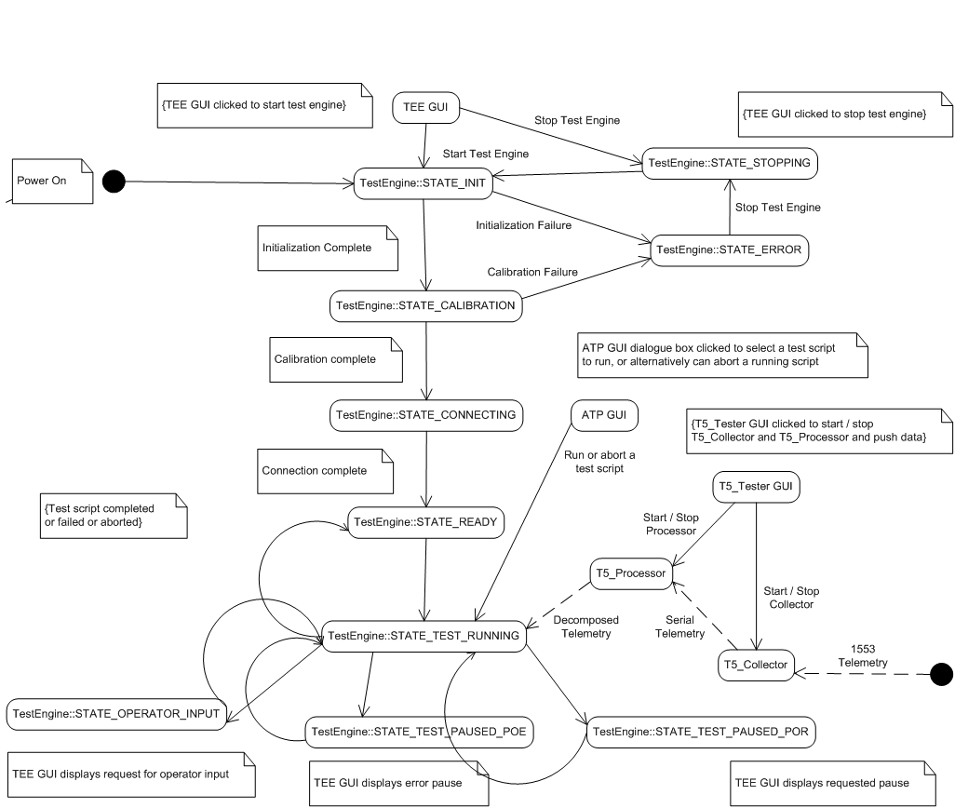

Figure 1 CSTS Functional Diagram

## Installation of TSW SIs

The SIQT STP requires that a clean installation of the Test Software SI be installed upon the respective target, be they MITE/MAR or NPEITE/TAR systems.

When performing a clean build all previous Test software, Cat 4 software tools, script files, mask data, and calibration data need to be removed and destroyed. This leaves a truly clean system. Once the system has been cleaned, it can then be repopulated with the correct software and data.

There are two areas of the Database that must be backed up so, they can be reloaded onto the test system after a clean install of the Test Software has been completed. The two areas are the mask data and the calibration factors. These two sections must be available in the Database during testing. The process by which the system is built is predominantly controlled by the standard build manager. The build manager uses software/data from the configuration management system to build the test environment. The build manager performs a number of standard steps. Note: The build manager is the same build manage used for the SIT Verification. The following steps are required to be performed:

1. Prior to running the build manager it is required to backup the existing databases for mask and calibration data from the previous STE environmental database. The build manager is selected by the user and build script is selected and used to initiate the build process. The build manager performs tasks in these general areas:
   1. Uninstalls the existing SIRN, destroys script and tool executables. This is performed using our installation build manager as part of our normal build process manager.
   2. Performs installation of NPE Test Software (TSW) SIRN 11796BE release.
   3. Performed an installation of test software (scripts, tool/utilities, test data and test vectors).
2. Obtain the LBCR build script and follow it for the installation of the LBCR SIRN 11853I_Secret.
3. The software SIRN 11796BE will establish both an empty mask and a calibration factors database tables following a new installation.
4. Execute the Test Deviation 2.4.1
5. Execute the scripts per the Software Test Plan procedures.

## Deviations at Start of Dry Run SIQT

### Deviation for Using Calibration Factor and Mask Databases for SIQT

The normal installation process leaves the STE with the correct installed software system but, the database is empty. A variation to the process will be required to allow the test team to populate some of the databases sections which will minimize the time required to get our system ready to run the SIQT activity.

In the previous sub section (on installing TSW Sis), it mentions the need for backing up two databases which will be needed during subsequent SIQT testing. These steps slightly depart from the normal test process because the normally process does not back up the data bases.

These backed up databases will be archived as part of our software SIRN release for SIQT. The backed up data bases will contain the calibration factors and mask database information available for SIQT testing. The SIRN used for the SIQT installation will contain non blank databases which is a variation from our normal process.

It will be required to backup the data in the database and also from the previous test activity database. The options below cover the back up and subsequent installation of database information.

Listed below are approach for the database backup and validation process:

1. Develop a series of SQL queries which will be used to create a backup copy of the Mask and calibration factors needed by the ITE system for SIQT.
2. The SQL script copies the mask and calibration factor data bases from the backup copy.
3. The SQL Script then takes the backed up mask and calibration information and populate the new mask and calibration database with this previously saved historical data.

The following subsection contains SQL commands to perform the reading and creation of the required to accomplish a database creation.

#### Database Script File Content Used to Implement the Deviation

The following text of this section is the contents of the SQL file which was used to perform the requested creation of the GPS-III to be used to create both the Mask and Calibration Facto databases. It takes respective databases for the

/**** This Script Will Copy Calibration and Mask data from an ****/

/**** Existing GPSIII Database to a newly created database ****/

-- Steps BEFORE Running Script

-- 1) Attach DESTINATION database with the name GPSIII

-- 2) Attach SOURCE database with the name GPSIII_Cal

-- Execute Script.. All Calibration / Mask Data in the GPSIII database

-- (tables listed below) will be DELETED and then the data COPIED from

-- The GPSIII_Cal database INTO the GPSIII database (tables listed below)

-- All copy actions are wrapped in a Transaction.. Any error will abort the

-- Update script and no changes will be committed.

--******* TABLES Copied *******

-- CalibrationFactor table

-- CalibrationFactor_Freq table

-- CalibrationFactorInterpolated table

-- CalibrationFactorList table

-- CalibrationFactorNames table

-- CalibrationFactorRaw table

-- CalibrationFactorTypes table

-- BE_MaskList table

-- BE_Masks table

USE [GPSIII_Cal];

GO

BEGIN TRANSACTION updateScript;

--####################################################################

--###### Process CalibrationFactor table

--####################################################################

Print 'Clearing Records In GPSIII.dbo.CalibrationFactor';

DELETE FROM GPSIII.dbo.CalibrationFactor;

Print 'Inserting Records Into GPSIII.dbo.CalibrationFactor';

INSERT INTO GPSIII.dbo.CalibrationFactor(CalibrationFactor_ID, Factor)

SELECT CF.CalibrationFactor_ID, CF.Factor

FROM GPSIII_Cal.dbo.CalibrationFactor CF;

Print CHAR(10) + CHAR(13);

--####################################################################

--###### Process CalibrationFactor_Freq table

--####################################################################

Print 'Clearing Records In GPSIII.dbo.CalibrationFactor_Freq';

DELETE FROM GPSIII.dbo.CalibrationFactor_Freq;

Print 'Inserting Records Into GPSIII.dbo.CalibrationFactor_Freq';

INSERT INTO GPSIII.dbo.CalibrationFactor_Freq(CalibrationFactor_ID, Frequency_Hz, MBW_Hz, Factor)

SELECT CF.CalibrationFactor_ID, CF.Frequency_Hz, CF.MBW_Hz, CF.Factor

FROM GPSIII_Cal.dbo.CalibrationFactor_Freq CF;

Print CHAR(10) + CHAR(13);

--####################################################################

--###### Process CalibrationFactorInterpolated table

--####################################################################

Print 'Clearing Records In GPSIII.dbo.CalibrationFactorInterpolated';

DELETE FROM GPSIII.dbo.CalibrationFactorInterpolated;

Print 'Inserting Records Into GPSIII.dbo.CalibrationFactorInterpolated';

INSERT INTO GPSIII.dbo.CalibrationFactorInterpolated (ParentCalibrationFactor_id, ChildCalibrationFactor_id, Frequency_Hz)

SELECT I.ParentCalibrationFactor_id, I.ChildCalibrationFactor_id, I.Frequency_Hz

FROM GPSIII_Cal.dbo.CalibrationFactorInterpolated I

Print CHAR(10) + CHAR(13);

--####################################################################

--###### Process CalibrationFactorList table

--####################################################################

Print 'Clearing Records In GPSIII.dbo.CalibrationFactorList';

DELETE FROM GPSIII_Cal.dbo.CalibrationFactorList;

SET IDENTITY_INSERT GPSIII.dbo.CalibrationFactorList ON;

Print 'Inserting Records Into GPSIII.dbo.CalibrationFactorList';

INSERT INTO GPSIII.dbo.CalibrationFactorList (CalibrationFactor_ID, CalibrationFactorName_ID,

CalibrationFactorType_ID, TestConfiguration_ID, CalibrationDate)

SELECT CF.CalibrationFactor_ID, CF.CalibrationFactorName_ID,

CF.CalibrationFactorType_ID, CF.TestConfiguration_ID, CF.CalibrationDate

FROM GPSIII_Cal.dbo.CalibrationFactorList CF;

SET IDENTITY_INSERT GPSIII.dbo.CalibrationFactorList OFF;

Print CHAR(10) + CHAR(13);

--####################################################################

--###### Process CalibrationFactorFactorNames table

--####################################################################

Print 'Clearing Records In GPSIII.dbo.CalibrationFactorNames';

DELETE FROM GPSIII.dbo.CalibrationFactorNames;

SET IDENTITY_INSERT GPSIII.dbo.CalibrationFactorNames ON;

Print 'Inserting Records Into GPSIII.dbo.CalibrationFactorNames';

INSERT INTO GPSIII.dbo.CalibrationFactorNames (CalibrationFactorName_ID, CalibrationFactorName)

SELECT N.CalibrationFactorName_ID, N.CalibrationFactorName

FROM GPSIII_Cal.dbo.CalibrationFactorNames N;

SET IDENTITY_INSERT GPSIII.dbo.CalibrationFactorNames OFF;

Print CHAR(10) + CHAR(13);

--####################################################################

--###### Process CalibrationFactorRaw table

--####################################################################

Print 'Clearing Records In GPSIII.dbo.CalibrationFactorRaw';

DELETE FROM GPSIII.dbo.CalibrationFactorRaw;

Print 'Inserting Records Into GPSIII.dbo.CalibrationFactorRaw';

INSERT INTO GPSIII.dbo.CalibrationFactorRaw (CalibrationFactor_ID, Raw)

SELECT R.CalibrationFactor_ID, R.Raw

FROM GPSIII_Cal.dbo.CalibrationFactorRaw R;

Print CHAR(10) + CHAR(13);

--####################################################################

--###### Process CalibrationFactorTypes table

--####################################################################

Print 'Clearing Records In GPSIII.dbo.CalibrationFactorTypes';

DELETE FROM GPSIII.dbo.CalibrationFactorTypes;

SET IDENTITY_INSERT GPSIII.dbo.CalibrationFactorTypes ON;

Print 'Inserting Records Into GPSIII.dbo.CalibrationFactorTypes';

INSERT INTO GPSIII.dbo.CalibrationFactorTypes(CalibrationFactorType_ID, CalibrationFactorType)

SELECT T.CalibrationFactorType_ID, T.CalibrationFactorType

FROM GPSIII_Cal.dbo.CalibrationFactorTypes T;

SET IDENTITY_INSERT GPSIII.dbo.CalibrationFactorTypes OFF;

Print CHAR(10) + CHAR(13);

--####################################################################

--###### Process BE_MaskList table

--####################################################################

Print 'Clearing Records In GPSIII.dbo.BE_MaskList';

DELETE FROM GPSIII.dbo.BE_MaskList;

SET IDENTITY_INSERT GPSIII.dbo.BE_MaskList ON;

Print 'Inserting Records Into GPSIII.dbo.BE_MaskList';

INSERT INTO GPSIII.dbo.BE_MaskList(BE_Mask_ID, Name, DateAdded)

SELECT L.BE_Mask_ID, L.Name, L.DateAdded

FROM GPSIII_Cal.dbo.BE_MaskList L;

SET IDENTITY_INSERT GPSIII.dbo.BE_MaskList OFF;

Print CHAR(10) + CHAR(13);

--####################################################################

--###### Process BE_Masks table

--####################################################################

Print 'Clearing Records In GPSIII.dbo.BE_Masks';

DELETE FROM GPSIII.dbo.BE_Masks;

Print 'Inserting Records Into GPSIII.dbo.BE_Masks';

INSERT INTO GPSIII.dbo.BE_Masks(BE_Mask_ID, Frequency_Hz, MBW_Hz, Spec)

SELECT M.BE_Mask_ID, M.Frequency_Hz, M.MBW_Hz, M.Spec

FROM GPSIII_Cal.dbo.BE_Masks M;

Print CHAR(10) + CHAR(13);

--####################################################################

--###### Script Completed

--####################################################################

COMMIT TRANSACTION- update Script;

Print 'Script Completed';

### Deviations Required for Recovery from Software Problems on a STE

During Dry Run testing the system might get into an unwanted state through a tester mistake or a random event which may necessitate a deviation of the procedures. To support a recovery from that problem a number of deviation scenarios have been anticipated as possibly being required. These are identified herein:

* Recovery of an MDU and STE from an Unknown State
* Recovery from a Hardware Change
* Steps to Take in Regression Testing a New Build
* Recovery Steps When System Cannot Enter Standard Codes
* Recovery Steps to Take in the Event of Having Missing Files

#### Deviation: Recovery of a MDU and STE from an Unknown State

This subsection describes what steps a tester should follow if the tester finds the MDDU or STE in some unknown state. These steps will be followed as our first attempt when a recovery from any unknown situation necessitates an initialization of the system.. Table 1 contains the steps the tester follows in this circumstance.

Table 2 STE Steps for Recovering from an Unknown State

|  |  |  |  |
| --- | --- | --- | --- |
| **What to do if the MDU and STE are in a bad/unknown state.** | | |  |
| **Steps** | **Execute** | **Pull Down Menu** | **Description** |
| **1** | Once logged into the AR, verify the services are up and running. If not, stop all three that are running and restart them. |  | The three services that need to be running are T5_Collector  T5_Processor.  GPSIII Test Engine |
| **2** | Once logged into the ITE, verify the services are up and running. If not, stop all three that are running and restart them. |  | The three services that need to be running are T5_Collector  T5_Processor.  GPSIII Test Engine |
| **3** | Make sure the Power Supplies in the MAR Rack are ON. PS70A and PS70B are the two Agilent N5748A instruments. MDU Side A and MDU Side B respectively. PS70B is located below PS70A on the MAR. Reference PS70_ is used which refers to either PS70A or PS70B depending on MDU side being tested.  Agilent N6701A front panel displays ON |  | Use the Agilent N6701A front panel display to view any information. On the power supply front panel display, the third row of the Multi-channel view should display ON for channels 1, 2 and 3. ON indicates the output is ON for that specific channel.  If the front display is dark, press the "Meter" key to illuminate the display. |
| **4** | Bring the T5-Tester up and verify telemetry is now available on the AR. | Click on 'Start Data Push' | Make sure all is Green and no Red. Open up the subscribe window and paste in the telemetry you desire to view. Telemetry should now be flowing. |
| **5** | Bring the T5_Tester up and verify telemetry is now available on the ITE. | Click on 'Start Data Push' | Make sure all is Green and no Red. Open up the subscribe window and paste in the telemetry you desire to view. Telemetry should now be flowing. |
| **6** | On the ITE bring up the ATP_Executive | Click on Open Script Button | Select the following scripts in order. You could queue them all at once if you wish to. |
| **7** | Utility_MDU_Power_OnOff.xts | Power Off True |  |
| **8** | Utility_MDU_Power_OnOff.xts | Power On (Config *) False | * represents the configuration you are presently in. |
| **9** | TSW_SIQT_ContinuousMonitor.xts |  | Select ON |
| **10** | MDU_ Configuration.xts | Power On (Config *) False | Nominal Testing |
|  | **Only if MDU is not responding use steps below** |  |  |
| **1** | Utility_MDU_Power_OnOff.xts | Power Off True |  |
| **2** | Utility_MDU_Power_OnOff.xts | Power On (Config *) False | * represents the configuration you are presently in. |
| **3** | TSW_SIQT_ContinuousMonitor.xts |  | Select ON |
| **4** | Utility_MDU_Reinitlization.xts |  |  |

#### Deviation: Recovery Steps to Take in the Event of a Hardware Change

This subsection describes what to do if the tester finds hardware changes to the test system. These steps should be followed as the first attempt to recovery from an unknown state. An initialization of the system is required if changes have occurred to any hardware component. The following Table 2 contains the steps the tester must follow in this circumstance.

Table 3 Initialization Steps in Event of Made Hardware Changes

|  |  |  |  |
| --- | --- | --- | --- |
| **What to do if nothing seems to be working or someone made some hardware changes or Power was interrupted.** | | | |
| **Steps** | **Execute** | **Pull Down Menu** | **Description** |
| **1** | Perform Hard Power Down all 3 of the LBCR's (FEP1, FEB2 & FEP_CTRL) |  |  |
| **2** | Make sure that the LBCR's are enabled. |  | In the Lab procedure (The LBCR's Idiot Guide) for bring up the LBCR's. Perform the section on "Process for Powering LBCR ON (or OFF)" page 7. |
| **3** | Perform Hard Power Down of ITE |  |  |
| **4** | Perform Hard Power Down of AR |  |  |
| **5** | Once back to the Login Prompt, Log into ITE PC |  | Wait for the McAfee and ITE_TE to appear. |
| **6** | Once back to the Login Prompt, Log into AR PC |  |  |
| **7** | Once logged into the AR, verify the services are up and running. If not, stop all three that are running and restart them. |  | The three services that need to be running are T5_Collector  T5_Processor.  GPSIII Test Engine |
| **8** | Once logged into the ITE, verify the services are up and running. If not, stop all three that are running and restart them. |  | The three services that need to be running are T5_Collector  T5_Processor.  GPSIII Test Engine |
| **9** | Make sure the Power Supplies in the MAR Rack are ON. PS70A and PS70B are the two Agilent N5748A instruments. MDU Side A and MDU Side B respectively. PS70B is located below PS70A on the MAR. Reference PS70_ is used which refers to either PS70A or PS70B depending on MDU side being tested.  Agilent N6701A front panel displays ON |  | Use the Agilent N6701A front panel display to view any information. On the power supply front panel display, the third row of the Multi-channel view should display ON for channels 1, 2 and 3. ON indicates the output is ON for that specific channel.  If the front display is dark, press the "Meter" key to illuminate the display. |
| **10** | Bring the T5-Tester up and verify telemetry is now available on the AR. | Click on 'Start Data Push' | Make sure all is Green and no Red. Open up the subscribe window and paste in the telemetry you desire to view. Telemetry should now be flowing. |
| **11** | Bring the T5_Tester up and verify telemetry is now available on the ITE. | Click on 'Start Data Push' | Make sure all is Green and no Red. Open up the subscribe window and paste in the telemetry you desire to view. Telemetry should now be flowing. |
| **12** | On the ITE bring up the ATP_Executive | Click on Open Script Button | Select the following scripts in order. You could queue them all at once if you wish to. |
| **13** | Utility_MDU_Power_OnOff.xts | Power Off True |  |
| **14** | Utility_MDU_Power_OnOff.xts | Power On (Config *) False | * represents the configuration you are presently in. |
| **15** | TSW_SIQT_ContinuousMonitor.xts |  |  |
| **16** | MDU_Configuration.xts |  |  |

#### Deviation: Steps Taken when Regression Testing a New Build

This subsection describes what to do if the tester finds that a regression test is necessitates a new build for changes to our test system. The steps will be followed as our first attempt when a regression test needs to be undertaken. The following Table 3 contains the steps the tester follows in this circumstance.

Table 4 Regression Steps for a New Build

|  |  |  |  |
| --- | --- | --- | --- |
| **What to do for Regression Testing of a New Build** | | |  |
| **Steps** | **Execute** | **Pull Down Menu** | **Description** |
| **1** | Log on to FEP2 | Start services | Wait till DOS window Prompt says 'Ready' |
| **2** | Log on to FEP1 | Start services | Wait till DOS window Prompt says 'Ready' |
| **3** | Log on to FEP_CTRL | Start services | Wait till DOS window Prompt says 'Ready' |
| **4** | Log into ITE PC |  | What for the McAfee and ITE_TE to appear. |
| **5** | Log into AR PC |  |  |
| **6** | On the ITE bring up the ATP_Executive | Click on Open Script Button | Select the following scripts in order. You could queue them all at once if you wish to. |
| **7** | AAAA_MDU_SET_Config_VAR_Utility.xts | Set MDUCONFIG to * False | Note: This script will "wake up" the LBCR. Measurements are OK, so just keep hitting continue to allow for the script to complete. * represents the configuration you are presently in. |
| **8** | Utility_MDU_ReInitialization.xts |  | Note: This is a soft reset of the MDU. |
| **9** | TSW_SIQT_MDU_Telemetry.xts |  | Note: This script verifies Status of the STE and MDU through Analyze TLM points. |
| **10** | Utility_RF_Assy_Manual_Control.xts |  | Note: This script will switch the RF signals to go from the SA to the LBCR instead. |
| **11** | Utility_NPE_LBCR_Diddle.xts |  |  |
| **12** | LBCR_Verification_with TTX.xts |  | Note: This script tests the Test Transmitter and LBCR functionality. While running on the TSW. |
| **13** | MDU_Configuration.xts | MDUConfig * False | Note: This does a hard reset of the MDU and also configures most of the instruments. * represents the configuration you are presently in. |
| **14** | TSW_SIQT_1553_Inject_All_Telemetry.xts |  |  |
| **15** | TSW_SIQT_Telemetry_Dump.xts |  | Note: This Dumps the contents of the entire diagnostic buffer that is stored. Content is used Later if needed. This script is run to confirm the function of the "DUMP" works by the TSW. |

#### Deviation Recovery Steps to Take When System Cannot Enter Standard Codes

This subsection describes what to do when the system cannot enter standard Codes for some reason. The follow steps will be followed as try to enter standard codes. The following Table 4 contains the steps the tester follows in this circumstance.

Table 5 Recovery Steps When the Systems Cannot Enter Standard Codes

|  |  |  |  |
| --- | --- | --- | --- |
| **What to do if you are not able to go into Standard Codes** | | |  |
| **Steps** | **Execute** | **Pull Down Menu** | **Description** |
| **1** | Log into ITE PC |  | What for the McAfee and ITE_TE to appear. |
| **2** | Log into AR PC |  |  |
| **3** | On the ITE bring up the ATP_Executive | Click on Open Script Button | Select the following scripts in order. You could queue them all at once if you wish to. |
| **4** | Utility_Send_AD_Upload.xts | Disable AD True | Note: Forces MDU to Ignore Standard Codes Anomaly Detection. |
| **5** | Utility_Set_NS_Codes_Off.xts** |  | Note: Forces Standard Codes On. This has to be run in conjunction with Step#4. |
|  |  |  | **Note: This cannot be run when executing standard/nonstandard codes Test, it will keep the MDU from reporting the loss of NS Codes. |
|  |  |  |  |
| **OPT.** | Utility_Send_AD_Upload.xts | Erase AD False | Note: Removes the Disable Uploaded Above. |
|  |  |  |  |

#### Deviation: Steps Taken in the Event of Missing Files

In the event that file is missing during the Dry Run SIQT the user must document the problem in a DR. The DR should document the information missing. Once the DR has been processed the tester can bring the missing file into the test configuration as a patch.

### Deviation

### Recovery Steps to Take When a Known Ste Hardware Based Issues Occurs (Based Upon Input from FC29227)

In the event that a known documented hardware problem occurs recovery steps for some of these problems have been defined. The following Table 5 contains the steps the tester follows in this circumstance. Each problem area is assigned a DR number, an issue summary description, a description of when the problem occurs, indicators of the issue and lastly a recovery procedure if one has been defined.

Table 6 Known Recovery Procedures for STE Hardware Issues

|  |  |  |  |  |  |
| --- | --- | --- | --- | --- | --- |
| **KNOWN STE Hardware ISSUES Derived from FC29227** | | | | | |
| **id** | **Headline** | **Issue Summary Description** | **How/When does the problem occur?** | **Key Indicators of Issue** | **Recovery Procedure - Step by Step** |
| GPS300002567 | STE 1553 Hardware needs occasional power cycle | The 1553 hardware is not completely stable and must be power cycled occasionally. | Intermittent. | Can occur in multiple scenarios on either 1553 Device independently: - (Red Bus) MDU Crosslink Transmit fails due to the MDU not putting out either a UHF or L3 message (because the event data never shows up at the MDU) - (Red Bus) MDU NDS BDP Commands fails due to either a GBD Ops Command or GBD Upload verification failing with error code -4 (timeout) - (Payload Bus) 1553 Serial Telemetry stops flowing to scripts, and cannot be restored by restarting either the Test Engine or T5 services. | QA Engineer required for this recovery: 1. Open right-side MAR rear door (right side when standing behind unit) 2. Stop MAR Test Engine Service. 3. If Red Bus affected, perform step 4. If Payload Bus affected, perform Step 5. If both affected do both steps 4 and 5, but one at a time. DO NOT DISCONNECT BOTH 1553 USB CABLES AT THE SAME TIME. 4. (Red Bus) Disconnect J14 USB cable and AC adapter on right side of rack, wait 15 seconds, and then reconnect first USB and then AC adapter. 5. (Black Bus) Disconnect J13 USB cable and AC adapter on left side of rack, wait 15 seconds, then reconnect first USB and then AC adapter. 6. Reconnect USB first, then AC adapter 7. Restart MAR Test Engine Service 8 Close STE and Reseal (QA) 9. Run “Utility_Continuous_Monitor_Start.xts” on MITE. 10. Verify that 1553 Payload Bus Telemetry is being published at the T5 Subscriber. 11. Verify the Agilent 34980A Multifunction Switch/Measure Unit (Data Acquisition System) is scanning and that Ground Telemetry is being published at the T5 Subscriber. 12. Re-run the test script that failed from the beginning, unless the FRB Huddle determines otherwise. |
| GPS300002578 | MDU RF Power Meter measurements need additional settling time for auto ranging | It appears that when a power sensor is required to switch between power ranges during the execution of a test script, the script may attempt to take the measurement before the range switch has occurred, and a script error results. | Intermittent, not seen in several months | Script failures caused by unexpected power meter errors. Two script errors that have been observed are:  • Failed due to "Data questionable; Input Overload ChB"  • Failed due to “Time Limit exceeded to complete Operation” | None anticipated. This has been resolved by a Power Meter firmware update – the issue has not been seen in 6 months.    If the issue does reoccur, the FRB Huddle process must be followed. |
| Table 7 Known Recovery Procedures for STE Hardware Issues   |  | | --- | | **KNOWN STE Hardware ISSUES Derived from FC29227** | | | | | | |
| **id** | **Headline** | **Issue Summary Description** | **How/When does the problem occur?** | **Key Indicators of Issue** | **Recovery Procedure - Step by Step** |
| GPS300001840 | 34980A Device Locked up on TAR | The Agilent 34980A Multifunction Switch/Measure Unit (Data Acquisition System) occasionally locks up. | Intermittent. The 34980A stops scanning. | The DAQ display stops changing. While in scan mode, the DAQ does not count down as expected. | It is possible that the 34980A may stop scanning without causing a script to fail. In this scenario, data would be lost, as "stale" telemetry would be sent to the database. To remedy this condition, the lab scorecard that the operators follow will include a check of the 34980A before the first script is run, and after each script is completed.  When it is discovered that the 34980A has stopped scanning during a script run or between script runs, the recovery procedure (after convening the Huddle) is the following: 1. Stop MAR Test Engine. 2. Press “Local” on 34980A. 3. Press and hold “Scan” on 34980 until the button’s backlight turns off. 4. Press “Scan” again. Light should turn back on and the unit should start scanning again. 5. Restart MAR Engine 6. Run Utility_Continuous_Monitor_Start.xts at MITE. 7. Verify the 34980A is scanning and that Ground Telemetry is being published at the T5 Subscriber. 8. Verify that 1553 Payload Bus Telemetry is being published at the T5 Subscriber. 9. Re-run the test script that failed from the beginning, unless the FRB Huddle determines otherwise. If the 34980A is found to be locked-up at the end of a script that has not failed, that script must still be re-run from the beginning, unless the FRB Huddle determines otherwise. |
| GPS300002865 | LBCR Does Not Run in the Background as a Service When Tester Logs Off | The LBCR is not a service, and therefore dependent on operator login. | The problem occurs when using the LBCR for tests with long duration. | The LBCR will stop functioning if the operator logs off. | None anticipated. The operator who starts a test using the LBCR must stay logged in until the test is complete. |
| Table 8 Known Recovery Procedures for STE Hardware Issues   |  | | --- | | **KNOWN STE Hardware ISSUES Derived from FC29227** | | | | | | |
| **id** | **Headline** | **Issue Summary Description** | **How/When does the problem occur?** | **Key Indicators of Issue** | **Recovery Procedure - Step by Step** |
| GPS300002843 | ATP Executive GUI Stops Populating with Script Run Information | Impacts only CSTS AU – DR was fixed in later SIRNs between AU and BC. | Intermittent. | ATP GUI does not update, but script still runs and prompts user through the TEE GUI. | 1. Terminate and restart ATP GUI only. 2. If step #1 is unsuccessful, terminate both ATP GUI and Test Engine service and restart. 3. If the Test Engine must be restarted, the test script will be aborted. Before the test script can be re-run, the following two utility scripts must be run:  a. Utility_Set_MDU_Config_Var.xts  b. Utility_Set_MDU_OpMode_Var.xts 4. If a Test Engine restart has aborted the test script, re-run the test script from the beginning, unless the FRB Huddle determines otherwise. |
| GPS300001372 | TSI causing High noise during TKS spurious between 12kHz and 10.224 MHz | High noise-level in MITE STE Test Signal Interface (TSI) drawer degrades measurement results. | TKS Spurious - between 12kHz and 10.224 MHz | Unexpected poor performance. | None anticipated.The ATP procedure has been revised to have the operator run the 10.23 MHz signal under test from the MDU directly into the 5120A Test Set during TKS Phase Noise testing. This manual cabling operation bypasses the TSI drawer completely. |
| GPS300002653 | NPE NDS BDP Commands and Crosslink Transmit issues (STE related) | This is a duplication of the Red Bus part of DR 2567 | See DR 2567 | See DR 2567 | See DR 2567 |
| Table 9 Known Recovery Procedures for STE Hardware Issues   |  | | --- | | **KNOWN STE Hardware ISSUES Derived from FC29227** | | | | | | |
| **id** | **Headline** | **Issue Summary Description** | **How/When does the problem occur?** | **Key Indicators of Issue** | **Recovery Procedure - Step by Step** |
| GPS300003178 | TEE displays Pause on Request/Pause on Error in SIRN AS special in Denver | TEE GUI status toggles between “Paused on Request” and “Paused on Error” during prompts. The status message does not interfere with the prompt, because it's at the bottom of the window. | Cosmetic issue – does not impact performance of SW or script. | Uninformed operators may think an error has occurred during a prompt when none actually occurred. | None anticipated. Ignore the GUI information – this can occur in CSTS AU, but is fixed as of AW.  The problem will be eliminated when the STE is updated to CSTS BC for Bin 2. |
| GPS300003364 | MAR T5 Collector stops when dump of MDU memory started by MITE | The Utility_Full_TKS_Buffer_dump script executes at the MITE. The dump telemetry process uses both the MAR and The MITE. The MITE does collect some telemetry, but the MAR T5 collector stops and so does the flow of dump data. | This has occurred on MITE/MAR #4, but has not been seen on MITE/MAR #2. The software team believes the issue to be fixed in SIRN 11796BB. | When the MAR T5 Collector stops, you no longer get TLM on the MAR or MITE. | Data Dump is only necessary when there is an issue and analysis is needed. Since this DR is related to a utility script used for analysis only, no recovery steps should be necessary to define ahead of time because the script would only be run in an FRB scenario.  Recovery: Log on to the MAR and restart the T5 Collector. |
|  |  |  |  |  |  |
| Table 10 Known Recovery Procedures for STE Hardware Issues   |  | | --- | | **KNOWN STE Hardware ISSUES Derived from FC29227** | | | | | | |
| **id** | **Headline** | **Issue Summary Description** | **How/When does the problem occur?** | **Key Indicators of Issue** | **Recovery Procedure - Step by Step** |
| GPS300003383 | LBCR Returns Bad Group Delay SW Measurements Intermittently | On 11/12/13 at the NPEITE in the Panel Lab, the Group Delay script was run and produced a bad result for one of the Software Type LBCR measurements. Specifically the L1P to L3CA measurement returned a value on the order of 500,000. A normal result is on the order of "-5". | Intermittent. | Software type LBCR measurements appear many orders of magnitude different from expected results. | Convene FRB Huddle to review the data and to determine if the magnitude of the outage indicates that the anomaly has reoccurred. Then proceed as dictated by the FRB Huddle.  The probability of this issue occurring during Flight MDU ATP is very low, because the issue has only been documented at the Panel (not at MDU-level). The issue was not repeatable. There is speculation that it may be attributable to an 8Hz drop-out, because the MDU on the Panel was an EDM. The Flight MDUs are not expected to have 8Hz drop-outs due to design improvements. |
| GPS300003328 | Exception thrown queuing same script back to back with different selection/filter made. | When queuing the same script twice with different selections and running them (as a batch), there was an exception. | When queuing the same script twice with different selections and running them (as a batch) | Exception thrown and script fails to execute. | None anticipated. Batching of scripts will not be employed during ATP testing. |
|  |  |  |  |  |  |
| Table 11 Known Recovery Procedures for STE Hardware Issues   |  | | --- | | **KNOWN STE Hardware ISSUES Derived from FC29227** | | | | | | |
| **id** | **Headline** | **Issue Summary Description** | **How/When does the problem occur?** | **Key Indicators of Issue** | **Recovery Procedure - Step by Step** |
| GPS300003316 | MDU Crosslink Transmit & Receive have bad rounding shown in the test report | The **SCRIPT** is applying the correct limits to the measurements, but the **DATA REPORT** is incorrectly displaying these limits due to rounding. For example, the Crosslink Receive Robust Code Offset lower limit of 4,337,515 should be displayed as 4.337515e+06, but the data report displays it as 4.33752e+06 instead. A data result of 4,337,516 would not be flagged as a failure in the data report, which is correct. However, a person reviewing the report might wonder why it wasn't flagged as a failure, because the lower limit shown on the data report is higher than 4,337,516. | Does not cause script failure – this is a cosmetic issue with the way the data report is generated; the actual values in the database are not rounded. | Uninformed individuals reading the test report can mistakenly think the script allowed a failing value to pass. | None anticipated. Inspection of measurement limits in script will show that the SW is performing/validating the measurement correctly, and the MDU Data Trending spreadsheet will show the true un-rounded values. |
| Table 12 Known Recovery Procedures for STE Hardware Issues   |  | | --- | | **KNOWN STE Hardware ISSUES Derived from FC29227** | | | | | | |
| **id** | **Headline** | **Issue Summary Description** | **How/When does the problem occur?** | **Key Indicators of Issue** | **Recovery Procedure - Step by Step** |
| GPS300003179 | OOBE script still runs with unpopulated mask data. | SW does not gate OOBE measurement evaluations on the presence of mask data in the database | Only occurs when no OOBE mask data present in STE database due to replacement of GPSIII DB (not known if archiving causes this as well, since we’ve never had to archive a GPSIII DB yet). | False PASS on testing. | None anticipated.The OOBE Mask file is under CM control and will be tagged as part of SIRN 11892 with scripts, MUBs, etc. The mask file will be loaded into GPSIII DB prior to the start of ATP. This step is documented in RWO 16289. A screen shot of the file's location in ClearCase is included in the RWO. |
| GPS300003373 | LBCR Data Capture does not work for Correlator Data | The LBCR Data Capture Tool is used to capture all the LBCR data buffers. It does not work for the correlation buffers. This is our primary analysis tool whenever there is a data issue. | Every time the Correlator outputs are selected from the Data Capture Tool. | Data Capture tool fails. | None anticipated. Data Capture of Correlator Buffers is only necessary when there is an issue and analysis is needed. This DR is related to a tool used for analysis only, therefore, no recovery steps should be necessary to define ahead of time because the tool would only be run in an FRB scenario.  In an LBCR-related failure does occur, the Raw Data Buffer Capture and Nav Recovery Buffer Capture Tools can be used for analysis. |
|  |  |  |  |  |  |
| Table 13 Known Recovery Procedures for STE Hardware Issues   |  | | --- | | **KNOWN STE Hardware ISSUES Derived from FC29227** | | | | | | |
| **id** | **Headline** | **Issue Summary Description** | **How/When does the problem occur?** | **Key Indicators of Issue** | **Recovery Procedure - Step by Step** |
| GPS300003399 | LBCR TTX setup - COM6 error | When trying to set up the test transmitter in the LBCR you can get a COMM 6 error | Seems to occur when attempts are being made by software commands for COM ports to be opened. In general, this happens if you make the request to open the ports twice. This occurred when running the MDU_LBand_Combined_Group_Delay with Auto Cal. It has happened twice in the last year. | System. Exception: Did not receive response after write on COM6  When trying to set up the test transmitter in the LBCR you can get a COMM 6 error. | 1. Shut down the LBCR PCs and TTX Hardware: a. Shut down LBCR Controller PC using the usual Start->Shut Down->Shut Down. Merely executing a Restart does not power down all the HW and may not clear the state. Shut Down will power-down the PC. b. Shut down FEP1 PC using the usual Start->Shut Down->Shut Down.  c. Shut down FEP2 PC using the usual Start->Shut Down->Shut Down.  d. Turn off the power delivered by the Agilent N6700B Power Supply by pressing the small On/Off button on the right-third of the power supply’s front panel.  e. Turn off the Digital Waveform Generator by turning off BOTH green toggle switched in the center of the unit. When off the switches are not illuminated. f. Turn off the RF Output delivered by the Agilent N5181A Signal Generator by pressing the small, grey switch (“RF On/Off”) on the extreme right edge of the front panel.   2. Turn the LBCR PCs and TTX Hardware back on:  a. Turn on the RF Output delivered by the Agilent N5181A Signal Generator by pressing the small, grey switch (“RF On/Off”) on the extreme right edge of the front panel. b. Turn on the Digital Waveform Generator by turning on BOTH green toggle switched in the center of the unit. When ‘on’ the switches are illuminated and the fans are running. c. Turn on the power delivered by the Agilent N6700B Power Supply by pressing the small On/Off button on the right-third of the power supply’s front panel. The display should show about 4.3 Volts for channel 1 and about 6 Volts for channel 2. On a STE with a crypto box, channels 3 and 4 should also show voltage. d. Turn on LBCR Controller PC by pressing the on/off switch on the front panel. e. Turn on FEP1 PC by pressing the on/off switch on the front panel. f. Turn on FEP2 PC by pressing the on/off switch on the front panel.  3. Restart the LBCR services in the usual way. |
| Table 14 Known Recovery Procedures for STE Hardware Issues   |  | | --- | | **KNOWN STE Hardware ISSUES Derived from FC29227** | | | | | | |
| **id** | **Headline** | **Issue Summary Description** | **How/When does the problem occur?** | **Key Indicators of Issue** | **Recovery Procedure - Step by Step** |
| GPS300003406 | LBCR Hardware Correlator Buffer Contains Incorrect Number of Waveforms | The LBCR normally receives 100 correlation waveforms for hardware data analysis. On occasion, the LBCR passes 200 waveforms to the MatLab analysis routines. | This error occurs randomly. | Code Power ratios are off by 6 dB. | None anticipated. The erroneous data point is logged, but the script continues. The script will fail if the erroneous result causes the average of 10 measurements to exceed the spec limit.  Upon failure, recalculate the average with the corrected data point and compare against the spec to determine Pass or Fail.  If the anomaly occurs without causing the average of 10 measurements to exceed the spec limit, recalculate the average with the corrected data point during the Data Review process. |
| GPS300003298 | LBCR FEP crashes for unknown reasons | It is sometimes observed that the FEP software "crashes," throwing an exception "Failed to configure clock distribution chip". This occurs when the software writes a configuration value into a register on the Nallatech board but finds a different value when it then reads back the value written. | Intermittent when starting the LBCR (happens more frequently on MM4) | The FEP software "crashes", throwing an exception "Failed to configure clock distribution chip". | 1. Shut down the LBCR PCs:a. Shut down LBCR Controller PC using the usual Start->Shut Down->Shut Down. Merely executing a Restart does not power down all the HW and may not clear the state. Shut Down will power-down the PC.b. Shut down FEP1 PC using the usual Start->Shut Down->Shut Down. c. Shut down FEP2 PC using the usual Start->Shut Down->Shut Down. 2. Turn the LBCR PCs back on:a. Turn on LBCR Controller PC by pressing the on/off switch on the front panel.b. Turn on FEP1 PC by pressing the on/off switch on the front panel.c. Turn on FEP2 PC by pressing the on/off switch on the front panel.3. Restart the LBCR services in the usual way. 4. Clean-up or recovery of script needs to be determined by the FRB uniquely for each occurrence of this outage. |
| Table 15 Known Recovery Procedures for STE Hardware Issues   |  | | --- | | **KNOWN STE Hardware ISSUES Derived from FC29227** | | | | | | |
| **id** | **Headline** | **Issue Summary Description** | **How/When does the problem occur?** | **Key Indicators of Issue** | **Recovery Procedure - Step by Step** |
| GPS300003441 | LBCR Matlab Returns Incorrect Phase Angle after Coherent Summation | The coherent summation section of the LBCR can return the wrong the quadrant for the phase angle after the summation. (It can be off by 180 degrees.) The current work around is to do the processing using software Correlator. | This occurs when running the Code Power Ratio Script | Two indicators show the problem: - The Lead Lag measurement looks correct, but has a sign flipped. - The In-Phase measurements are closer to 180 degrees instead of 0 degrees. | This is a Bin 2 DR.  The recovery steps will be determined by the FRB Huddle and may include repeating the measurement through the LBCR Private Interface. |

### Deviation Steps to Take I in the Event of Missing Files

In the event that file is missing during the Dry Run SIQT the user must document the problem in a DR. The DR should document the information missing. Once the DR has been processed the tester can bring the missing file into the test configuration as a patch.

### Deviation Steps to Taken to Configure Data Sets for Testing on NPEITE

When running test cases on the NPEITE test environment; a tester must follow a deviation in which is required to move a data set into the NPEITE from Clear Case. These are necessary because we are running on a separate environment located on a NPEITE.

Table 16 Deviation Steps to Install ITE/AR Data Set Files

|  |  |
| --- | --- |
| **Step** | **Steps To Install TSW SIQT ITE/AR Data Set SIRN files:** |
| **1** | Log on to the AR PC by entering your user name and password into the window box provided on the Monitor |
| **2** | Stop the TEE Engine by opening the TEE GUI if it is not already open, right clicking on the TEE icon on the bottom right tool bar. Select Stop Engine. |
| **3** | Log on to the ITE PC by entering your user name and password into the window box provided on the Monitor |
| **4** | Stop the TEE Engine by opening the TEE GUI if it is not already open, right clicking on the TEE icon on the bottom right tool bar. Select Stop Engine. |
| **5** | From the ITE OPEN Clear Case:  Create/Configure a Clear Case view to see only files that are labeled with the SIRN number **11989.** Files that have been labeled with this SIRN will be accessible in this view. |
| **6** | Copy/Paste **(SCRIPT)** files from Clear Case: \MITE\07_Integration_Testing\TSW_SIQT\FILES\MITE Script Directory TO: ITE C:\Documents&Settings\All Users\Application Data\ITT\GPSIII\Scripts  Copy/Paste files from Clear Case: \MITE\07_Integration_Testing\TSW_SIQT\FILES\MAR Script Directory  TO:  AR C:\Documents&Settings\All Users\Application Data\ITT\GPSIII\Scripts  Copy/Paste files from Clear Case: \NPEITE\07_Integration_Testing(SWI&T)\TSW_SIQT\Scripts TO: NPEITE C:\Documents&Settings\All Users\Application Data\ITT\GPSIII\Scripts TAR C:\Documents&Settings\All Users\Application Data\ITT\GPSIII\Config\Scripts |
| **7** | Copy/Paste **(MUB)** files from Clear Case: \NPEITE\07_Integration_Testing(SWI&T)\TSW_SIQT\MUBs TO: TAR C:\uploads  MITE\07_Integration_Testing\TSW_SIQT\MUBs TO: MAR C:\uploads |
| **8** | **Contact Network Admin for the following information for the ITE/AR**  Name of this STE :_____________________  Port the event broker will be hosted on:_____________________  Port that the EGSE TCIP port will listen on:_____________________  Remote SQL server DB for all data backup:_____________________  sync_time_domain name:_____________________  sync_time_interval:_____________________  hour= 0  minute= 10  Open on each STE: ITE/AR  C:\Documents&Settings\All Users\ITT\GPSIII\Config\TestEngine\EngConfig.xml  Update this file as per the data collected above. |
| **9** | Copy/Paste files from Clear Case:  \NPEITE\07_Integration_Testing(SWI&T)\TSW_SIQT\LBCR Files TO: LBCR(FEP_CTRL) C:\LBCR\Controller\Configuration  LBCRRxConfigurationNominalMITE.xml  LBCRRxConfigurationNominalNPEITE.xml |
| **10** | Return to the AR PC. Start the TEE Engine by opening the TEE GUI if it is not already open, right clicking on the TEE icon on the bottom right tool bar. Select Start Engine. |
| **11** | Return to the ITE PC. Start the TEE Engine by opening the TEE GUI if it is not already open, right clicking on the TEE icon on the bottom right tool bar. Select Start Engine. |
| **12** | Since the both Test Engines have been restarted, the following scripts must be run:  Utility_Enable_Continuous_Monitor Utility_Set_NPE_Config(4) (ONLY FOR NPEITE) Utility_Set_NPE_OPMODE (0) Utility_Set_NPE_Power_Variable (Boost) (ONLY FOR NPEITE) Utility_Set_Red_Bus_Side.xts (Side B) (ONLY FOR NPEITE) MDU_Configuration.xts (ONLY FOR MITE) |

## Conventions to Use During SIQT

This sub-section describes conventions to be followed the TSW Dry Run our team during TSW Dry Run SIQT. The team developed a number of conventions during the development of the test environments, script development and script execution activities.

### Redline and Black Line Conventions

#### Redline and Black line Process

Deviation when they occur will be assessed as allowable. Allowable deviations to approved test procedures are to be processed IAW SSD-SSD-2300-10-002 Rev B.

Minor corrections to the test procedures *can* be implemented by Exelis without Lockheed Martin pre-approvals. Minor corrections consist of, but are not limited to typos, spelling, and grammatical errors. The appropriate Lockheed Martin engineer should be informed of these updates during ATP testing.

Any other changes to the test procedure require Lockheed Martin approval of redlines. Changes consist of the following:

* Test Sequence Changes
* Parameter Changes
* STE substitutions
* deferring/bypassing data review as specified in the ATP
* stopping or starting ATP flow
* Retesting / de-mating UUT
* Any deviations from the TRR agreement

#### Red Line Process Steps

Red Lines to a Test procedure include Real-time changes for things like typographical errors, minor procedural errors, work-a-rounds, equipment substitutions or non-critical sequence changes. There are 4 required procedural parts to Redline Changes (to be done in order):

Part 1 – Modify Working Copy using red ink/font

* + Label with alpha-numeric identifier (when testing to revision “-” label first redline change -1, second -2, etc., when testing to revision A label first redline change A1, second A2, etc.)
  + Initial and date by the originator and Test Engineering (minimum 2 people)

Part 2 – List change in Document Change Record of Working Copy

* + Reference by alpha-numeric identifier and include brief description

Part 3 – Create / Update Hanging ECR

* + Create Hanging ECR with attached electronic/scanned copy showing Redline Change and / or a “from-to listing” to detail changes

Part 4 – Submit/Approve Hanging ECR

#### Black Line Process Steps

Black Lines to a Test procedure are One-time changes made to a Working Copy that apply only to a specific unit being tested

* + Black lining shall be documented via the same basic process as redlines (marked in same manner with alpha-numeric identifier, using a Hanging ECR and with the same approvals)
  + Black ink/font shall be used to modify the Working Copy and the black-line shall be clearly labeled ”Black-line Change – not incorporated” on the Hanging ECR and on the Test Procedure Document Change Record sheet

Black-line changes shall NOT be incorporated into next revision

#### Additional Redline Process Guidance

CAUTION: Extreme care must be taken when using redlines. Upon completion of test all redline changes must be formalized and approved. **Any redlines not approved at that time are considered unacceptable and any testing per those unapproved redlines is considered null and void.**  If there is any doubt a redline would be approved, it should be initialed additionally by appropriate subject matter experts (same functional groups that approved procedure) prior to executing changed steps or else treated as a Major Change.

To help reduce anticipated down time and expedite Lockheed Martin approvals of redlines during ATP a call down contact list of Lockheed Martin approvers can be made available to the test operations team in advance of ATP start up.

### ITE AR Convention

During SWIT Exelis developed certain conventions which instruct the test operator on how execute a review of artifacts from a test execution. An analyst will occasionally see and make references to this document to provide guidance on how to proceed. References to ITEs and ARs may be somewhat confusing to new reviewers of our artifacts. When a user sees such terminology in our artifacts we ask them to associate the two terms as follows:

* For the term ITE associate it with MITE or NPEITE system type systems
* For the term AR associate it with MAR or TAR type systems

### Test Procedure Execution Order Convention

All test procedures and scripts will be run in order from top to bottom. So we will run from Test Case 1 down through 6 in order. The scripts which make up the sub cases will in turn be executed in sequence.

### Follow the Test Capture Process Convention

All test procedures and scripts will be run in order from top to bottom. But just as importantly the tester is strongly encouraged to follow the specific instructions in the test procedure when executing a test. This may seem to be obvious but follow direction as written.

## MITE MAR TSW SWIT/SIQT Results Capture Steps

This sub-section describes steps to be followed during TSW SIQT Dry Run where our team needs to properly capture test result information. The team developed a number of conventions and instructions during the development of the test environments, script development and script execution activities. These instructions should be followed scrupulously. Execute all tests in the sequence dictated by our procedures. Execute each individual test as directed in our procedures. After test finishes, follow the steps below to capture the test results. Follow instructions to run a test.

Table 17 SIQT Capture Steps

|  |  |
| --- | --- |
| **Step** | **MITE MAR TSW SWIT/SIQT Results Capture Steps** |
| 1 | In the test procedure book, write name of test run and SID #. |
| 2 | Open Windows explorer, traverse to directory <Storage_Dir>, under the relevant Test Case (TC1 to TC5) create a directory for the particular test section (e.g., 7_1_2_1_1) and under that create a directory named SID<#> where <#> is the SID number resulting from test run. This SID#### directory is the location of saved test result logs for the current test. |
| 3 | If test report is displayed, export the report as Excel file and save it in SID#### directory. If a report is not displayed, then open the report from ATP Executive pull-down menu of Reporting > Open Reporting Server. Save this result with the default name of ScriptsResults.xls in the SID#### directory. If multiple scripts are run and if results are saved under the same directory, this file should be saved as ScriptsResults_####.xls where #### is the SID number. |
| 4 | In MITE PC, copy log files ITT_Debugging.log from <Logs_Dir> directory to SID#### directory, rename as ITT_Debugging_MITE.log. If the test verifies a DR fix, it is best to add comment (e.g., DR #) when checking in this log file. If the log expands to more than one log file, then save all the log files. |
| 5 | Copy XTSHistory.log and XTS_Filtered.xml files from <XTSHistory> directory SID#### directory. Note: XTS_Filtered.xml needs to be captures prior to next test run as it contains only data from the latest test run. |
| 6 | If verifying Discrepancy Report (DR) fixes with test run, consider capturing relevant screen capture and place in SID#### directory also. |
| 7 | In MAR PC, copy log file ITT_Debugging.log from <Logs_Dir> directory to  SID#### directory , rename as ITT_Debugging_MAR.log. |
| 8 | At the end of the test operator’s shift, copy all the log files saved during that shift and check them into ClearCase under directory <CC_Dir>.  Perform the following steps:   1. Open ClearCase explorer. 2. Copy log files into <CC_Dir>. 3. Select the (view-private) files from previous steps, and   Right-click and “add to source control”.  Note: May need to rename files with extension .log to be extension txt if having trouble checking .log files into ClearCase.} |
| 9 | At the end of the day, copy the logs from <CC_Dir> into \\gpssrv\LM share for Lockheed Martin. |
| 10 | If the test involves LBCR, capture the LBCR logs per instruction from LBCR User’s Guide. |

### Results Capture Steps Data Locations

This table in the previous subsection contains narrative mnemonics substituted for directory path names. Below are the three definitions for these file name mnemonics

<Storage_Dir> //gpssrv/data/GPSIII/TSW SIQT Dry Run/Results (inside has TC1 to TC5)

<Logs_Dir>: C:\ Documents and Settings\All Users\Application Data\ITT\GPSIII\Logs

<XTSHistory>: C:\ Documents and Settings\All Users\Application Data\ITT\GPSIII\ XTSHistory

<CC_Dir>: MITE\07_Integration_Testing\Results\Dry Run\

### Results Capture Steps Log Sample Directory Structures

The following Figures 2 provides sample directory structures. They show sample directories and file types which will be produced during our testing as well as their respective locations.

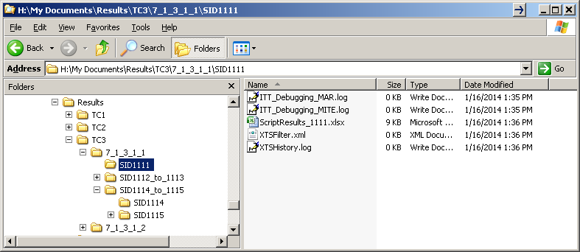

## 

## 2.7 LBCR Instructions

**Process for Powering LBCR On (or OFF)** 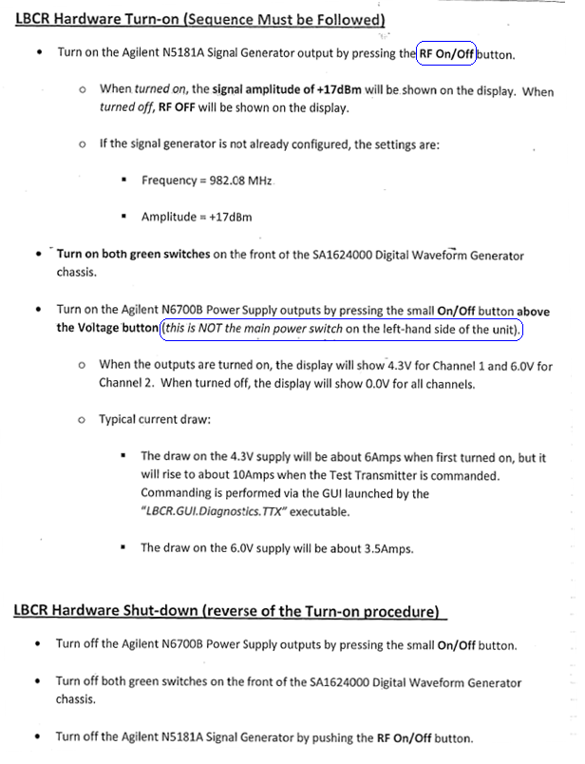

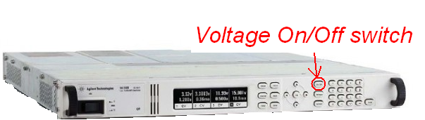

Power Supply

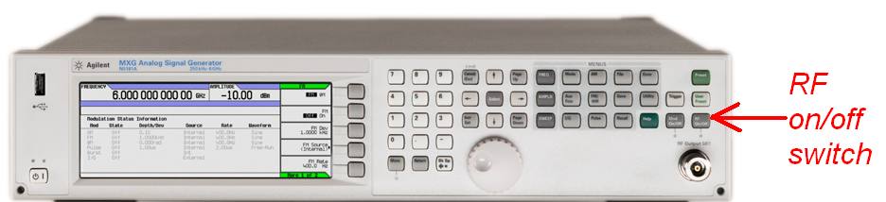

RF Signal Generator

### 2.7.1 How to Start LBCR SW

1. Log onto FEP1. (If logging on remotely, some machine’s node names are listed below. Check that these are still correct before using them.)

**Target type | Controller Name | FEP1 Name | FEP2 Name**  
"MITE1" : ["MITE", "SSDNJLBCR_CTRL", "SSDNJ4R7LSL1", "SSDNJLBCR_FEP2"]

"MITE3" : ["MITE", "SSDNJ5KNHSL1", "SSDNJ9KNHSL1", "SSDNJ1R7LSL1"]

“MITE4” : [“MITE”, “LBCR4_CTRL”, “LBCR4_FEP1”, “LBCR4_FEP2”]  
"NPEITE1" : ["NPEITE", "SSDNJ9R7LSL1", "SSDNJ8K6LSL1", "SSDNJ5R7LSL1"]  
"NPEITE2" : ["NPEITE", "FEP_CTRL_NPE", "FEP_1_NPE", "FEP_2_NPE"]  
"NPEITE3" : ["NPEITE", "SSDNJ7K6LSL1", "SSDNJHJNHSL1", "SSDNJBK6LSL1"]  
“NPEITE5” : [“NPEITE”, “USCLF22KHNSL1”, “USCLF28KNHSL1”, “USCLF2HZSQPS1”]

1. Open Explorer; navigate to c:/LBCR
2. Either:
   1. Click on shortcut to manually start the FEP’s ServiceManager service
   2. Navigate to C:\LBCR\FEP\LBCR.Service.ServiceManager and click on LBCR.Service.ServiceManager.exe (being sure you are selecting the executable and not the configuration file).

Observe DOS shell open and service start.

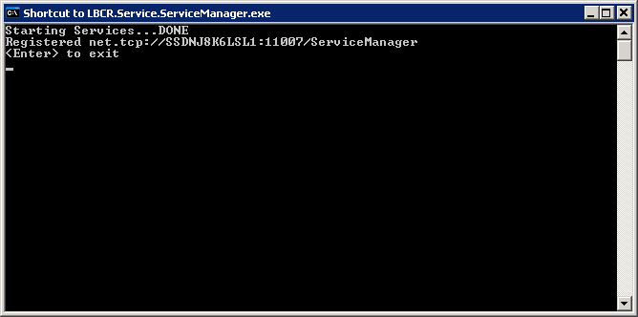

1. Log into and repeat steps for FEP2.
2. Log onto LBCR’s Controller, open Explorer, and either:
   1. Navigate to c:/LBCR and click on shortcut to start ServiceManager (ServiceManager.exe)   
      or, if no shortcut was created,
   2. Navigate to c: /LBCR/Controller/ LBCR.Service.ServiceManager and click on LBCR.Service.ServiceManager.exe (being sure you are selecting the *executable* and not the configuration file – configuring file explorer to show file extensions makes this error less likely).

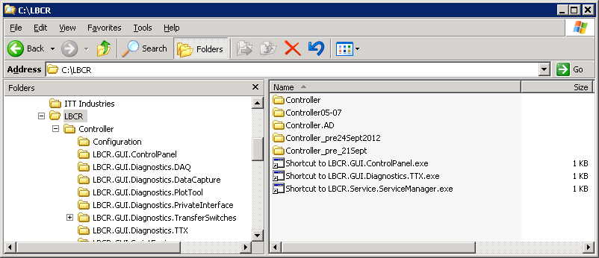

1. Observe DOS shell open and service start.

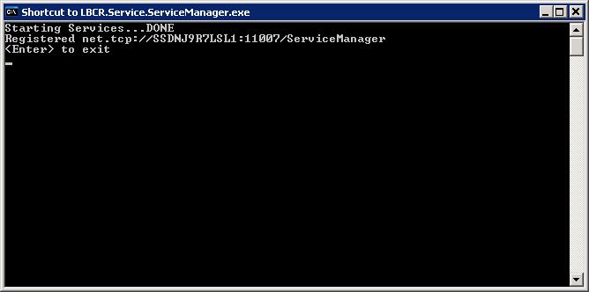

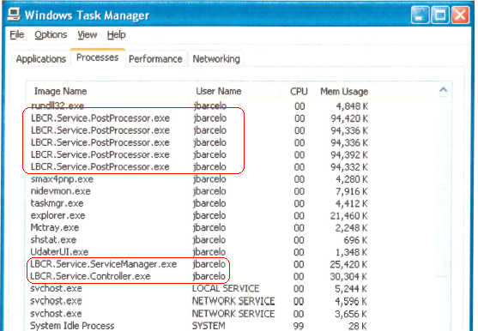

(Optional) In task manager observe the associated processes start.

1. Click on shortcut to start GUI.Diagnostics.TTX (GUI.Diagnostics.TTX.exe)  
   Observe GUI window open.

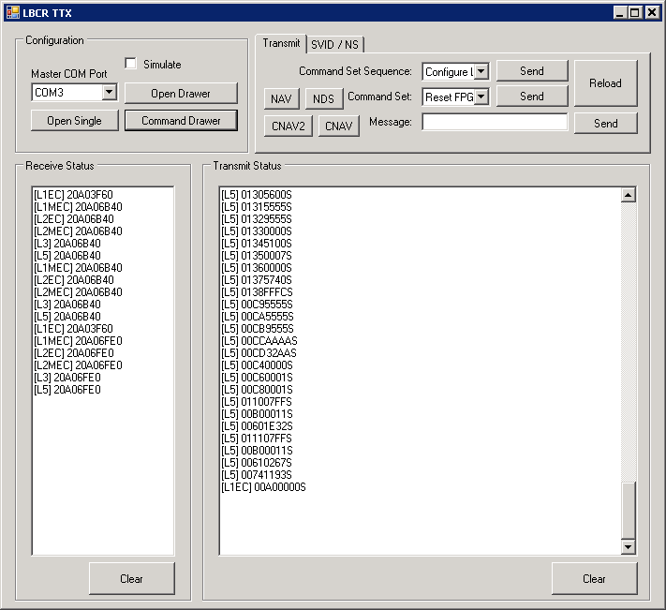

1. Verify Master COM Port is set to **COM3**.
2. Click on **[Open TTX Drawer]**
3. Click on [**Send**] associated with Reset FPGA.
4. Click on [**Command Drawer**]
5. Configure as needed (nominal setting is shown below) and click [**Command**].
6. Click on [**Close**].

Nominal is:

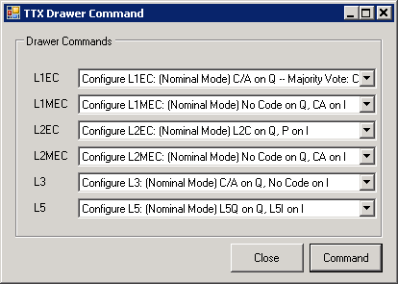

Optionally: On a crypto system, if the user needs to see LxM codes:

* Set L1MEC to Configure L1M – Mode 0 – Nominal setup.
* Set L2MEC to Configure L2M – Mode 0 – Nominal setup. No Data – No setup released.

Here’s an extract from the code power use case:

|  |  |  |  |  |  |  |  |  |  |  |  |  |  |  |  |  |  |  |
| --- | --- | --- | --- | --- | --- | --- | --- | --- | --- | --- | --- | --- | --- | --- | --- | --- | --- | --- |
| Mode # | Description | L1EC | | | | L2EC | | | L5 | | L1MEC | | | | L2MEC | | | L3 |
| C | C/A | P(Y) | M | L2C | P(Y) | M | I | Q | C | C/A | P(Y) | M | L2C | P(Y) | M | C/A |
| 1 | GPS III Nominal | X | X | X |  | X | X |  | X | X |  |  |  | X |  |  | X | X |
| 2 | GPS III Code Flex 1 |  | X | X |  | X | X |  | X | X | X |  |  | X |  |  | X | X |
| 3 | GPS III Code Flex 2 | X |  |  | X |  |  | X | X | X |  | X | X |  | X | X |  | X |
| Note: L1C has L1Cd and L1Cp code components | | | | | | | | | | | | | | | | | | |
| Note: L2C has L2CL and L2CM code components | | | | | | | | | | | | | | | | | | |
| MITE Configuration: L1EC Data, L2EC Data, L5 Data, L1MEC Data, L2MEC Data, L3 Data | | | | | | | | | | | | | | | | | | |
| NPEITE Configuration: EC Composite (L1EC, L2EC, L5), MEC Composite (L1MEC, L2MEC), L3 Data | | | | | | | | | | | | | | | | | | |

1. Manually start Control Panel service: in explorer window either
   1. click on shortcut for **LBCR.GUI.ControlPanel.exe** , or
   2. Navigate to c: /LBCR/Controller/ LBCR.GUI.ControlPanel and double click on **LBCR.GUI.ControlPanel.exe.**
   3. Observe Control Panel window open.

Below is a view of the Control Panel at a later stage – don’t expect to see Controller, DAQ1 & DAQ2 or messages immediately upon opening.)  
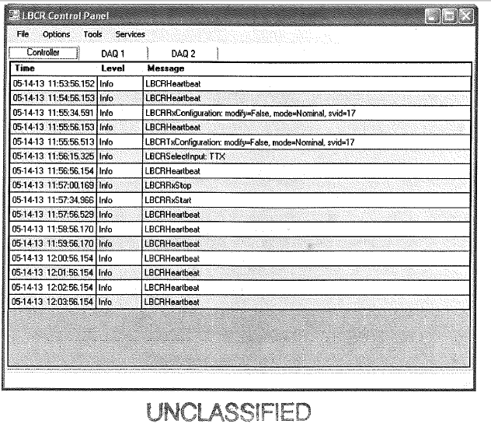

### 2.7.2 How to View LBCR Correlator Plots

1. At the Control Panel, select **tools->correlation plots**
2. Check [**Auto**].
3. On NPEITE click **NPEITE Nominal**. On MITE click **MITE Nominal**.
4. Observe Correlation plots as shown below.

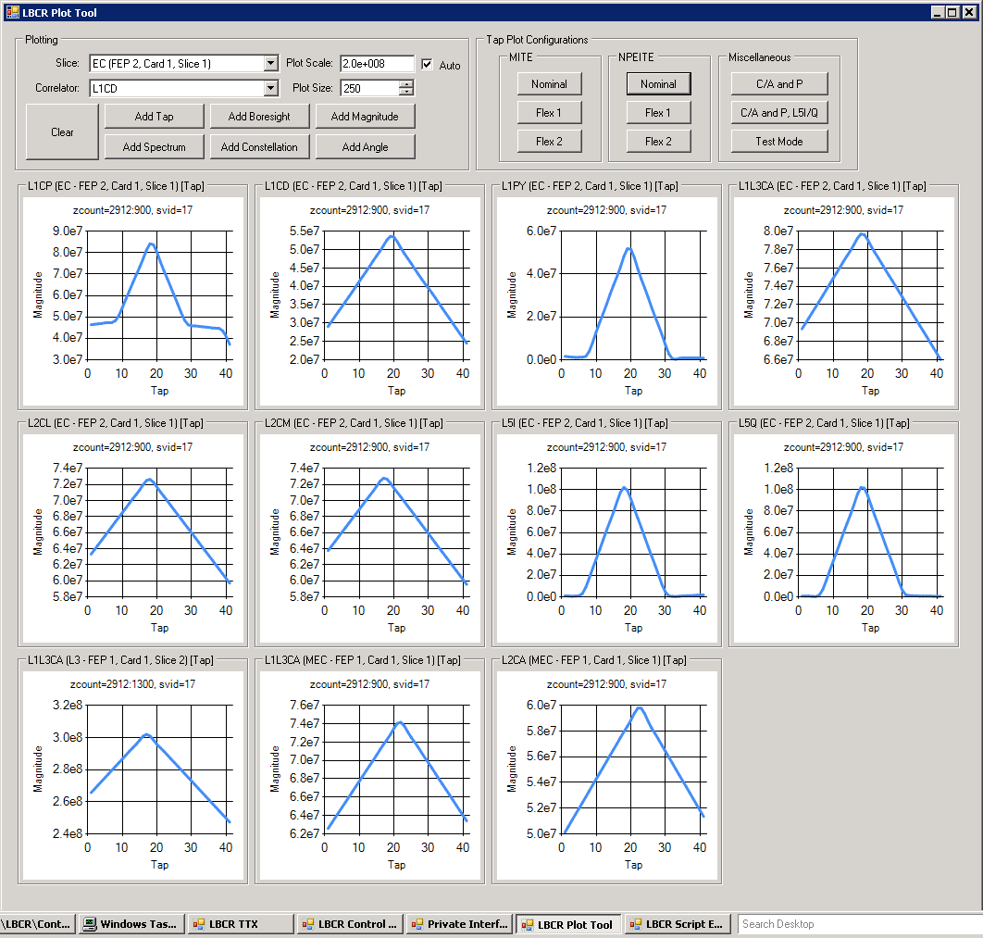

### 2.7.3 How to Save LBCR Log Files

Saving log files on the LBCR is a manual step. Logging occurs in the Control Panel window, so one prerequisite is that the user brings up the control panel on the LBCR after starting the services. The steps are listed below:

1. Start service on each FEP.

Once running (indicated by three lines of output on the DOS window)…

1. Start service manager on the FEP_Controller (a.k.a. LBCR Controller)

Once running (indicated by three lines of output on the DOS window)…

1. Start the Control Panel.

Once up, begin tests that need to be logged.

1. To save LBCR logs following test, perform the following steps:
   1. In the Control Panel, select **File**
   2. Select **Save Logs**
   3. In the pop-up window, select or create a directory in which the multiple LBCFR log files will be written.
   4. Using Windows Explorer, observe files in specified directory.
2. Note that the act of saving files creates a snapshot of what has been logged to the Control Panel to date. IT does not start a logging process that continually updates the files on disk.

If you click on Save Logs a second time, the first log files will be over-written with later logs that contain a superset (T=0 to T=time of click) of the material originally logged.

# Post SWIT Procedure Issues list Data.

This section synopses the open issues raised by the Exelis team and customers during their reviews of the test results and data. The following table identifies our Post SWIT Issues List. The column labeled Issue Status is used to try document some situational information as to the closure of the issues identified.

Table 18 Post SWIT Issues by Sub Case

| Test Section | Issue Status |
| --- | --- |
| OVERLAP SECTION | |
| 7.1.4.1.2 | The DR was never opened and therefore no change to a script was done. Based upon discussion with technical management there will be no impact to TSW Dry Run SIQT. |
| 7.1.4.1.2 | The o FSW check for it is commented out in FSW test script. FSW M-code is not ready. Per the a discussion with the technical team there will be no impact to TSW Dry Run SIQT |
| Aero Data Review | |
| TSW | These cited messages found in the history log files are expected warning messages. These warnings have been determined not to affect either TSW SIQT or FSW. |
| General | Test procedures are written to keep the user within a certain hardware contexts. Each procedure indicates to a tester the system (MITTE or MAR) used in running the procedure. The user should examine the debug file located on the hardware. This has been determined not to affect either TSW SIQT or FSW. |
| General | While there is a de-synchronization between the script filename and the results filename file name. Our analysis indicates that this has no impact on the results of the test. This has been determined not to affect either TSW SIQT or FSW. |
| General | Our test process has our scripting environment capture the historic log file to a known directory. This enables us to make sure that no data is lost or modified. This issue has been determined not to affect either TSW SIQT or FSW. |
| General | The messages cited are expected responses and not errors. Our logging system has the ability to notify the user at five different levels. This constitutes a warning or an informational message about the status and is not considered errors. This issue has been determined not to affect either TSW SIQT or FSW. |
| General | We capture the core data as it is acquired. The core data is not extracted by any editing process. Scripts file execution produce only those files they need on a case by case basis. As such it is not required for all tests to produce a Mar and will only be created when explicitly specified in a script file. This issue has no impact on TSW SIQT. |
| 7.1.1.1.5 | All software revision information is available through various means. The script information is recorded in a SIRN designation and is witnessed during installation. Additionally a script returns the MDU flight software information n two pieces a build number and a hash value which constitute its information. The TEE GUI returns the TSW SI version information. So we meet this requirement by returning data for all three SIs. This issue has been demined not impact upon TSW SIQT. |
| 7.1.1.1.5 | As stated in the previous issue we do provide sufficient information to discern that the proper FSW Si item is installed. The test is not meant to be a validation of the MDU complete configuration. This issue does not impact upon TSW SIQT. |
| 7.1.1.1.5 | Testers receive the version and hash information for verification against test information. Recorded information from the MFU is considered beyond this testing and has been determined to not impact TSW SIQT. |
| 7.1.2.2.1 | In this document we describe a convention where this issue is discussed please look in sub section 2.5.This has been determined not impact TSW SIQT. |
| 7.1.3.3.3 | The simulator reference found is not a reference to a “simulation mode” but a reference to an actual piece of hardware in the STE (instead of a piece of the MDU). This has been determined not impact TSW SIQT. |
| 7.1.3.4.1 | In the context of this test we are not concerned with the value of the data. We are verifying that a function was called and return completed. The fact that the data is masked with “0” is acceptable. This has been determined not impact TSW SIQT. |
| 7.1.4.2.1 | Researched as part of the subsequent issue. TLM #79 is NOT classified.  The comment was incorrectly made at the time. It is more than two years outdated. The issue has been corrected but the script was not updated. This issue has no impact on TSW SIQT. |
| 7.1.4.2.3 | The comment in the description does not match the error observed. So we cannot comment since the comment is not self consistent. This issue is determined not to affect TSW SIQT. |
| 7.1.4.3.2 | No only newer versions going forward are supported will have the appropriate nit setting. This has been determined to not have an impact upon TSW SIQT. |
| 7.1.4.3.2 | This is a known result and an acceptable error due to an early technique used in uploading MUB information. As such it is a vestigial result. This issue does not impact TSWW SIQT. |
| 7.1.4.3.5 | This response presupposes that the comment is based upon data related to a telemetry message. There are standard techniques for the recovery of data with its expected response times. This expectations cause the repeated sequence of messages until an expected messages result is found is found. This issue does not impact TSWW SIQT. |
| 7.1.4.3.5 | This is a known acceptable result and an acceptable error due to an early technique used in uploading MUB information. As such it is a vestigial error and result. This issue does not impact TSWW SIQT. |
| 7.1.4.3.5 | The power meter has a Calibration factor insertion to offset measurements for unbiased by cable losses qualitative measurements. This script was copied from MDU ATP in order to exhibit functionality which the software must provide and exhibited the correct functional behavior. This issue does not impact TSWW SIQT. |
| 7.1.4.3.5 | The script was investigated and found to be overcome by events. The comments made were here prior to the TSW software’s modification to apply the applications of automated calibration factors. This issue does not impact TSW SIQT. |
| 7.1.4.3.5 | No it’s a qualitative setting that does affect the result. The referenced DR was void/cancelled. The DR references DR1727. DR 1727 is validated and the controls for the FAS are core functionality for the MDU configuration scripts. The comment is no longer valid and may be ignored. This issue does not impact TSW SIQT. |
| 7.1.4.3.5 | No the referenced DR is closed so the comment is no longer valid and may be ignored. This will have no impact to TSW SIQT. |

# Post SWIT Deficiency Report Data.

This section identifies the DRs against the NPE TSW. The lists of DRs are cataloged in Figure 5 through 9. The figures show all DRS against the TSW software. They also show any deferred DRs that were deferred with LM concurrence. These figures are derived from the TRR presentation. The last table of this section summarizes DRs which were not part of the DR presentation but were call DR Assignments to Events. This last table is being tracked by the process group.



Figure 2 Open and/or Postponed DRs



Figure 3 Opened or Postponed DRs (Enhancements)



Figure 4 DRs Held for Delta SIQT with LM SCCB



Figure 5 DRs Deferred for SIQT with LM SCCB Concurrence



Figure 6 Other DRs

Table 19 SIQT Dry Run DRs (Not Part of TRR)

|  |  |  |
| --- | --- | --- |
| DR | DR Short Title (Headline) | Severity |
| GPS300003474 | Running Key Supersession Unit Testy Script Causes LBCR Controller to Throw | 4-Enhancement |
|  |  |  |
|  |  |  |
|  |  |  |
|  |  |  |