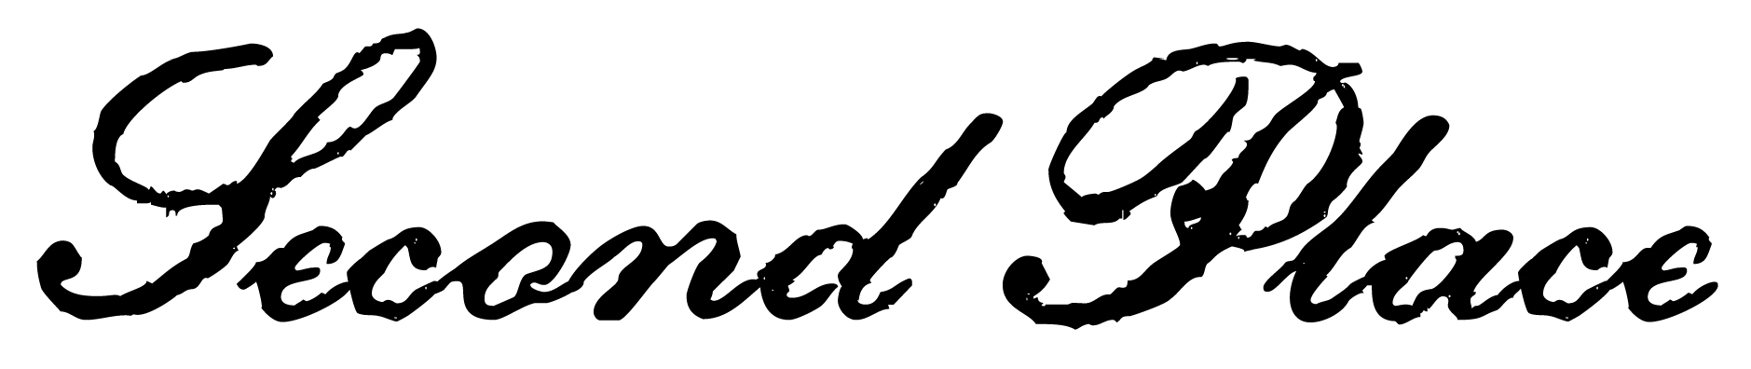
this certifies that
addison blake
has been awarded second place in the
Adam elementary spelling bee


___________________
Date
___________________
Signed

