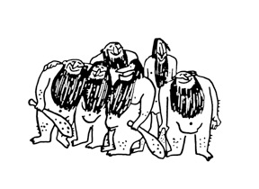

Rochester DX Association



This certificate of recognition and appreciation is presented to

Ed Gable K2MP
_________________________________________

For outstanding generosity and dedication to The RDXA in providing

a presentation for the club meeting on the below date

The above named is also awarded a 1 year membership in the RDXA

____________________________ _________________________
RDXA President Date

____________________________ _________________________
RDXA Membership Chairman Date

