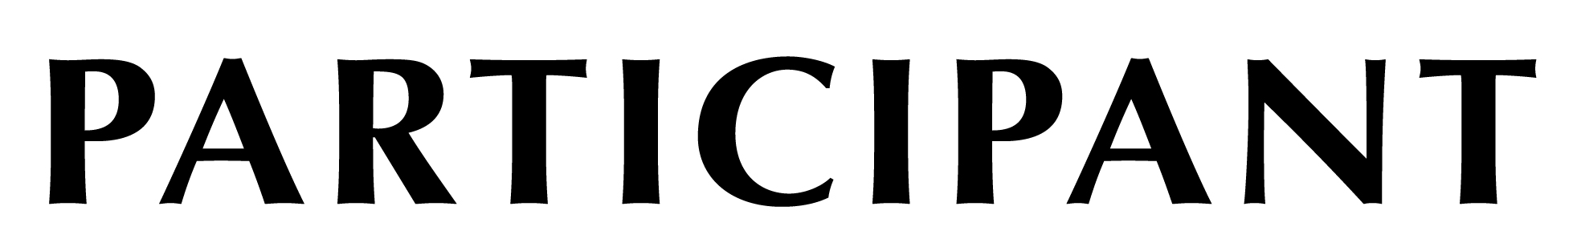

This certifies that

Kelly Nygard & “Maggie”

have participated in

Puppy Obedience Training – I

K-9 Corner Obedience Center

Cleveland, OH

