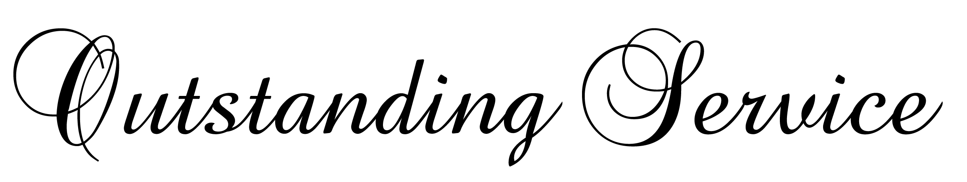
in honor of your outstanding performance and dedication
we gladly present

William M. Taylor

with this certificate of recognition for your high standards of excellence in

Product Sales Management

________________________ ______________________
Paul K. Norman Martha Wilhom
District Manager Corporate Sales

