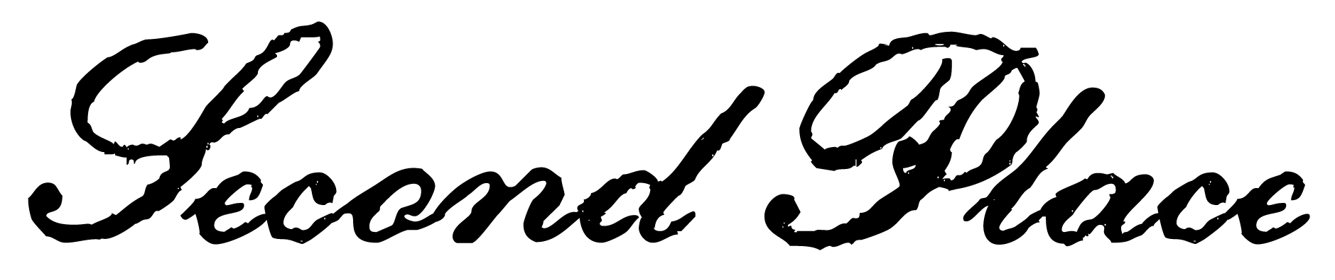
this certifies that
isabell johnson
has been awarded first place in the
Adam elementary spelling bee

___________________ 
Date
___________________
Signed

