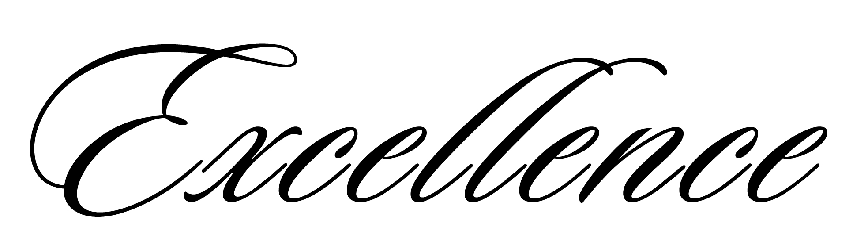

We express our sincere appreciation to

WILLIAM M TAYLOR

In recognition of your personal commitment,

dedication, and performance.

_____________________________ ______________________________
Paul K. Norman, Store Manager Martha Wilhom, District Manager

