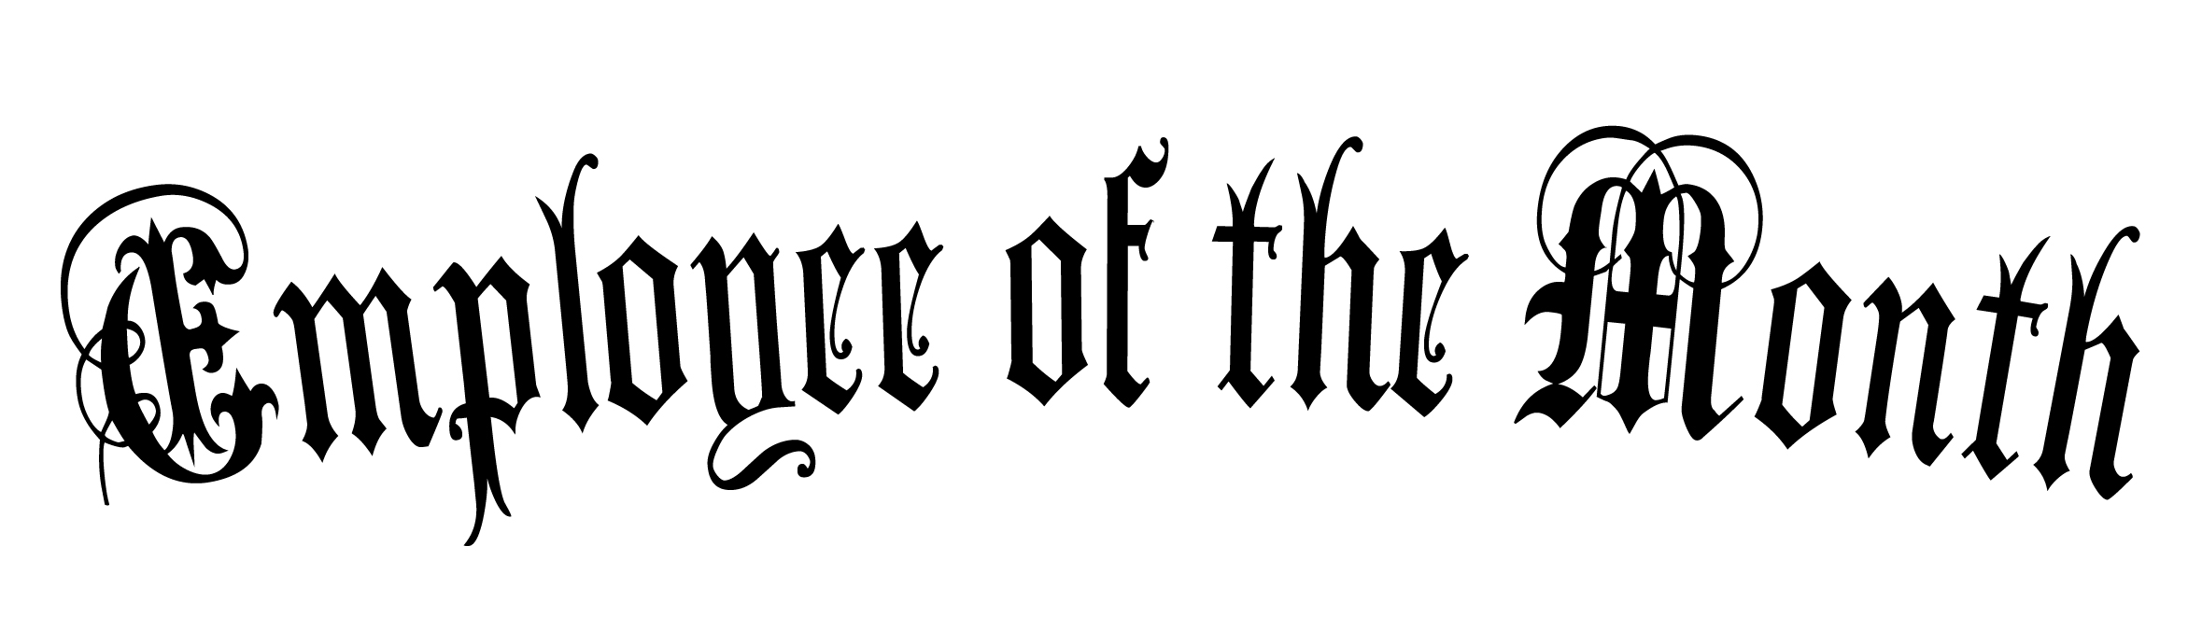
Awarded to

WILLIAM M. TAYLOR

for your outstanding work ethic

___________________________ _________________________
Paul K. Norman, Manager Martha Wilhom, Owner

