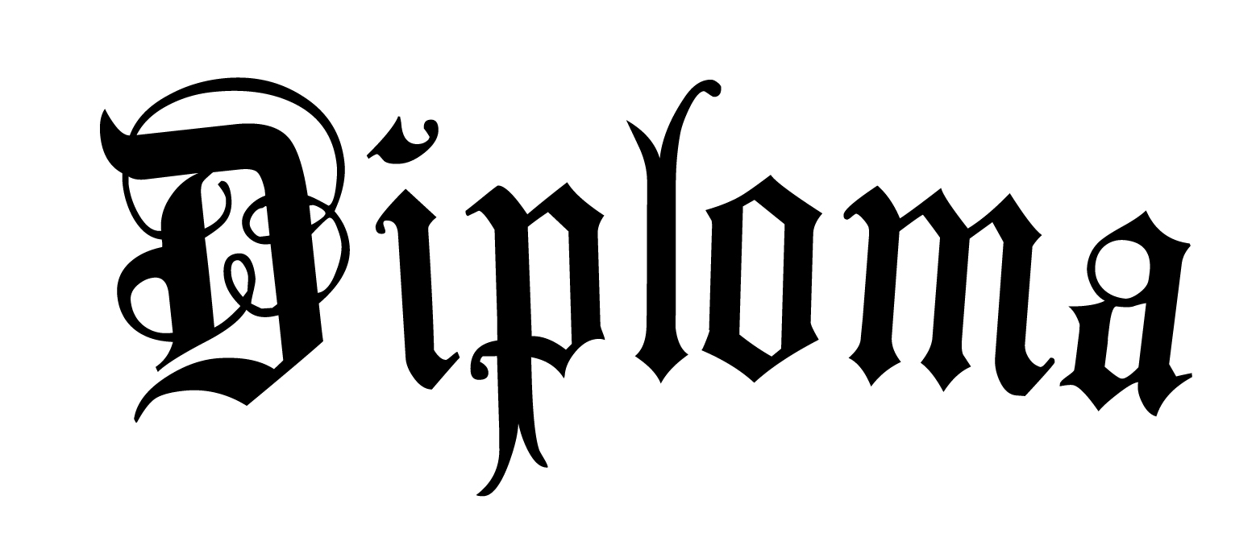

Apple Valley High School
This certifies that
Kelly Elizabeth Nygard
has successfully complete all of the requirements for graduation by the Apple Valley Board of Education and is hereby awarded this diploma

___________________________ _________________________
Signed Awarded On

