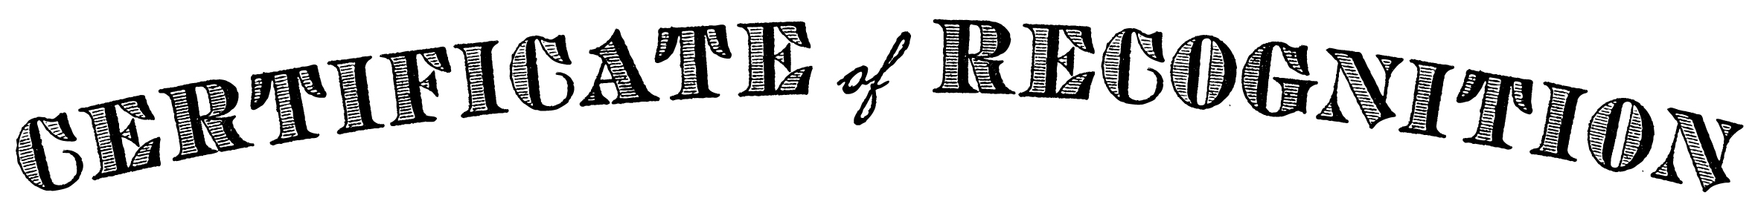

This certificate of recognition and appreciation is presented to

Ann Smith

For outstanding generosity and dedication to community service in the

Thanksgiving Day Helping Hands In Houston Event

____________________________ _________________________
Signed Date

