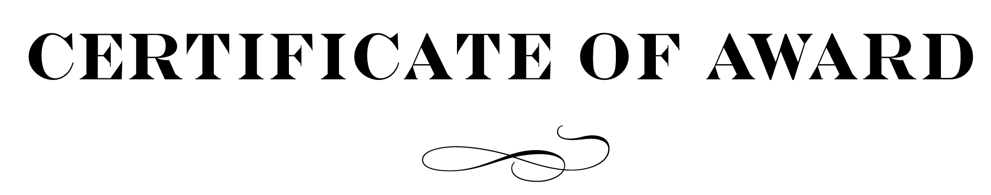

This certificate is awarded to

William M. Taylor

in recognition of your participation as a valuable resource in the

Lakeview School Playground Project

____________________________ _________________________
Paul K. Norman, Superintendent Martha Wilhom, Principal

